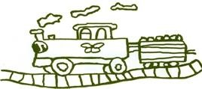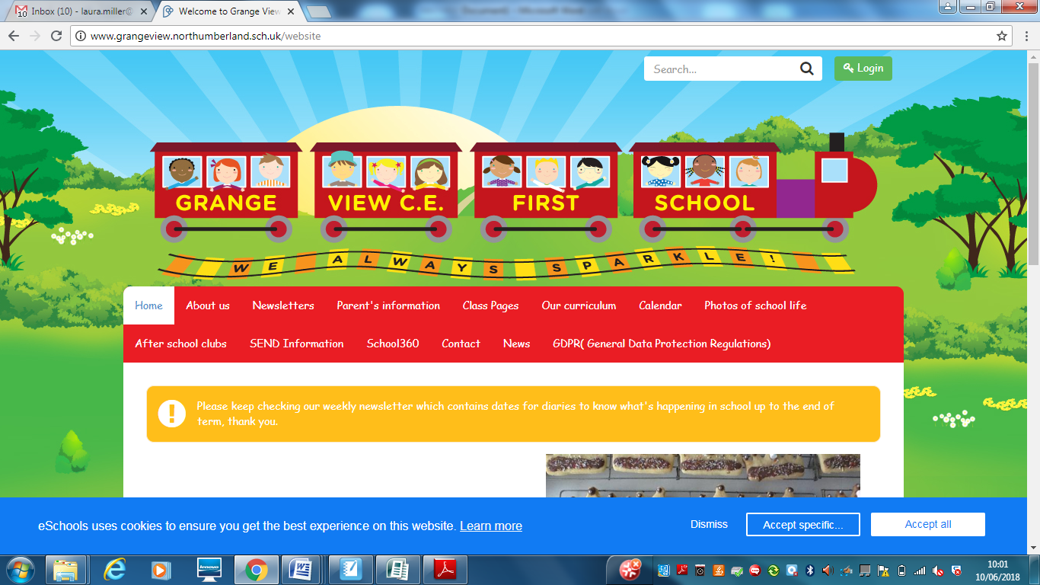

**Science at Grange View CE First School**

**This is a guide for anyone who is visiting Grange View C.E First School to explain our approach to Science in school. *Updated February 2023***

**Planning**

Our curriculum planning follows a two year rolling cycle in Early Years, Key Stage One and Two. The topics have been chosen based on the National Curriculum and ensuring the themes are engaging and interesting to the children.

The Science focus for each term is mapped out within Topics to ensure all areas of Science are covered.

**Skills progression:**

Skills progression from Early Years to Year 4 has been developed to ensure all areas of the Science curriculum are covered and to ensure clear progress throughout the year groups. This will also give staff the confidence to teach Science and know what needs to be achieved by the end of each year.

**Scientist Spine**

In addition to our Science curriculum, children also learn about scientists and their work linked to the area of the curriculum they are learning.

**OUR INTENT: What our Science teaching Intent is:**

Our teaching of science for all children is to develop a curiosity and interest in the subject during their time with us and beyond.   It is about developing and challenging children’s scientific knowledge and conceptual understanding through the different disciplines.  Science teaches children to have care and concern for living and non-living things and promotes curiosity about the world they live in.

Through the Programme of Study for Science in the National Curriculum, children will develop knowledge, concepts, skills and a positive attitude, supported through engaging outdoor learning opportunities. Working scientifically is developed throughout their time at Grange View as they progress through each year group, building on their enquiry skills and subject knowledge. By developing these skills it allows them to have greater independence in planning and carrying out fair tests.  These tests will allow children to explain concepts using scientific language, build arguments and ask questions showing curiosity about the world. We believe every child can flourish and is encouraged to strive for success.

**Science across the Curriculum**

Science is taught as part of topic time so it is relevant to what they are learning. It can be also taught as part of other subjects including Geography, outdoor learning, ICT, (recording data from experiments) Literacy, (writing scientifically) and Maths (Measurements, statistics etc). There is also a clear link to Relationships, Sex and Education which covers Human Science, lifecycles and Healthy living.

**Subject Spotlight – STEM week**

We celebrate STEM week in school as a way of developing children’s knowledge in Science, Technology, Engineering and Maths and how the subjects link. We have a variety of visitors in from STEM careers and children enjoy workshops and carrying out additional Science investigations. We then come together at the end of the week to share and celebrate our learning.

**Science resources**

We have a range of resources in school to help with the teaching of Science and to allow children to complete experiments in all year groups. These resources are checked by the subject leader and replenished and replaced when need be. Some of the resources include;

* Magnifying glasses
* Magnets
* Resources to complete basic electric circuits
* Thermometers
* Torches
* Pond dipping

**Assessment:**

Science is a very practical and orally taught subject, through each unit of learning a series of assessment for learning techniques will be used such as no stakes quizzes, show me boards and exit tickets to determine what the children have retained and understood. At the end of every term, assessment tracking sheets are completed by class teachers to identify the children who have and have not achieved the expectations of the National Curriculum.

At the end of a unit a pop task will be used to encourage the children to showcase and apply their learning of Science taught in relation to the intended outcomes.

**Where it all begins: Early Years Starting points.**

On entry to the Early Years, many children are working below age expectations in ‘Understanding of the world.’ This could be due to poor communication skills and lack of prior knowledge and experiences. During their time in Nursery and Reception, children participate in opportunities to discover the world around them and extend their vocabulary. Science is taught as part of ‘Understanding of the world’ covering forces, materials, different environments, natural world and weather/seasons. This gives children the basic knowledge needed in order to access the National Curriculum from Year 1. These aspects are taught in different areas of provision across our Early Years Unit both indoors and outdoors.

**Q of E - SEND provision**

* Using floor books so that they have the opportunity to develop scientific skills without the pressure of written evidence
* A vast majority of learning takes place in mixed ability pairs, to ensure that support and challenge is available and peer support is encouraged.
* Practical tasks and outdoor activities are used throughout the curriculum to support and engage the slower graspers.
* Pre teaching of key vocabulary with pupils with specific needs.

**Q of E - Pedagogical choices**

* Using a range of resources such as magnifying glasses, magnets etc.
* Matching it to real-life experiences
* Opportunities for partner discussion and collaborative working
* Use of word power to build awareness and confidence with tier three subject vocabulary

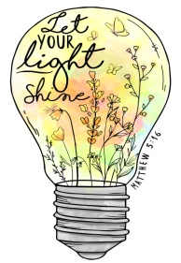

***What is it like to be a pupil at Grange View studying Science on a daily basis?***

At Grange View First School, Science is purposeful, stimulating, enjoyable and thought-provoking. Children see the relevance of Science to their own lives and the world they live in.

**Implementation: How are they knowing more and remembering more?**

|  |  |
| --- | --- |
| **Quality of Education** | Science is taught as part of a 2 year cycle which incorporates alongside our topic themes. The curriculum is portrayed through the S plan, with National curriculum content identified for each term. Each lesson is planned and delivered with the Scientific types of enquiry throughout allowing children to ask and answer questions, allowing them to contribute to the investigations. Information is presented clearly to children through pictures and words and teachers check their understanding throughout all lessons. The sequence of learning starts in Early Years which is covered in ‘understanding of the world’ where children will explore creatures, people, plants and objects in the world around them. Key Stage One children then build on this knowledge where they learn to develop their own enquiry skills and carry out investigations in plants and animals, habitats and materials. Key Stage 2 children then build on this knowledge and are introduced to further scientific enquiries such as Electricity and Sound. By children participating in fun, engaging and purposeful activities that is broad and balanced then they will remain in their long term memory allowing them to recall previous knowledge and continue to build on it. Topic floor books provide a visual illustration of the learning that has taken place in each lesson, these are referred to throughout the term helping the children make links to prior knowledge. Big Writes on a Friday allow opportunities for writing across the curriculum, with the assistance of word power vocabulary the children can apply their understanding of the subject individually and demonstrate long term memory, these form part of the assessment process. After each section of Science, teachers complete data to identify children working at the expected level and those children who will require further support before building on this knowledge. |
| **Behaviour and Attitudes** | Science is a subject that the children are curious about as it is relevant to the world they live in. Children have a positive attitude to their learning in Science and as they are in a safe and secure environment allowing children to explore and ask questions. Children always work together which encourages our core values of friendship, trust and respect, as children learn to take turns and listen to each other. Praise is used throughout lessons, to encourage positive behaviour from all pupils and planning of carefully structured lessons to ensure all children are involved in each lesson. |
| **Personal Development** | Through group and partner work, discussion and investigation the children develop their tolerance and respect for others. Through our favourite five, children learn all about diversity and learn to accept others around them. We offer a breadth of a curriculum which is above the National Curriculum as we encourage children to be ambitious and succeed in later life. During STEM week, we have a variety of visitors in to inform children of their careers in Science, Technology, Engineering and Maths which motivates children to want to work hard and find a passion. We then try to involve parents with STEM week by inviting them in to see their work and inform them of the learning. Topic letters are also sent home every half term, so parents can see the Science that will be happening and how parents can support with it at home. All Science lessons allow children to explore the beauty of nature and allows lots of ‘wow’ moments as well as ‘now’ as they learn what is happening all around them. During Science lessons, children learn about how the world is changing due to climate change and learn how to make a positive contribution to saving our planet. |
| **Leadership and Management** | Science is monitored through pupil voice and looking at evidence in floor books with children to see if they can articulate aspects of their learning. By using the floor books, children can recount their learning and demonstrate their knowledge of key vocabulary. An action plan is written each year for Science, focusing on key priorities from SIP and ensuring the children’s needs are at the centre of the plan. Science lead delivers CPD to all staff, to continue to develop their expertise and confidence in the teaching of the subject. Interventions are not required for the subject, however children are identified who are less secure in data, the class teacher will amend their planning and address misconceptions. Governors are informed termly of subject developments, with termly meetings taking place with the link governor sharing successes, areas for development or key priorities. |
| **Early Years** | Science is part of ‘Understanding the world’ in Development Matters. They learn about their natural world around them, and look at animals and plants. They also learn about the changes in weather during the seasons. It builds on children’s prior knowledge and experiences as children are allowed the opportunity to share their experiences in role-play which is closely observed by staff.  The content taught is Early Years are the building blocks needed to access the National Curriculum in Key Stage One and data is shared with staff to identify children who may need additional support. |