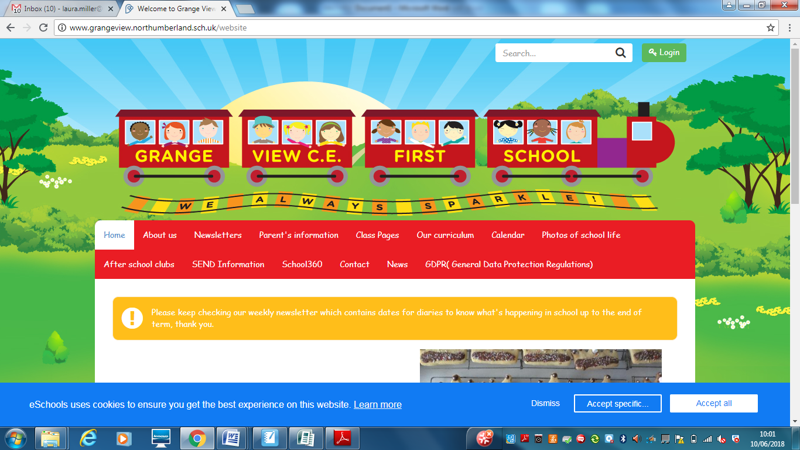

**Our Christian Vision is that- Everyone sparkles.**

Grange view welcomes everyone to flourish and thrive. We are lifelong learners that strive to achieve our God given potential.

*So don’t hide your light! Let it shine brightly before others.*

[**Matthew 5:16**](https://www.biblegateway.com/passage/?search=Matthew+5%3A16&version=TPT)The Passion Translation of the bible





**Our Ethos**

The children are living a Christian life where they aim to sparkle, thinking about our core Christian Values; Love, Friendship, Trust, Forgiveness, Respect and Wisdom

. **Our Aims**

* To provide a stimulating and secure environment, inclusive of children from all faiths and cultures.
* To provide an engaging, meaningful and relevant curriculum that equips all learners with the necessary skills for their educational journey.
* To value all individuals and support them to reach full potential and create an atmosphere of equal opportunity where expectations are high.
* To grow caring citizens who value the world we live in and celebrate moments of awe and wonder.
* To offer opportunities for collective reflections and inspire spiritual development that shape daily lives.
* To help the children to form values which will allow them to make moral choices throughout their lives, not just during their school years.
* To work in partnership between home, school, church and the wider community.