Grange View C.E.FirstSchool
Grange Road, Widdrington Morpeth, NE61 5LZ.
Telephone: 01670 790 686
email: admin@grangeview.northumberland.sch.uk
Headteacher: Mrs Louise Laskey B.Ed(Hons) www.grangeview.northumberland.sch.uk

Dear Parents/Carers 8th May 2017

*REMINDER please return Parent Questionnaire is with this newsletter by tomorrow at the latest and online to be entered for Prize Draw!

NEWS!
We are pleased to announce that we have a new teacher joining us in September 2017 in KS2 to work in a new class alongside Willow Class. She will be meeting the children very soon and we can’t wait for her to join our team! We will also be advertising very soon for new teaching assistant so if you know anyone who is qualified and interested please keep checking the County council website for the adverts.

Swimming
From September 2017 Year 3 and Year 4 will continue to go swimming, as it is a statutory requirement for Key Stage 2 pupils to swim as part of their PE curriculum. We will continue to swim weekly at Morpeth Leisure Centre but we hope to confirm that it will change to a Wednesday afternoon which will mean the children will return to school for home time slightly later. We will confirm this when we have further information but wanted to give parents plenty notice.
YEAR 2 will no longer be swimming from Sept 2017 as it is not statutory for them to do so until KS2 (these are our current Year 1 children).

Gates
The Educational Welfare Officer was on site this morning carrying out a “late gate” check to encourage all families to be on time at 8.50am when the bell rings for the start of the school day. She will be returning unannounced this term to monitor attendance.
All gates apart from the entrance next to the school bungalow will be locked at 9am daily to avoid any late comers in school. All pupils should be in line for 8.50am for the bell ringing.

Nursery and Reception Places
If you have a baby in the family or know someone who lives in the village who has a baby, please can a Nursery application form be completed. We are asked by the Local Authority to predict our Nursery pupil numbers as far ahead as 2020/21. This helps the Local Authority allocate funding and helps us calculate if we can offer an afternoon Nursery and places to ‘Rising 3’s’.
We now have been informed by the local authority who has a place for Reception for Sept 2017, you should have all received confirmation of this if you applied for Grange View.

PE Kit
It is vital that your child has his/her full PE kit in school (shorts/tee-short/sandshoes), otherwise they may miss out on valuable PE/sporting activities due to incorrect clothing & footwear. This is necessary for the safety of everyone, thank you.

School Dinners
From September 2017 our current Yr 2 children (Beech Class) who will be moving in to Yr 3 will be required to pay for school dinners or bring a packed lunch. If you know your child will be having dinners (£11.00 per week), would you please let the office know so we can give our Unit Manager Mrs Palmer an indication of numbers for September, thank you.

Packed Lunches
Please can all families ensure they give the office at least a week’s notice if their child wishes to change to a packed lunch. Food is ordered in advance for all school lunches. Thank you.

Dates for diaries:

Please check these weekly - all are subject to change or additional dates being added:-
- Wed 10th May – Messy Wednesday at 3.15pm (NO DANCE AFTER SCHOOL CLUB)
- Thurs 11th May – Willow Class visit to Centre of Life (all payments to be up-to-date)
- Mon 15th May – all of Y4’s to Striking & Fielding event at JSCS - PM only
- Thurs 18th May – small Y4 group to Tag Rugby event at Ashington – PM only
- Fri 19th May- Willow Class - Ford Castle Day (all payments to be up-to-date)
- Thurs 25thMay - Y4s to JCSC for the day – slips to be returned to office please
- Fri 26th May- Half term, school closes at 3.15pm
- Mon 5th June- school re-opens for Summer Term 2 at 8.50am
- Wed 7th June – all of Y4’s to Quad Kids event at Amble Links – all day
- Wed 7th June – last Messy Wednesday for this term at 3.15pm
- Tues 13th June – all of Y3’s to Rugby Festival at Ashington Rugby Club – PM only
- Tues 20th June - Big Gig Music Event for Willow class at JCSC, further details to follow
- Wed 21st June - Y4 Leavers service with staff at St. Nicholas cathedral in Newcastle
- Fri 23rd June - Summer Fair at 3pm
- Year 4 Leavers Tea and end of year evening - dates to be confirmed
- Fri 21st July - School closes at 1.30pm for the summer
- Mon 5th Sept – TTD, school closed to pupils
- Tues 6th Sept – school opens at 8.50am for the Autumn Term

Sainsbury’s Vouchers – this is is now drawing to a close, so please hand any in for our collection please, and thank you for all that have come in so far! Check your bags, purses, etc for any that you may have missed, thanks.

Attendance – Does it matter? YES IT DOES!!
To promote and reward good attendance across the school the governors have agreed to provide an AMAZING incentive!
The class with the greatest attendance at the end of the year will win a MINI IPAD and a family with 100% attendance will be entered to a prize draw to win £30 shopping voucher.

Please remember your child’s attendance in school is extremely important. Awards will continue to be given to each class with the best attendance. Can we remind parents about a section of the Education Act 1996: “Central to raising standards in education and ensuring all pupils can fulfil their potential is an assumption so widely understood that it is insufficiently stated – pupils need to attend school regularly to benefit from their education. Missing out on lessons leaves children vulnerable to falling behind. Children with poor attendance tend to achieve less in both primary and secondary school.
NO HOLIDAYS will be authorised in term time.

Last week’s attendance: We had joint winners!!
Well done Acorn Class & Beech Class who both had 98.7%
Acorn – 98.7% Oak – 94.8%
Elm – 96.5% Beech – 98.7% Willow – 96.7%
TOTAL FOR THE LAST WEEK – 97%
Our school target of 96%

PLEASE TRY to get your child to school on time every day
and help us achieve our target EVERY week, thank you.

Stars of the week

Beech
Merit – Annabelle, Riley B-A
Sparkle – Vincenzo
Writing – Jake
Presentation – Evan

Willow
Merit – Reagan, Elsie
Sparkle – Mia
Writing – Caitlyn
Presentation – Logan

Acorns
Merit – Reshay, Mason
Sparkle – Elliott
Writing – Poppy A
Oak
Merit – Katie, Grace Y
Sparkle – Porscha
Writing – Harry
Presentation – Dillon
Elm
Merit – Leah, Leon
Sparkle – Riley C
Writing – Aaron
Presentation – Imogen

Football
Ashton, Rhys, Katie

DON’T Forget- Easy Fund Raising- www.easyfundraising.org.uk. Please register and keep Shopping online on this website for school funds. Every penny you spend helps school.

Reminder from Mrs Chapman about Extreme Reading!

What bizarre and unusual places could you photograph your child or the family reading? Please bring in photographs or send to our new home learning email address grange.view@school360.co.uk either over the holidays or in the forthcoming weeks of the Summer Term. You can do it from your mobile phones!
We look forward to seeing your extreme reading adventures. Thanks Mrs Chapman

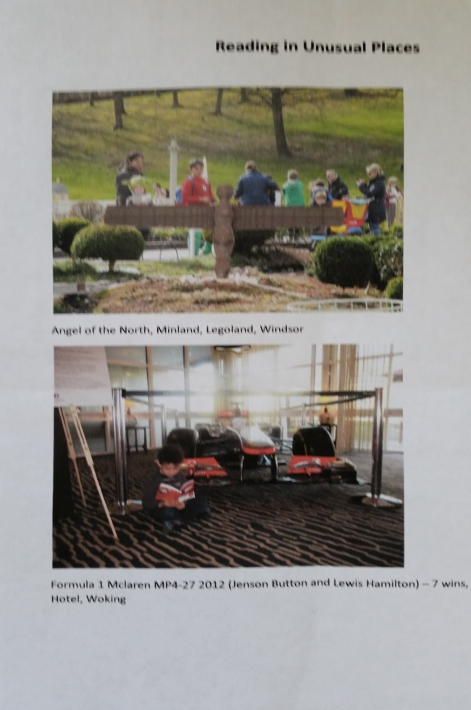
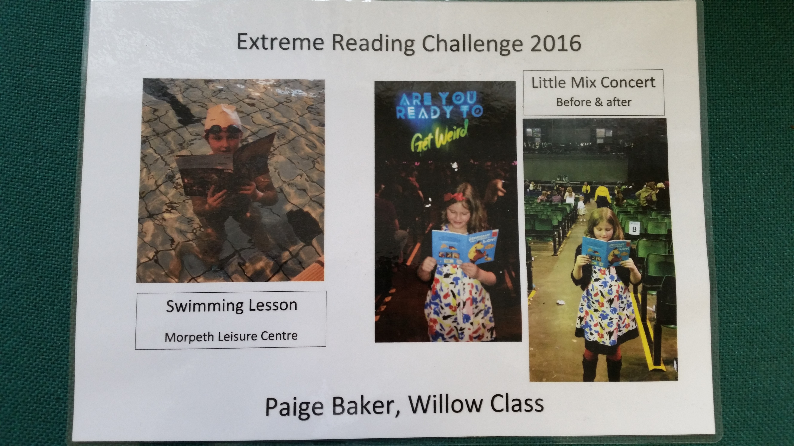

Kind Regards
Louise Laskey
Mrs L Laskey – Headteacher

