

**Grange View C.E. First School**   
Grange Road, Widdrington  
Morpeth, NE61 5LZ.

Telephone: 01670 790 686email: [admin@grangeview.northumberland.sch.uk](mailto:admin@grangeview.northumberland.sch.uk)

Headteacher: Mrs Louise Laskey

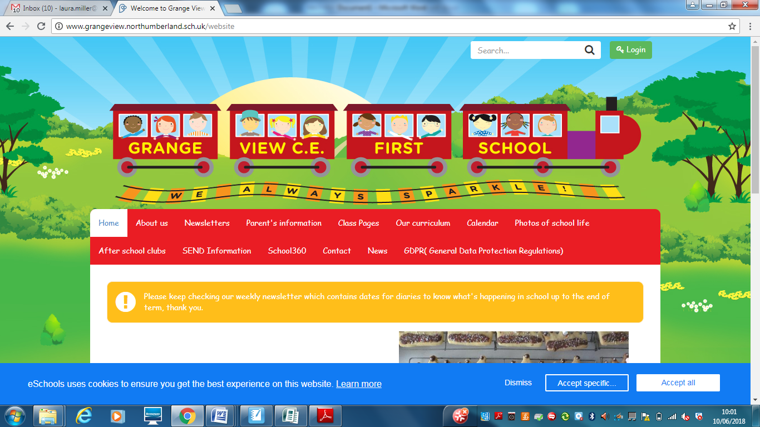

***We aim to SPARKLE!***

**Dear Parents / Carers 5 March 2021**

**Welcome back!**

**We are so excited to welcome all our children back on Monday 8th March. Please ensure you have read the timetable emailed to you all so you know the arrangements for pickups and drop offs.**

**It will be amazing to have all our children back in each class in their Key Stage Bubbles and don’t worry we will still keep you all updated on Class Dojo and through emails.**

**As restrictions hopefully ease we will eventually be able to have all our parents and carers back on site soon too!**

**Please ensure your child is in normal full uniform and has their water bottle and book bag with them.**

**New Risk Assessments for the safe return to school are on our school website in the COVID Section.**

**All staff will now be wearing face maks around school and in communal areas for the safety of all until this is reviewed at Easter by the government.**

**See you all on Monday!**

Acorns class- Nursery- arrive 8.30am Bungalow gate and pick up 11.30 same place.

Oak Class- Reception- arrive 8.45am Bungalow gate and pick up 3.10pm same place.

Elm Class- Year 1- arrive 8.40am main gate and pick up 3.05pm same place.

Beech Class- Year 2- arrive 8.50am cycle path gate and pick up 3.15pm same place.

Chestnut Class- Year 3- arrive 8.40am Grange Court gate and pick up 3.05pm same place.

Willow Class- Year 4- arrive 8.50am Grange Court gate and pick up 3.15pm same place.

Please remember to be on time , keep your social distance and do not linger around to avoid any congestion and groups/crowds forming at any of our gates. Thankyou.



**RED NOSE DAY(Comic Relief)- We will be supporting Red Nose Day on Friday 19th March this year, by asking your child to wear something Red. We will also be selling Red Noses in school for £1.50 each to support this charity – these will be available to buy from school on Monday.**

**As this is a Non uniform day the Friends of Grange View are asking you to send in a donation for the Easter Raffle please.**

**Early Years and KS1- Easter Eggs please**

**KS2- Drinkable Bottles please.**

Thank You!

**FREE Library books-** eLibrary Service. We are very excited to have access to an online eLibrary service allowing you to loan eBooks at home. Each child will be sent their own individual username and password on Class Dojo to log in to this service and Mrs Timmins will be uploading a video onto Class Dojo and the school website with a step-by-step guide on how to download the app and access the books. Please get in contact if you need any assistance using the service and we will do our best to help.



**NEW NURSERY**

Please can all parents of younger siblings ensure they have completed their Nursery application form asap as we need to plan staffing for the upcoming years. If we don’t have your child on our list we can’t write to you and offer a place. From September 2022 we are nearly full up so please don’t delay and spread the word in Widdrington!

***Dates for the diary:***

* **RETURN TO SCHOOL – Mon 8th March- YEAH !!!!!!!**
* **\*\*\*\*\*\*RED NOSE DAY /Non uniform day******* 19th March – Wear RED and Easter Raffle Donations – Acorns/Oak/Elm/Beech- Easter Eggs please. Chestnut and Willow Class- Bottle donations. Watch out for news from the Friends of Grange View**
* **Last week- Easter Egg Competition TBC/Easter Class Songs TBC/ Easter Lunch- Wed 24th March- order with the school office.**
* **Friday 26th March- Break up for Easter**
* **Mon 12th April- TT day, children return on Tues 13th April with same staggered drop off etc.**

**Shopping Link to support Grange View CE First School**

<https://smile.amazon.co.uk/ch/1049905-0>

This is the link to The Friends of Grange View Fundraising. It takes you to Amazon for any purchasing. Everything you buy raises funds for the school and generates extra funding to the PTA who in turn spend it on resources for your child and the school. Thankyou for supporting us with this as every penny counts.

**SIMS Online payments – COIVID SAFE CASH FREE SYSTEM**

Our new online payment system for any services in school is now active. Thank you to all of those who have already signed up and began using it. You should have received an activation code via email. Please follow the online instructions to set this up to make any future payments. Any issues please email or call the office. Thank you.

Please don’t hesitate to contact us if you have any questions or concerns at [admin@grangeview.northumberland.sch.uk](mailto:admin@grangeview.northumberland.sch.uk)

****Please note – no cash is to be brought into school unless we ask specifically (often for the Friends of Grange View events) All payments for school lunch, milk, uniform, trips etc. should all be made online. Due to Covid, we need to avoid handling cash as much as we can.*****

**Stars of the Week:**

**Beech**

Merit – Bailey H & Harleigh

Sparkle - Frankie

**Chestnut**

Merit – Year 3 Pod & George

Sparkle - Roseann

**Willow**

Merit – Grace Y & Katie

Sparkle - Harry

**Acorn**

Merit – Jacob & Lucas

Sparkle – Milly B

**Oak**

Merit – Robson & Archie

Sparkle – Bella-Rose

**Elm**

Merit – Amie & Logan

Sparkle – Year 1 Bubble

**COVID Update:**

**COVID STAFF TESTING**

**Staff testing continues.** Any staff who test postive will then have to follow government guidelines and isolate for 10 days as well as booking another PCR TEST through 119 . Therefore this may obviously have an impact on any children who are in the same bubble as that member of staff and the bubble will also have to close until the PCR Test results come back. If the postive test is confirmed then the whole bubble will isolate for the recommended 10 day period. If the result comes back negative then the bubble will reopen.

We hope you can understand that this a postive move to stop any further transmission of the virus and we will continue to keep all staff and children as safe as possible.

**Attendance**

**School attendance is mandatory again from 8th March. It is essential that your child is in school to give them the very best chance of success. Non-attendance will be followed up immediately by the school and education welfare officer if required.**

**All primary children are expected to attend school from 8th March.**

**It is essential that your child returns to school unless they have symptoms or are isolating with you at home. We will need to ask you to follow the government guidelines and seek a test and share the results to allow us to keep everyone safe.**

However, pupils, staff and other adults should not come into school if they have coronavirus (COVID-19) symptoms, or have tested positive. Anyone developing those symptoms during the school day will be sent home.

This includes any of the following symptoms:

● New and persistent cough

● Fever / temperature

● Loss of sense of taste and / or smell

They will be advised to follow ‘stay at home: guidance for households with possible or confirmed coronavirus (COVID-19) infection’, which sets out that they must self-isolate for at 10 days and should arrange to have a test to see if they have coronavirus (COVID-19). Other members of their household (including any siblings) should self-isolate for 10 days from when the symptomatic person first had symptoms.

If, during the course of the school day, your child demonstrates any symptoms of COVID-19 (as outlined above), they will be isolated immediately and you will be contacted to collect them from school with immediate effect. Your child will be treated with care and compassion, but there is a process that we are required to follow and this may include the member of staff dealing with them using PPE kit to protect themselves (goggles, face mask and gloves) while they await collection if a distance of 2 metres cannot be maintained.

Any pupils who have been in close contact with them do not need to go home to self-isolate unless they develop symptoms themselves (in which case, they should arrange a test) or if the symptomatic person subsequently tests positive or they have been requested to do so by NHS Test & Trace.

**Remote education will still be provided where pupils are self-isolating or shielding.**

**Asymptomatic testing information for parents and adults in households with children at school or college**

NHS Test and Trace announced earlier this week, that all adults in households with school and college age children without symptoms can now access regular rapid coronavirus (COVID-19) testing.

Test kits can either be collected or ordered online, as set out below.

Undertaking regular, rapid coronavirus (COVID-19) testing helps reduce transmission of the virus. Parents and other adults in households with children at school or college, who do not have symptoms, can now access regular, rapid coronavirus (COVID-19) testing. This includes childcare and support bubbles.

Tests are fast, easy and completely free. There are [different ways](https://www.gov.uk/guidance/rapid-lateral-flow-testing-for-households-and-bubbles-of-school-pupils-and-staff) for a household, childcare or support bubble to collect their test to take at home, twice-weekly:

|  |
| --- |
| * **through your employer, if they offer testing to employees** * **by collecting a home test kit from a local test site – anyone aged 18 or over can collect 2 packs of 7 tests** * **by ordering a home test kit online – please do not order online if you can access testing through other routes, this frees up home delivery for those who need it most** |

If you have any queries about the tests, and you live in England, please call 119 (free from mobiles and landlines). Lines are open every day from 7am to 11pm.

Children of primary school age (and below) without symptoms are not being asked to take a test.

Testing is voluntary, but strongly recommended to all who are eligible. Alongside the vaccine, washing hands, wearing face coverings, and maintaining social distancing, rapid testing plays a vital role in reducing transmission rates. Getting into the habit of regular testing as part of our everyday lives will help us all to play our part and do what we can to protect each other.

**Chromebooks**

Please could all Chromebooks that were loaned out during the last few months be returned on the 8th March. Thank you.

Thank you once again for your support and patience during all of these changes.

**We continue to follow the government message:**

**STAY HOME – PROTECT THE NHS- SAVE LIVES**

Louise Laskey – Headteacher



**Safe to Learn section**

This is a section on our newsletter where we will share and update any safeguarding information for all parents/carers to be aware of. Mrs Pat Treanor is our Chair of governors and safeguarding governor, Mrs Laskey and Mrs Chapman are our Designated Safeguarding lead staff.

 

Mrs Laskey- Head Mrs Chapman-Assistant Head

**OPERATION ENCOMPASS INFORMATION**

The original initiative was aimed at supporting children who are affected by domestic abuse. The next part of the project will help all children to learn about friendships, relationships, emotions and rules so that they can live and work together safely. Our Safeguarding liaison officer Karen Kirkbride will be in school this term delivering these workshops.

**Operation Endeavour**- This is an innovative project in which schools and colleges in Northumberland are participating, and which is run in partnership with Northumberland County Council and Northumbria Police.

Operation Endeavour commenced in November 2018, aims to support children and young people who go missing from home. Children who go missing from home are at risk of significant harm and they may be vulnerable to sexual exploitation, violent crime, gang exploitation, or to drug and alcohol misuse.

As a result, following any report of a child going missing to the Police, the Police will make contact with Children’s Social Care who will then communicate relevant and necessary information to nominated school staff.

Each school has members of staff (key adults) who have been fully trained in liaising with the Police and Children’s Social Care when required, and will ensure that the necessary support is made available to the child or young person following their return.

I believe that this project demonstrates our school’s commitment to working in partnership to safeguard and protect children, and to providing the best possible care and support for our pupils.

**Onecall**

Onecall is the number for all adult social care, children’s services and community health enquires in Northumberland. Helping the most vulnerable to keep safe and well 24-7.

**Telephone- 01670 536400**

