

**Grange View C.E. First School**   
Grange Road, Widdrington  
Morpeth, NE61 5LZ.

Telephone: 01670 790 686email: [admin@grangeview.northumberland.sch.uk](mailto:admin@grangeview.northumberland.sch.uk)

Headteacher: Mrs Louise Laskey

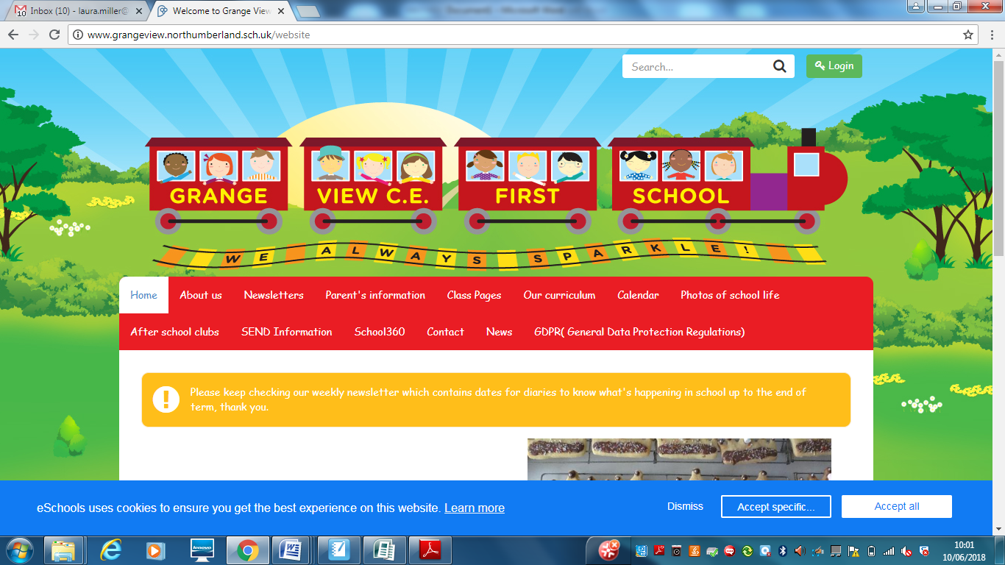

***We aim to SPARKLE!***

**Dear Parents / Carers, 18th June 2021**

**September 2021**

**Since the Government announcement and advice from the local authority, we will continue to follow our Risk assessments and let you know of any changes with transition and other arrangements.**

**All our Key stage bubbles and COVID safety arrangements will not change and will remain in place. We hopefully will be able to have families back on site in the autumn term although at the moment for the first week back we will still continue with staggered drop off and pick-ups. BUT if circumstances change we will obviously communicate this with all our families.**

**Thankyou for all your support this year with all the changes we have had to make, to keep everyone safe. We really appreciate everything!**

**Sports week - 21st June**

The governors and I are sorry to inform you that following the government's announcement on the restrictions remaining in place until July 19th we have had to make some difficult decisions.

There are rising numbers of positive Covid cases in our local area and some schools very close by have already had to close bubbles again. Therefore unfortunately we will not be inviting one parent on site for any of our Sports days.

So that you do not miss anything the staff will take lots of photos and record one set of races for you to see on Class Dojo or the school Facebook page. We are so sorry but we need to keep you all safe and our children, until it is safe to resume normal activities. **NEW DATES!**

**Mon 21st- Acorns Sports events- please wear School PE KIT.**

**Wed 23rd KS2 Sports Events pm- please wear School PE KIT.**

**Thurs 24th Oak / Beech Sports Events pm- please wear School PE KIT.**

**Friday 25th Elm Sports Events pm - please wear School PE KIT.**

**Summer Raffle**

Summer Raffle tickets have been sent home this week. They are £1 per ticket and there are 5 in a book.

Please write your name on the stubs and return no later than Thursday 24th June.

Raffle will be drawn Friday 25th June.

As this is for the Friends of Grange View PTA fund we request cash only. It has not been set up on SIMS to make payment as it is a different account.

If you have any tickets you don't want please return to school.

**School Class Photos**

**SAMPLE COPY - EMAILED TO ALL FAMILIES**

Please pay for all photographs via SIMS, we are a cash free school, thank you. To make payment on SIMS it is under the online shop tab and then school photos and these are £10 each.

**\*\*\*\*YEAR 4 LEAVERS EVENTS- CHANGES TO DATES\*\*\*\***

**Due to Covid, this year’s events are very restricted and different and some will still need to be confirmed after the government make further announcements. Please bare with us and read all communications.**

Thurs 1st July- SEND pupils transition visit JCSC morning only and Chantry transition visits day

Wed 7th July - Whole school transition day / Y4 to JCSC. Separate letters already sent home from JCSC.

Tues13th July – Y4 afternoon Forest school pupils and staff only on school site. NO Lollo visit due to restrictions

Wed 14th July - ****5-6pm Y4 LEAVERS Celebration***** Awards + Pizza and refreshments. Sorry no parents dues to restrictions continuing.

**\*\*\*\*New Diary Dates\*\*\*\***

21st – 25th June - Sports week: see above

Fri 25th June – **Friends of GV Cake Box day + Raffle**

Mon 28th June - New nursery visits 2pm

Wed 30th June- Y3 Beach school visit- see separate letter

1st July - Chantry Transition visits + SEND transition visits to JCSC

Fri 2nd July - Reports sent home

Wed 7th July - Whole school transition day / Y4 to JCSC (to be confirmed by the Middle school)

Mon12th July – 2.30pm Rev Joanna farewell tea on Field - children and staff only

Tues13th July – Y4 afternoon Forest school

Wed 14th July - ****5-6pm LEAVERS Celebration***** Pizza + refreshments

Fri 16th July - School closes at 1.30pm - Oak - 1.15pm / Elm + Chestnut - 1.20pm / Beech and Willow - 1.30pm.

**September uniform**

Following our school uniform policy your child will be expected to wear the following:

A school sweatshirt / cardigan in the correct colour

Yellow polo shirt

Grey trousers / skirt / pinafore or yellow gingham dress

All black school shoes with no logos

A school PE t-shirt with black shorts or joggers.

We have lots of clean good second hand for anyone who needs it and we will keep spares for any child who turns up for school in the wrong uniform.

These supermarkets and shops store correct colours: Asda / Sainsbury’s / Matalan / Marks and Spencer’s and many others.

**JEWELLERY- NO EARRINGS.**

PE's Health and Safety guidance states- “Schools have a duty of care to ensure students are able to participate actively without unnecessarily endangering themselves or those working around them. A clear and consistently applied policy for the removal of personal effects should be in place. The Association for Physical Education (afPE) strongly recommends the practice of removing all personal effects at the commencement of every lesson to establish a safe working environment. This applies to all ear and body piercings, including retainer and expander earrings.”

***Please ensure all jewellery is removed before all PE lessons at home or can your child remove them on their own.***

**FREE STORYTIME- Sat 19th June 11-11.45am**

[**https://www.thebritishacademy.ac.uk/events/the-british-academy-summer-showcase/we-can-be-heroes-classical-stories-for-wellbeing-today/**](https://www.thebritishacademy.ac.uk/events/the-british-academy-summer-showcase/we-can-be-heroes-classical-stories-for-wellbeing-today/)

**Theme- We can be heroes: classical stories for wellbeing on Zoom**

**Summer term attendance expectations for schools**

School attendance continues to be mandatory for all pupils and the usual rules on school attendance apply. This includes parents’ duty to ensure their child regularly attends school, and schools’ and local authorities’ ability to issue sanctions, including fixed penalty notices, for poor attendance.

We expect schools and local authorities to continue to communicate clear expectations around attendance to families, identify pupils at risk of disengagement and develop plans to re-engage them.

As restrictions begin to lift, we know some families may be looking to take holidays during term time. As usual, parents should plan their holidays around school breaks and avoid seeking permission to take their children out of school on holiday.

**E-safety-** Remember all you need is on our school website and Facebook page to support you at home with the internet and its use.

**http://www.grangeview.northumberland.sch.uk/website/esafety/102589**

**TRIDENT SUMMER FOOTBALL CLUB**

We would like to work with Trident Football club and provide a Summer Football school during the holiday’s this year. This will take place at Grange View week beginning 26th July (Monday – Thursday 9.30am – 12.30pm) The Football camps run for four days and the cost is £40, or £10 a day.

***If you are interested in booking a place please ring the office to add your child’s name to the list asap***

**AFTER SCHOOL CLUBS AUTUMN 2021- All clubs from Sept will be £2 per session**

**These are the clubs we are offering for the Autumn Term:**

**Mondays - Fun and games outdoors - Newcastle Thunder**

**Tuesdays – CLUB with Miss McQuade – Theme to be confirmed**

**Wednesdays - Football Club- with Trident football and coaches**

**Thursdays- Little Movers – Reception, Y1 and Y2 with Fiona**

**Shopping Link to support Grange View CE First School**

<https://smile.amazon.co.uk/ch/1049905-0>

This is the link to The Friends of Grange View Fundraising. It takes you to Amazon for any purchasing. Everything you buy raises funds for the school and generates extra funding to the PTA who in turn spends it on resources for your child and the school. Thankyou for supporting us with this as every penny counts.

*“This email is to notify you that Amazon has donated £22.71 to your organisation (Friends Of Grange View County First School) as a result of AmazonSmile programme activity between 1 January and 31 March, 2021. The donation has been deposited to your organisation's bank account on or before 19 May, 2021”*

**SIMS Online payments – COVID SAFE CASH FREE SYSTEM**

Thank you to all of those who have already signed up and are using it. We cannot accept cash and the SIMS system is what should be used. You should have received an activation code via email and it is very quick and easy to set up. Please follow the online instructions to set this up to make any future payments. Any issues please email or call the office. Thank you.

Please don’t hesitate to contact us if you have any questions or concerns at [admin@grangeview.northumberland.sch.uk](mailto:admin@grangeview.northumberland.sch.uk)

****Please note – no cash is to be brought into school unless we ask specifically (often for the Friends of Grange View events) All payments for school lunch, milk, uniform, trips etc. should all be made online. Due to Covid, we need to avoid handling cash as much as we can.*****

**Acorn**

Merit – Alice & Thomas

Sparkle – Theia G

**Oak**

Merit – Marcie & James

Sparkle – Mary-Jayne

**Elm**

Merit – Alex & Joseph

Sparkle –Domenica

**Stars of the Week:**

**Beech**

Merit – Jayce & Matilda

Sparkle – Bailey R

**Chestnut**

Merit – Roseann & Jacob

Sparkle – Kristian

**Willow**

Merit – Grace B & Taylor S

Sparkle – Taylor-Leigh Mc

**ATTENDANCE**

**The most important message is children should be in school as much as possible as every day that a child misses school, for whatever reason, they miss out on vital learning.**

We will be continuing to monitor our classes’ attendance every week and individual class percentages will be published here each week. It is vital that children attend school every day possible to ensure that they are able to start catching up on learning that they may have missed during the school closure and holidays.

Children should not attend school if they are showing any Covid symptoms or if they are required to self-isolate as a result of being in contact with anyone who is showing symptoms.

**Can my child go to school if they have a cold?** The NHS advises that if a child has mild cold-like symptoms they

should continue to go to school. Sore throats and blocked or runny noses are not symptoms of Coronavirus. We have routines in place should a child in school show symptoms of Coronavirus and will isolate the child and contact parents to collect them immediately, self -isolate and book a test.

**This week’s attendance stars**

Well done to **ELM** Class who won with 98.7%

Acorn – 95% Oak – 95.6% Elm – 98.7% Beech 90.9%

Chestnut – 98.4% Willow – 90.9%

TOTAL FOR THE WEEK 94.6%

Which is below our new school target which is now 97%

**W/C: 14.06.2021**





**Sparkling Afternoon Tea**

**4 wonderful Year 3 children joined Mrs Laskey outside last week – Arron, Lucie B, Lucy F and Angelo had treats and a chat for all their efforts last week in school. I wonder who it will be this Friday in Year 2 again?????**

**COVID**

Schools and colleges continue to play an important role in contact tracing for pupils, students and staff. We recognise the challenges of this responsibility during holidays, but this remains vitally important in the continued national effort to limit the spread of the virus.

Where pupils, students or staff test positive for COVID-19 having developed symptoms within 2 days of being in school or college, you are asked to assist in identifying close contacts and advising self-isolation, as the individual may have been infectious whilst in school or college.

If, during the course of the school day, your child demonstrates any symptoms of COVID-19 (as outlined above), they will be isolated immediately and you will be contacted to collect them from school with immediate effect. Your child will be treated with care and compassion, but there is a process that we are required to follow and this may include the member of staff dealing with them using PPE kit to protect themselves (goggles, face mask and gloves) while they await collection if a distance of 2 metres cannot be maintained.

Any pupils who have been in close contact with them do not need to go home to self-isolate unless they develop symptoms themselves (in which case, they should arrange a test) or if the symptomatic person subsequently tests positive or they have been requested to do so by NHS Test & Trace.

**Remote education will still be provided where pupils are self-isolating or shielding.**

**Asymptomatic testing information for parents and adults in households with children at school or college**

NHS Test and Trace announced earlier this week, that all adults in households with school and college age children without symptoms can now access regular rapid coronavirus (COVID-19) testing.

Test kits can either be collected or ordered online, as set out below.

Undertaking regular, rapid coronavirus (COVID-19) testing helps reduce transmission of the virus. Parents and other adults in households with children at school or college, who do not have symptoms, can now access regular, rapid coronavirus (COVID-19) testing. This includes childcare and support bubbles.

Tests are fast, easy and completely free. There are [different ways](https://www.gov.uk/guidance/rapid-lateral-flow-testing-for-households-and-bubbles-of-school-pupils-and-staff) for a household, childcare or support bubble to collect their test to take at home, twice-weekly:

|  |
| --- |
| * **through your employer, if they offer testing to employees** * **by collecting a home test kit from a local test site – anyone aged 18 or over can collect 2 packs of 7 tests** * **by ordering a home test kit online – please do not order online if you can access testing through other routes, this frees up home delivery for those who need it most** |

If you have any queries about the tests, and you live in England, please call 119 (free from mobiles and landlines). Lines are open every day from 7am to 11pm.

Children of primary school age (and below) without symptoms are not being asked to take a test.

Testing is voluntary, but strongly recommended to all who are eligible. Alongside the vaccine, washing hands, wearing face coverings, and maintaining social distancing, rapid testing plays a vital role in reducing transmission rates. Getting into the habit of regular testing as part of our everyday lives will help us all to play our part and do what we can to protect each other.

Thank you once again for your support and patience during all of these changes.

**We continue to follow the government message:**

**Hands- Face- Space- Fresh Air**

Louise Laskey – Headteacher





**Safe to Learn section**

This is a section on our newsletter where we will share and update any safeguarding information for all parents/carers to be aware of. Mrs Pat Treanor is our Chair of governors and safeguarding governor, Mrs Laskey and Mrs Chapman are our Designated Safeguarding lead staff.

 

Mrs Laskey- Head Mrs Chapman-Assistant Head

**OPERATION ENCOMPASS INFORMATION**

The original initiative was aimed at supporting children who are affected by domestic abuse. The next part of the project will help all children to learn about friendships, relationships, emotions and rules so that they can live and work together safely. Our Safeguarding liaison officer Karen Kirkbride will be in school this term delivering these workshops.

**Operation Endeavour**- This is an innovative project in which schools and colleges in Northumberland are participating, and which is run in partnership with Northumberland County Council and Northumbria Police.

Operation Endeavour commenced in November 2018, aims to support children and young people who go missing from home. Children who go missing from home are at risk of significant harm and they may be vulnerable to sexual exploitation, violent crime, gang exploitation, or to drug and alcohol misuse.

As a result, following any report of a child going missing to the Police, the Police will make contact with Children’s Social Care who will then communicate relevant and necessary information to nominated school staff.

Each school has members of staff (key adults) who have been fully trained in liaising with the Police and Children’s Social Care when required, and will ensure that the necessary support is made available to the child or young person following their return.

I believe that this project demonstrates our school’s commitment to working in partnership to safeguard and protect children, and to providing the best possible care and support for our pupils.

**Onecall**

Onecall is the number for all adult social care, children’s services and community health enquires in Northumberland. Helping the most vulnerable to keep safe and well 24-7.

**Telephone- 01670 536400**

