

**Grange View C.E. First School**   
Grange Road, Widdrington  
Morpeth, NE61 5LZ.

Telephone: 01670 790 686email: [admin@grangeview.northumberland.sch.uk](mailto:admin@grangeview.northumberland.sch.uk)

Headteacher: Mrs Louise Laskey

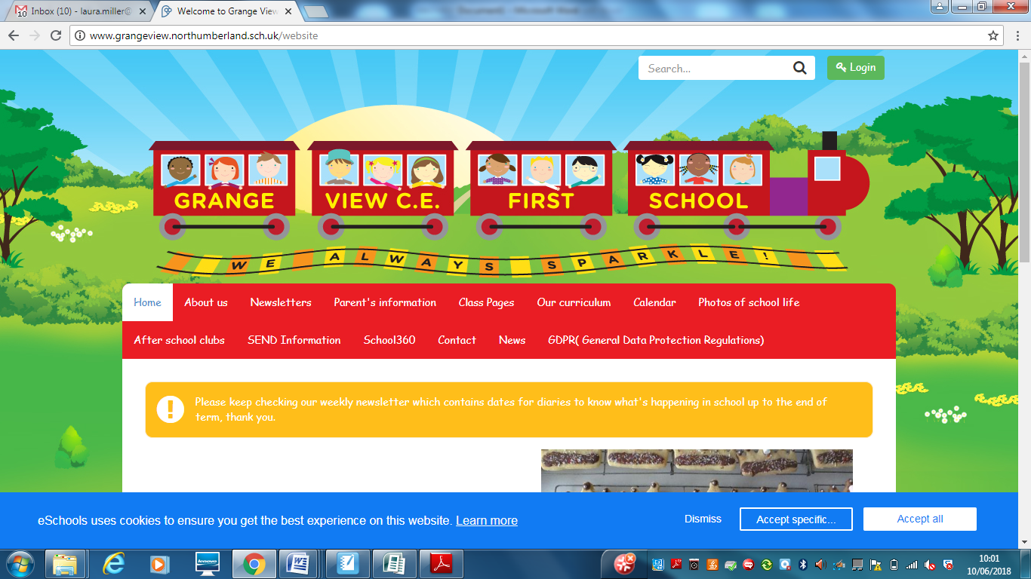

***We aim to SPARKLE!***

**Dear Parents / Carers, 16th Sept 2021**

**COVID Update-** we are continuing with all our COVID safety measures until further notice but will be reviewing these this term and may change our dropping off and pick up systems to eventually allow parents back on school site. We will also be keeping classrooms well-ventilated so ask that as colder weather comes, children are sent to school in suitably warm clothes and additional layers under their school uniforms.

We have restarted assemblies with the children twice weekly and in their key stages the children are now able to play together outside. We have an ‘outbreak plan’ in place which involves working closely with Public Health to monitor and manage cases. Please continue to support us by not sending children to school if they have any of the symptoms of Covid-19 and ensuring that they are tested if any symptoms are seen. In school, we will be very vigilant for symptoms and will not hesitate to send children home and advise testing if we are concerned. Thank you for your continued support.

**Goodbye and Good luck**

We say a sad farewell to Mrs Coombe who retired in August. We wish her lots of luck in her retirement.

**School Lunches**

Thankyou to all the parents have signed up to the school meal service. Mrs Palmer serves 3 roast lunches each week plus Pizza, Pasta, chicken curry (which the children love) plus many more meals. We are happy to be flexible for you and if you would like your child to have school lunch on another day each week then Mrs Palmer is happy to serve this. So you could choose to give your child a school lunch every Friday. It is £11 per week or £2.20 per day. Reception, Year 1 and 2 receive universal free meals.

Please apply for Free school meals if you think you meet the criteria as this would entitle your child to a free school lunch, free milk and many more other benefits in school.

The link to apply is: https://www.northumberland.gov.uk/Education/Schools/Meals.aspx

**Morrisons -"It's Good to Grow"**

They are giving away free gardening equipment for schools and nurseries.

On Monday 6th September they will launch "It's Good to Grow". The programme aims to encourage children to get outdoors and get growing, helping them to understand where their food comes from and how to grow their own fruit and vegetables, in order to make healthier food choices now and in the future.

To take part, customers just need to have a My Morrisons account and everytime they swipe when they shop they'll collect Grow Tokens.

How does this work?

● Between Monday 6th September and Sunday 24th October for every £10 spent in store or online, customers

will get 1 Grow Token which they can donate to their chosen school or nursery

● Customers will use their My Morrisons app or card when paying to collect their Grow Tokens

● Customers can select the school or nursery they’d like to donate their tokens to within their My Morrisons account

● From 1st November schools will be able to redeem their Grow Tokens against a wide variety of gardening equipment

● Schools will start receiving their order between the end of January and the end of March.

**PLEASE SUPPORT US WITH THIS CAMPAIGN- THANKYOU.** We would like the children to help maintain our school garden every Friday afternoon and grow our own fruit and vegetables again.



**\*\*\*\*New Diary Dates- more to follow\*\*\*\***

Oct 8th – Harvest celebrations

Oct 11th – Week beginning - Parents consultations

Oct 15th – Reception to Year 1 - Flu Jab day

Oct 22nd – Half term

Nov 1st – School reopens

Dec 8th – Panto am - R-Y4

Dec 13th - EYFS Christmas Party

Dec 14th – Elm and Beech party

Dec 16th – Willow Party

**Applying for your Middle School place:**

It's that time of year again where the admissions portal is open for the 2022 admissions round. The Portal will open on Sunday 12th September for all Secondary, Middle and High Phase changes.  The deadline for applications is the 31st of October. It is very important you make your application on time.

**Reception applications:**

The Reception application Portal will open on 1st November and close on 15th January 2022.

**September uniform**

Following our school uniform policy your child will be expected to wear the following:

A school sweatshirt / cardigan in the correct colour

Yellow polo shirt

Grey trousers / skirt / pinafore or yellow gingham dress

All black school shoes with no logos

A school PE t-shirt with black shorts or joggers.

We have lots of clean good second hand for anyone who needs it and we will keep spares for any child who turns up for school in the wrong uniform.

These supermarkets and shops store correct colours: Asda / Sainsbury’s / Matalan / Marks and Spencer’s and many others.

**JEWELLERY- NO EARRINGS.**

**No Jewellery for swimming lessons for health and safety reasons .**

PE's Health and Safety guidance states- “Schools have a duty of care to ensure students are able to participate actively without unnecessarily endangering themselves or those working around them. A clear and consistently applied policy for the removal of personal effects should be in place. The Association for Physical Education (afPE) strongly recommends the practice of removing all personal effects at the commencement of every lesson to establish a safe working environment. This applies to all ear and body piercings, including retainer and expander earrings.”

***Please ensure all jewellery is removed before all PE lessons at home or can your child remove them on their own. We would strongly encourage no jewellery whatsoever to keep your child safe. Thankyou***

**E-safety-** Remember all you need is on our school website and Facebook page to support you at home with the internet and its use.

**http://www.grangeview.northumberland.sch.uk/website/esafety/102589**

**AFTER SCHOOL CLUBS AUTUMN 2021- All clubs from Sept will be £2 per session - Please collect all your children from the main gate at 4.15pm.**

**These are the clubs we are offering for the Autumn Term:**

**Mondays - Fun and games outdoors - Newcastle Thunder - R- Y4**

**Tuesdays – Craft CLUB with Miss McQuade – Y2-Y4**

**Wednesdays - Football Club - with Trident football and coaches R-Y4**

**Thursdays - Little Movers – Reception, Y1 and Y2 with Fiona**

**Shopping Link to support Grange View CE First School**

<https://smile.amazon.co.uk/ch/1049905-0>

This is the link to The Friends of Grange View Fundraising. It takes you to Amazon for any purchasing. Everything you buy raises funds for the school and generates extra funding to the PTA who in turn spends it on resources for your child and the school. Thankyou for supporting us with this as every penny counts.

**SIMS Online payments – COVID SAFE CASH FREE SYSTEM**

Thank you to all of those who have already signed up and are using it. We cannot accept cash and the SIMS system is what should be used. You should have received an activation code via email and it is very quick and easy to set up. Please follow the online instructions to set this up to make any future payments. Any issues please email or call the office. Thank you.

Please don’t hesitate to contact us if you have any questions or concerns at [admin@grangeview.northumberland.sch.uk](mailto:admin@grangeview.northumberland.sch.uk)

****Please note – no cash is to be brought into school unless we ask specifically (often for the Friends of Grange View events) All payments for school lunch, milk, uniform, trips etc. should all be made online. Due to Covid, we need to avoid handling cash as much as we can.*****

**Beech**

Merit – Olivia T & Bailey H

Sparkle – Harleigh Mc

**Willow**

Merit – Elliott & Emma

Sparkle – Roseann

**Stars of the Week:**

**Acorn**

Merit – Daisy & Dexter

Sparkle – Ellie-May

**Oak**

Merit – Thomas & Theia

Sparkle - Lucas

**Elm**

Merit – Nylah & Marcie

Sparkle – Jessica

**ATTENDANCE**

**The most important message is children should be in school as much as possible as every day that a child misses school, for whatever reason, they miss out on vital learning.**

**AMAZING ATTENDANCE – thankyou to all our families for supporting getting your child in school everyday**

Well done to **WILLOW** Class who won with 100%

Acorn – 94.9% Oak – 94.2% Elm 91.6%

Beech – 98.5% Willow – 100%

TOTAL FOR THE WEEK 95.6%

Which is below our new school target which is 97%

**W/C: 13.09.2021**





**Sparkly Afternoon Tea:**

Last week 4 wonderful children joined Mrs Laskey - George, Jessica, Georgie and Ella had treats and a chat for all their efforts last week in school.

**COVID Updates:**

Coronavirus hasn’t gone away so there will still be a need for schools, pupils and students to follow basic measures to avoid the spread of the virus:

Testing remains important in reducing the risk of transmission of infection within all schools.

Ensuring good hygiene including frequent and thorough hand cleaning and the ‘catch it, bin it, kill it’ approach.

Maintaining appropriate cleaning regimes.

Keeping occupied spaces well ventilated.

Following public health advice on testing, self-isolation and managing confirmed cases of COVID-19.

Our priority is we are able to deliver high-quality, face-to-face education to all pupils and to ensure all pupils receive the education they deserve with minimal disruption.

What if someone tests positive or has symptoms? Do they need to isolate?

Self-isolate straight away and get a PCR test (a test that is sent to the lab) on GOV.UK as soon as possible if you have any of these 3 symptoms of COVID-19, even if they are mild:

a high temperature

a new, continuous cough

a loss or change to your sense of smell or taste.

You should also self-isolate straight away if:

You've tested positive for COVID-19 either according to a PCR test or a lateral flow device test – this means you have the virus. If you get a positive LFD test you should book a PCR test.

A negative PCR test will override a positive LFD test.

If someone you live with has symptoms or tested positive (unless you are not required to self-isolate – see below if this applies to you) you've been told to self-isolate following contact with someone who tested positive – find out what to do if you're told to self-isolate by NHS Test and Trace or the NHS COVID-19 app.

Pupils should only self-isolate if they have symptoms or if they get a positive PCR or Lateral Flow Device (LFD) test.

If they develop symptoms or get a positive LFD test they should book a PCR test. A positive PCR test cannot be overridden. If a pupil is asked to get a PCR test as a result of contact with a positive case they may continue to attend education until they get the result of their PCR back.

And what will happen for people who have been in contact with positive cases?

Individuals are not required to self-isolate if they live in the same household as someone with COVID-19, or are a close contact of someone with COVID-19, and any of the following apply:

they are fully vaccinated

they are below the age of 18 years and 6 months

they have taken part in or are currently part of an approved COVID-19 vaccine trial

they are not able to get vaccinated for medical reasons.

Instead, they will be contacted by NHS Test and Trace, informed they have been in close contact with a positive case and advised to take a PCR test. They do not need to isolate while awaiting the PCR test. We would encourage all individuals to take a PCR test if advised to do so.

Staff who do not need to isolate, and children and young people aged under 18 years 6 months who usually attend school, and have been identified as a close contact, should continue to attend school as normal.

If none of the above applies, people should self-isolate as per the instructions from NHS Test and Trace.

Thank you once again for your support and patience during all of these changes.

**Regards,**

Louise Laskey- Head Teacher

**Safe to Learn section**

This is a section on our newsletter where we will share and update any safeguarding information for all parents/carers to be aware of. Mrs Pat Treanor is our Chair of governors and safeguarding governor, Mrs Laskey and Mrs Chapman are our Designated Safeguarding lead staff.

 

Mrs Laskey- Head Mrs Chapman-Assistant Head

**OPERATION ENCOMPASS INFORMATION**

The original initiative was aimed at supporting children who are affected by domestic abuse. The next part of the project will help all children to learn about friendships, relationships, emotions and rules so that they can live and work together safely.

**Operation Endeavour**- This is an innovative project in which schools and colleges in Northumberland are participating, and which is run in partnership with Northumberland County Council and Northumbria Police.

Operation Endeavour commenced in November 2018, aims to support children and young people who go missing from home. Children who go missing from home are at risk of significant harm and they may be vulnerable to sexual exploitation, violent crime, gang exploitation, or to drug and alcohol misuse.

As a result, following any report of a child going missing to the Police, the Police will make contact with Children’s Social Care who will then communicate relevant and necessary information to nominated school staff.

Each school has members of staff (key adults) who have been fully trained in liaising with the Police and Children’s Social Care when required, and will ensure that the necessary support is made available to the child or young person following their return.

I believe that this project demonstrates our school’s commitment to working in partnership to safeguard and protect children, and to providing the best possible care and support for our pupils.

**Onecall**

Onecall is the number for all adult social care, children’s services and community health enquires in Northumberland. Helping the most vulnerable to keep safe and well 24-7.

**Telephone- 01670 536400**

