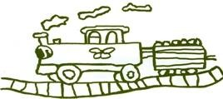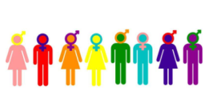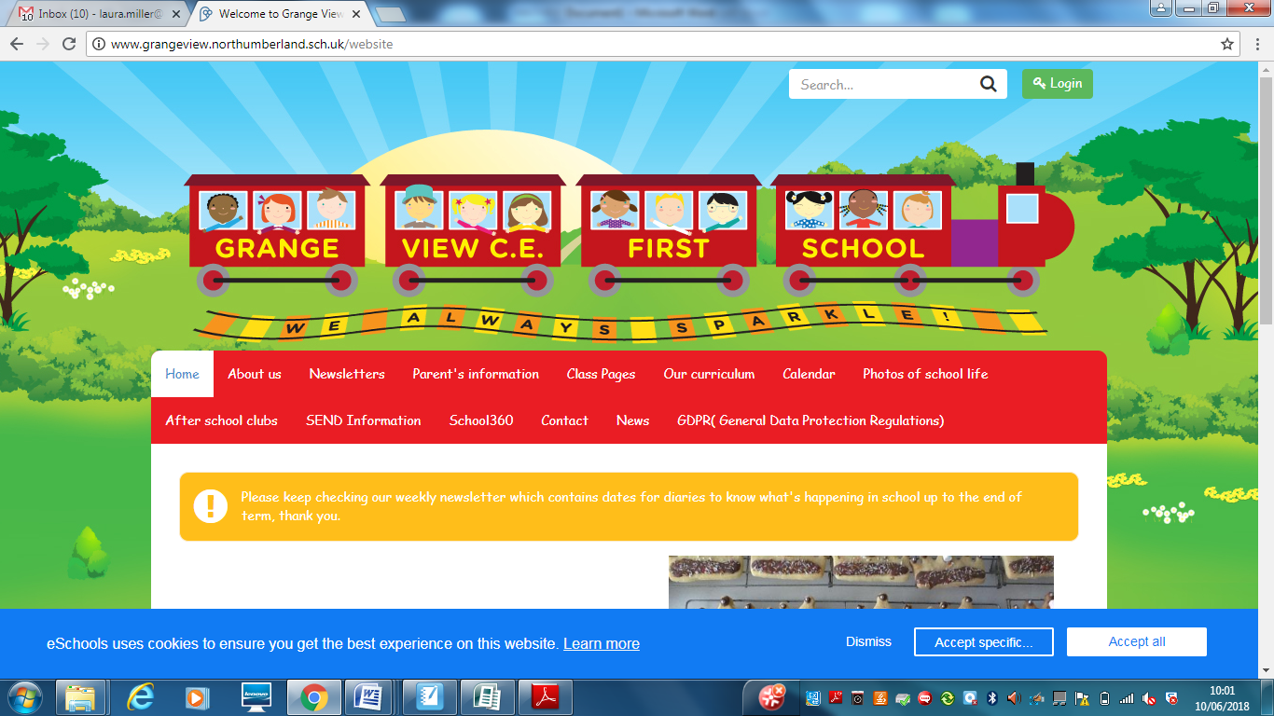

**RHSE at Grange View CE First School**

**This is a guide for anyone who is visiting Grange View C.E First School to explain our approach to Relationships, Health and Sex education (RHSE). (Updated February 2023)**

**Assessment:**

Prior to each unit of the JIGSAW units, children are asked to ‘draw or write’ about their knowledge of the subject. It will then be repeated at the end of the topic to show progress of their knowledge and identify any misconceptions or gaps. PSHE is mostly orally taught with practical activities, where teachers observe and listen to the children to check their understanding throughout.

**RHSE across the Curriculum**

There is a clear link between RHSE and Science including human science E.G body parts and keeping healthy. PE is also linked to RHSE in terms of the importance of keeping fit and healthy. Alongside this, 1 lesson per week is dedicated to the solitary teaching of RHSE.

**Subject Spotlight – Anti-bullying week and Children’s Mental Health week**

We celebrate our uniqueness during Anti-bullying week and learn the importance of treating others with respect regardless of any differences. We also focus on Cn Children’s Mental Health week to ensure children know what Mental Health is and what to do if they are suffering. In addition to this, we also celebrate Internet Safety Day which is part of the PSHE curriculum. Children learn how to be safe online and what to do if they have concerns.

**Planning**

The planning of RHSE follows a yearly overview covering all areas of RHSE for each year group. It covers all of the required expectations and is regularly monitored by the subject leader.

**Skills progression:**

Skills progression from Early Years to Year 4 has been developed to ensure all areas of RHSE are covered and to ensure clear progress throughout the year groups. This will also give staff the confidence to teach RHSE and know what needs to be achieved by the end of each year.

**RHSE resources**

Here are some of the resources we currently have available to help with the teaching of RHSE.

* We follow the Jigsaw scheme which has planning and resources available.
* PSHE Association – resources and support with planning
* Operation Encompass workshops – support to help with the teaching of Healthy relationships

**OUR INTENT: What our RHSE teaching Intent is:**

At Grange View First School, the RHSE curriculum covers subject knowledge, skills and understanding in Relationships, sex and Health education which will prepare children to become healthy and responsible members of society currently and in their future lives.

It will support them with the development of their social and personal skills and tackle many of the moral, social and cultural issues that are part of growing up. We provide children with opportunities to learn about their rights and responsibilities and appreciate being a member of a diverse society. We encourage our children to be open and honest about their feelings and emotions, to create a secure environment within which mental health can be supported and discussed. Effective communication will be encouraged for all the children by ensuring all views are listened to and respected.

All of the children at Grange View First School will be supported in developing their self-worth by playing arole in contributing to school and the wider community. We strive for all our children to leave Grange View having a secure sense of self, how to be safe and how to care for others.

Sex and Relationship Education

Sex education is taught in the context of healthy growing bodies, relationships, RE and the statutory requirements of the science national curriculum. Parents have the right to withdraw their child from any part of sex education that is outside the compulsory requirements of the curriculum. We invite you to discuss this with the headteacher.

**Where it all begins: Early Years Starting points.**

Children enter Nursery at lower entry points for their age due to poor language skills and lack of experiences. Personal, Social and Emotional development is a Prime area so it is fundamental throughout their time in the Early Years. It is intertwined into all aspects of play and throughout all adult led activities. Children in Nursery and Reception are supported to be independent by selecting their own resources and taking responsibility of their self-help E.G putting their coats on. Children are supported in their play, to play alongside others and begin to interact with them. They are supported to take turns, solve conflict and identify their feelings. They are then encouraged to think about and be aware of the feelings of others. Children’s confidence is developed which will develop their resilience to keep trying when something is difficult. Children are also taught basic personal hygiene such as washing hands after the toilet and brushing their teeth.

**Implementation: How are they knowing more and remembering more?**

|  |  |
| --- | --- |
| **Quality of Education** | PSHE is taught using JIGSAW which covers all elements of the statutory requirements for the subject. The skills progression shows all knowledge and skills developing in small steps from Early Years until the end of their time at Grange View. Each lesson begins with some calm time and children are reminded about respecting each other to allow us all to feel confident to talk and share views. In Early Years, children discuss what makes them unique which is then built on in Key Stage One where they learn about tolerance. Key Stage Two children learn about different kinds of bullying and discrimination and how we can prevent this. Information is clearly shown through pictures or a hook to allow children to understand the new learning. The lessons are broad and balanced offering a wide variety of opportunities and discussions, relevant to the children’s age. Teachers check children’s understanding throughout lessons and address any misconceptions. ‘Draw and write’ is used as a form of assessment where children draw what they know about a subject prior to any teaching and then repeat it again after the teaching. This will show progress and help teachers identify any gaps in their knowledge and understanding which will then be addressed. |
| **Behaviour and Attitudes** | PSHE is a subject that teachers children about the world they live in. Children have a positive attitude to the lessons as they feel safe and confident to be part of a discussion with their peers and teacher. They can ask questions and know they will be respectively answered. Children work together and talk and listen to each other which encourages our core value of friendship, trust and respect. Children are praised throughout lessons for their contributions which motivates all children to be involved. |
| **Personal Development** | PSHE teachers children many important life skills and how to keep themselves safe as a child and in later life. Children learn tolerance and respect to help with living in a diverse society and the importance of equality. We support children in making positive choices to be part of British Society and to treat others fairly. We teach children important life skills beyond the curriculum to allow children to succeed in later life. PSHE also develops spirituality as it provides many ‘ows’ ‘wows’ and ‘nows’ moments allowing children to reflect on their own lives and experiences. Parents and carers are involved in the curriculum by sharing the skills progression so they can identify what their children will be learning. They are also invited to discuss this if they have any concerns or queries. |
| **Leadership and Management** | PSHE is monitored through pupil voice and looking at evidence in floor books with children to see if they can articulate aspects of their learning. By using the floor books, children can recount their learning and demonstrate their knowledge of key vocabulary. An action plan is written each year for PSHE, focusing on key priorities from SIP and ensuring the children’s needs are at the centre of the plan. ‘Draw and writes’ for each year groups are monitored to ensure all children are making progress and that any misconceptions are identified. Interventions are not required for PSHE but children who require additional Social and Emotional support participate in THRIVE. Governors are informed termly of subject developments, with termly meetings taking place with the link governor sharing successes, areas for development or key priorities. |
| **Early Years** | Children develop their Personal, Social and Emotional skills throughout their time in Early Years as a Prime area of learning. Adults support children in their play to take turns and work well with others, listening to them and accepting others. Staff intervene if needed to resolve conflicts and encourage children to talk through any difficulties. Through circle time, children can learn to take turns to speak and are supported in listening to each other. The staff continue to monitor the progress of all children’s Personal, Social and Emotional development and continue to build on their skills. This then prepares children for Year 1 in being able to work with others. |

**Q of E - SEND provision-**

**-** Using PSHE floorbooks to allow children to show their learning without the pressure of writing

* - A vast majority of learning takes place in mixed ability pairs, to ensure that support and challenge is available and peer support is encouraged.
* Practical tasks are used throughout the curriculum to support and engage the slower graspers.
* Pre teaching of key vocabulary with pupils with specific needs.

**Q of E - Pedagogical choices**

-Making the lessons relevant to real life in the world we live in

-Allowing children plenty opportunities for discussion

- Ensuring all children feel respected and valued when sharing their views

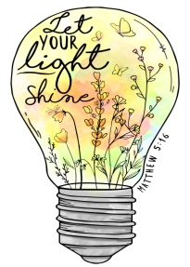

***What is it like to be a pupil at Grange View studying RHSE on a daily basis?***

At Grange View First School, PSHE is thought-provoking, engaging and encourages all children to be articulate and involved. Children see the connections PSHE has to their current and future lives and how they can contribute successfully to society.

**Assessment:**

At the end of every term, assessment sheets are created to match the areas of RHSE being taught for each year group, created by the subject leader. The assessment sheets cover statutory requirements for all areas of RHSE. Three children of different attainments (low, middle and high) will have their work looked at to complete an assessment which will be used as representation for the whole class. The subject leader will keep these assessments and any examples of work.