`

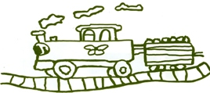

Welcome to this half terms Topic Information letter for Willow Class

**Mrs Chapman and Mrs Timmins**

**Miss Appleby and Miss Scott-Shirley**

**Mrs Cessford, Miss Carr and Miss Gray**





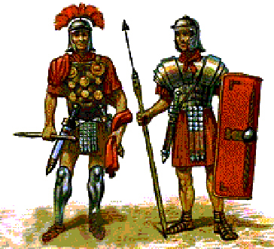Journeys:

Rotten Romans

**Summer Half Term (2)**

**Science** – *Materials, planting*

Our big theme this term is Romans as part of the ‘Travellers Tales’ umbrella, which provides a great context for testing our materials for strength and durability both in battle clothing and catapult design.

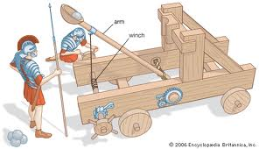 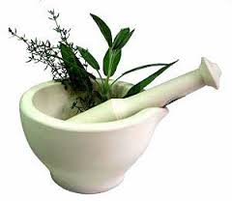

Additionally, we will be in our Forest Area planting a Roman Herb Garden to use for Roman medicines and even eating Roman food using the Forest School Fire Pit. As well as learning about the difference between weeds and plants and the indicators of plant pollinators now our plants are growing.

**PE** *– Games*

In preparation for Sports Day, the children will be learning and practising a range of athletic style sports and activities as well as developing their multi skills with Alnwick Bears

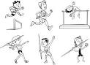 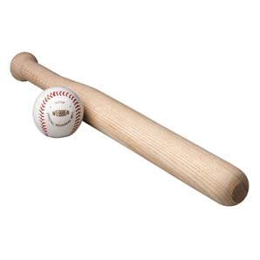 j0303462

Swimming is taught by qualified swimming coaches at Morpeth Leisure Centre every Thursday morning, the children are always supervised by school staff.

**Literacy**

Reading

During this half term children will read in a variety of situations throughout the week at school in a shared whole class session, in a small group guided session, one to one with an adult and also independently. The children will look at a range of stories during carpet time

Writing

The children will write in the following genres; Persuasive texts: Looking and innovating the conventions of posters, leaflets and adverts persuading you to do things. Participating in debates and discussions.

Stories that raise issues and dilemmas: Reading, innovating and writing stories with problems and moral messages. They will focus on sentence structure in target writing, as well as continuing to work through their spellings in a weekly test.

Speaking & Listening

We will be doing our Apprentice task again this year – the children will work in groups to design, advertise and pitch their Roman inspired product to a panel of judges in class!

**ICT** –*Morfo and Comic Life*

Using the laptops and possibly some new ipad apps the children will present their facts and pictures in a comic format using comic life. Following their learning about Romans they will also be animating their own talking objectives and Roman facts to present facts about the topic – hopefully we will blog some on our school website!

**Numeracy;**

We will be continuing to look at statistics and then move on to 2D and £D shape as well as coordinates and measures. . In the middle of the term we will be looking at time, ***To help at home please encourage your child to read times on an analogue and/or digital clock as well as look at times on timetables etc and dates on calendars.***

**PSHE-** ‘*Changes’.*

During circle time discussions they will be preparing for the changes that are happening, with moving to middle school or becoming a Year 4.



They will discuss their feelings about the changes, ways to deal with change and action plan changes they would like to make.

**Geography / History** – *The Romans!*

Our main theme is learning about the Romans, hence the children will be studying the Roman empire, the rulers, soldiers, and life about Claudius.

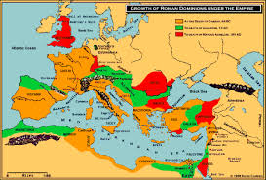 

Additionally themed writing day this term is ‘’Around the World in a Day’ so we will learn lots about many other countries on our travels.

**MFL** – French – *Petit Chaperon Rouge*

As part of their language learning the children will be reading the animated French story of Little Red Riding Hood. Throughout the term they will learn phrases, sequence events, match words and pictures and construct simple sentences in French.

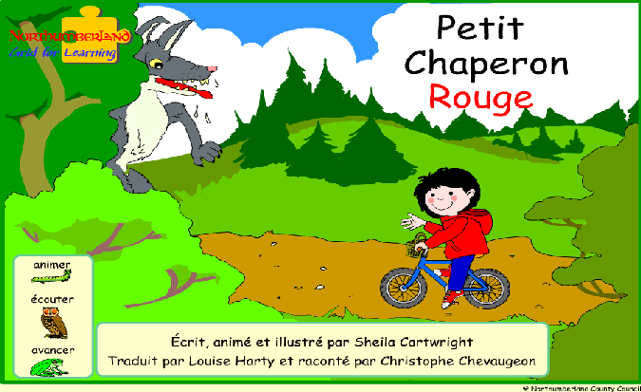

The children can also access the animated story at home using their school360 account.

**Art/ DT** – *Making helmets and catapults*

Within the Roman topic, the children will be using paper Mache to create and decorate their own Roman Helmets in small groups. As well as design, create and test in the forest their own groups Roman Catapult.

[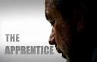](http://search.babylon.com/imageres.php?iu=http://www.tvsa.co.za/mastershowimages/1669_apprentice_uk_468.jpg&ir=http://www.tvsa.co.za/mastershowinfo.asp?mastershowid=1669&ig=http://t2.gstatic.com/images?q=tbn:ANd9GcT_pYDix-PCBIAWi3pPg4BBGl_b5cNtY6H62JVYibvTG1VyTSFUoZEPtBA&h=300&w=468&q=apprentice+uk&babsrc=SP_ss) 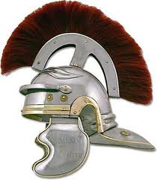 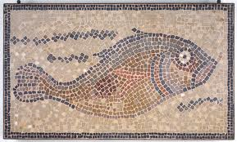

For our Art Exhibition the children will also be individually studying, designing and making their own Roman Mosaic.

As part of the Apprentice task, they will design and make their own prototype product of their Roman invention.

**Music – *Djembe Drums******Tuesdays***

As part of our Music connections, the children have been learning to play the Djembe Drums. Since September, our percussion teacher has been coming into school each week and teaching us. We have learnt lots of rhythms as well as many facts about Africa. So watch this space for a show stopping performance in our school hall!

 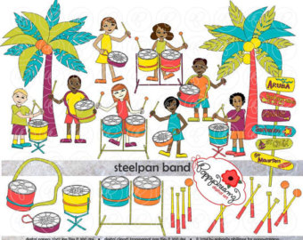 

**RE** –



Throughout this topic we will be learning about Pentecost. We will learn what it is and the impact that it has on Christians today. This will involve discussions and activities which provoke deeper thought. The children will be considering why Pentecost is celebrated and how it is important.

**Summer Weather Preparations (Sunwear)**

**As the weather theoretically improves throughout the summer term, please ensure your child has sun cream on and a hat to protect them from the heat. Thank you**

**DIARY DATES**

03/06/19: All KS2 Centre for Life trip (packed lunch – none available from school)

05/06/19: Year 4 Quad Kids (PE kit, water bottle, packed lunch and sun wear needed)

06/06/19: Year 4 Countryside Show (water bottle and sun wear needed)

20/06/19: Year 4 Leavers Service at Newcastle Cathedral (packed lunch, water bottle & sunwear)

21/06/19: Sports Day (pm )

24/06/19: Y3 Lifepath at Brinkburn Priory (PE kit, water bottle and sun wear needed)

02/07/19: Djembe Drum performance in school 2.15pm

**Swimming**

We would be grateful if you could please ensure your child’s clothes are clearly labelled with their name. This is especially helpful when we go swimming, as there are occasions when clothes do get mixed up, or are left in the changing rooms. Could parents also ensure they have their swimming hats, and pierced ears need to have the earrings removed.

**Forest School**

We are very proud of the developments we have made to our forest area and are now making it a regular learning experience within the weekly timetable. We have waterproof trousers which we provide for each child but please ensure their wellies are in school.

[](http://www.google.co.uk/imgres?imgurl=http://image.shutterstock.com/display_pic_with_logo/216823/216823,1221931717,1/stock-vector-winter-clothes-collection-vector-illustration-17677663.jpg&imgrefurl=http://www.shutterstock.com/pic-17677663/stock-vector-winter-clothes-collection-vector-illustration.html&usg=__cMrJqURdxY89CHm-Dmyu1piKelo=&h=456&w=450&sz=62&hl=en&start=6&zoom=1&tbnid=GicP_6woJRqd6M:&tbnh=128&tbnw=126&ei=mS3zTvr3KtCBhQflqvCdAQ&prev=/search?q%3Dwinter%2Bclothes%26um%3D1%26hl%3Den%26sa%3DN%26gbv%3D2%26rlz%3D1W1ACAW_en%26tbm%3Disch&um=1&itbs=1)

**Homework  
Reading** – Children will be bringing home their home reading books during the week. It would be helpful if you could either write or sign the book to say you have heard them read, it helps us to avoid repeat reading the same pages. ***Group Reading*** takes place each week in class, the children will be given a set number of pages to read for their next weekly session. Please sign their book once they have read them. Additionally the children may bring home a third book that they have taken out of the library on our Friday visit.

**Spellings and Times Tables** – Children will be given differentiated spellings to learn for their weekly spelling test on a Friday morning. Please help your child as much as possible learn these words as they will help with their confidence and fluency as both a reader and writer. They will also have a specific times table to focus on within Times Table Rock Stars – the participation so far has been excellent and shows great improvements in the pupils speed.

**Maths / English Homework** - Children will be given some Maths homework on Mathletics each Friday that needs to be completed by the following Friday morning for class dojo rewards. The maths homework is usually linked to the work they have done that week in Numeracy and should be appropriate for them to complete independently. Once a term they will also be given a short writing task to complete in their purple home writing books, the focus of which will be written in their books along with the date for it to be handed in. Usually they have about three weeks to do the writing. The thought process behind this writing, is for your child to work on their ideas and sentence construction with you, in the hope that they will learn new phrases and ideas which they can then use in their everyday writing in class.

**Thanks for your help and continued support**

**Home Time**

If you need to change the usual arrangements for picking up your child from school, please let school know as soon as possible. As you will understand we cannot allow children to leave the school premises unless we have permission from parents or carers.