

**Grange View C.E. First School**   
Grange Road, Widdrington  
Morpeth, NE61 5LZ.

Telephone: 01670 790 686email: [admin@grangeview.northumberland.sch.uk](mailto:admin@grangeview.northumberland.sch.uk)

Headteacher: Mrs Louise Laskey

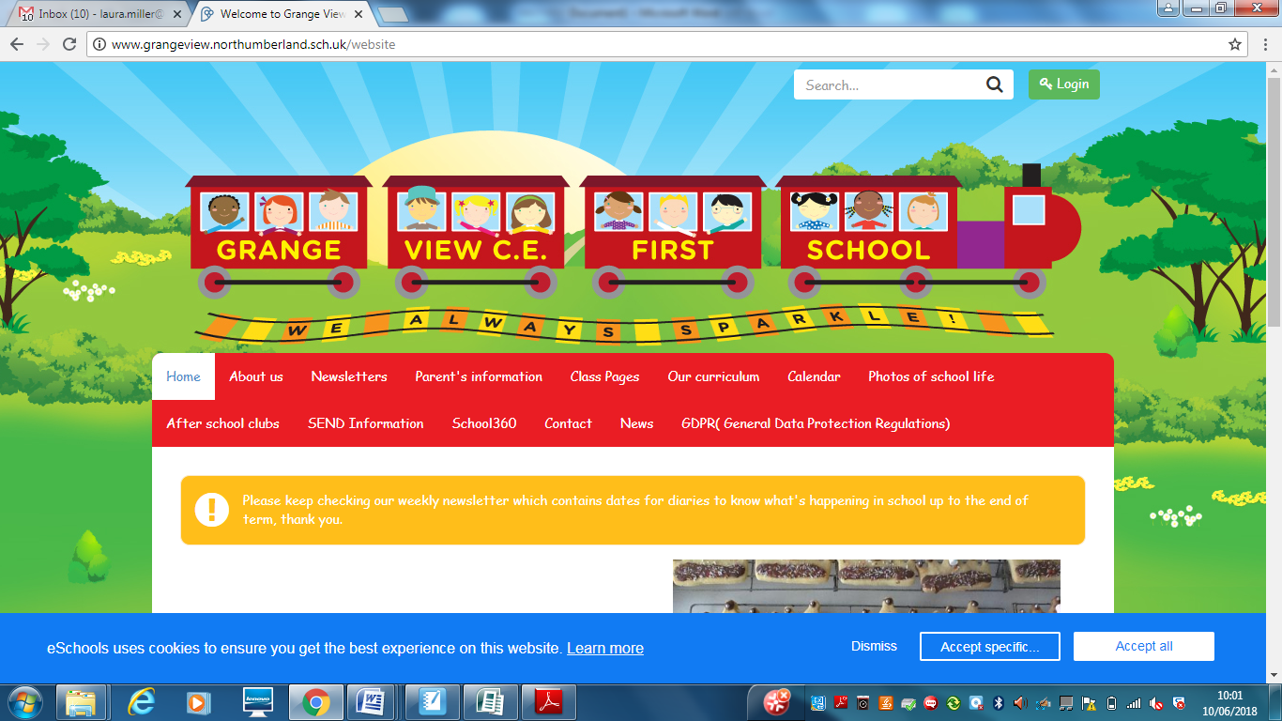

***We aim to SPARKLE!***

**Dear Parents / Carers, 22nd Oct 2021**

**Thankyou to all our families and staff for making this half term a happy and busy one back at Grange View, we are looking forward to Autumn 2 and the run up to all our favourite Christmas festivities!**

***Goodbye and Good luck***

***It is with great sadness that we say goodbye to Mrs Brown today who is off to start the next chapter of her career at Thomas Bewick Academy. She has been an amazing office manager and we hope to secure a new office manager very soon. Please share our advert on the school Facebook page. Thankyou***

**Drop offs and pick ups**

Thankyou for a smooth transition back to dropping off and picking up your child/ren. It now seems we have this system back in place.

As the Autumn term continues and COVID rates of infection/transmission hopefully do not go up we hope to gradually have parents back in the school building.

Please read the newsletter each week and check your emails for all future updates

**Vacancies**

**https://www.northeastjobs.org.uk/job/Senior_Admin_and_Support_Manager_Grange_View_C_E_First_School/215081**

<https://www.northeastjobs.org.uk/job/Teaching_Assistant_Level_3_Band_4_/213420> - closing date Monday 1st November

PUMPKIN COMPETITON

**We are holding our Pumpkin completion this year after half term.** Since Halloween is on Sunday 31st Oct please keep your pumpkins and bring them into school on Monday 1st Nov. There will be prizes for a winner from each class. Please enter with your child and be as creative as possible and share your creations with a photo on Class Dojo. All the winners will be displayed on the school yard on Monday 1st Nov. Thankyou



**Inclement weather**

During these cold and rainy mornings the school drop off and pick up times remain the same. So we encourage you to arrive on time.

If you arrive early you may get wet and cold! Children will be escorted into school as usual by the class teacher, so please don’t try to come into school early. Doors will only open at 8.45am in severe weather.

In the case of school closure due to severe weather please always check school website, Face Book page, Northumberland County Council Website and listen to Radio Newcastle. The school will also use the Text2Parents Messaging Service.



THE THRIVE APPROACH- Mrs Tait is our recently qualified Thrive trained member of staff. The Thrive approach is to support the well-being of all pupils and we have been using it for a number of years. A leaflet for parents has been emailed home to explain what it is all about.

**RAF Boulmer 2021 – Christmas Card Competition**

Your child is bringing a letter home today about this. Your design can be anything you like, the only rules are that you must be aged 4-11 and live in Northumberland, it must be hand-drawn, contain the RAF roundel and must be sent in to us on this form. Closing date is Thursday 4th November 2021. One winner from each age group (4-7/8-11) will receive a £20 Toy Store voucher, with one highly commended entry from each group winning a £10 Toy Store voucher. Please return to school by Monday 1st November so we can post them in time. Good Luck!

**Scholastic Books**

Friday 5th Nov - please return your Christmas book orders to your child’s class from the Scholastic leaflet that is coming home today. Lots of fantastic books at great prices. We can accept cash/cheque but are unable to put your bank details in as a form of payment. Alternatively you can order from home online and you can nominate our school so we still receive the reward points towards new books in our school.

**Trident Soccer – October Half Term – Alnmouth**

Trident Soccer is running a half term holiday club in Alnmouth. If anyone is interested please let the office know and a form can be sent home.

**PE Uniform**

Please can all parents ensure your child has the correct school PE kit, we have plenty in stock and spares for children to use if needed. NOT your child’s favourite tracksuit no matter how much they moan at you! Thankyou

**PTA- The Friends of Grange View NEED YOU !**

The Friends of Grange View desperately need your help and support to run, organise and think of new fund raising ideas and events for the school. Mr Guy and Mrs Chapman cannot do it all on their own. Please let us know if you can spare some time to help us.

**Water Bottles**

Please can we remind all parents that we are a heathy school and only plain water is allowed in your child’s water bottles in the classroom. If your child brings a packed lunch they can bring juice or flavoured still water at lunchtimes.

**Packed Lunches**

Please can we remind parents that we are a healthy school and encourage healthy packed lunches through our packed lunch policy. This includes a savoury sandwich or pasta pot, fruit, yoghurts, water, savoury snacks and one biscuit/cake treat please. No nut based product including chocolate spread that may contain nuts and please remember to avoid choking hazards by cutting all grapes and large fruit up.

Please apply for Free school meals if you think you meet the criteria as this would entitle your child to a free school lunch, free milk and many more other benefits in school.

The link to apply is: https://www.northumberland.gov.uk/Education/Schools/Meals.aspx



**Morrisons -"It's Good to Grow"- DOUBLE POINTS AT THE MOMENT !**

They are giving away free gardening equipment for schools and nurseries.

How does this work?

● LAST WEEKEND -**Sunday 24th October** for every £10 spent in store or online, customers

will get 1 Grow Token which they can donate to their chosen school or nursery

● Customers will use their My Morrisons app or card when paying to collect their Grow Tokens

● Customers can select the school or nursery they’d like to donate their tokens to within their My Morrisons account

● From 1st November schools will be able to redeem their Grow Tokens against a wide variety of gardening equipment

● Schools will start receiving their order between the end of January and the end of March.

**\*\*\*\*New Diary Dates- more to follow\*\*\*\***

Fri Oct 22nd – Half term

Mon Nov 1st – School reopens normal drop off and pick up times. 8.50am and 3.10pm for Reception to Y4.

**PUMPKIN COMPETITION ENTRIES ARRIVE ON SCHOOL YARD PLEASE!**

Fri 12th Nov – Children in Need – info to follow soon.

Wed 8th Dec- NO SWIMMING –Reception to Y4 Panto visit to Whitley Bay.

Fri 10th Dec – Early Years Panto in school – The Greedy Elf.

Tues 14th – Christmas party - Early Years am

Wed 15th Dec- Flu Jab morning Reception- Year 4- NEW DATE!

Thurs Dec 16th – Christmas Jumper and lunch day

Fri Dec 17th – Y1/2 party and Y3/4 Parties am. School closes at 1.30pm

Training Days 2022- 4th Jan and 28th February

**JANUARY 2022- BAGSTO SCHOOL collection, please keep all your winter wardrobe clear out for the Friends of Grange View campaign for when we return after Christmas - thankyou**

**Applying for your Middle School place: DEADLINE IS IN HALF TERM!**

It's that time of year again where the admissions portal is open for the 2022 admissions round. The Portal will open on Sunday 12th September for all Secondary, Middle and High Phase changes.  The deadline for applications is the 31st of October. It is very important you make your application on time.

**Reception applications:**

The Reception application Portal will open on 1st November and close on 15th January 2022.

**JEWELLERY- NO EARRINGS.**

**No Jewellery for swimming lessons for health and safety reasons .**

PE's Health and Safety guidance states- “Schools have a duty of care to ensure students are able to participate actively without unnecessarily endangering themselves or those working around them. A clear and consistently applied policy for the removal of personal effects should be in place. The Association for Physical Education (afPE) strongly recommends the practice of removing all personal effects at the commencement of every lesson to establish a safe working environment. This applies to all ear and body piercings, including retainer and expander earrings.”

***Please ensure all jewellery is removed before all PE lessons at home or can your child remove them on their own. We would strongly encourage no jewellery whatsoever to keep your child safe. Thankyou***

**E-safety-** Remember all you need is on our school website and Facebook page to support you at home with the internet and its use.

**http://www.grangeview.northumberland.sch.uk/website/esafety/102589**

**AFTER SCHOOL CLUBS AUTUMN 2021- All clubs £2 per session - Please collect all your children from the main gate at 4.15pm. Must be paid up front please a week in advance on SIMS**

**These are the clubs we are offering for the Autumn Term:**

**Mondays - Fun and games outdoors - Newcastle Thunder - R- Y4**

**Tuesdays – Craft Club - CANCELLED UNFORTUNATELY – Separate email gone out.**

**Wednesdays - Football Club - with Trident football and coaches R-Y4**

**Thursdays - Little Movers – Reception, Y1 and Y2 with Fiona**

**Shopping Link to support Grange View CE First School**

<https://smile.amazon.co.uk/ch/1049905-0>

This is the link to The Friends of Grange View Fundraising. It takes you to Amazon for any purchasing. Everything you buy raises funds for the school and generates extra funding to the PTA who in turn spends it on resources for your child and the school. Thankyou for supporting us with this as every penny counts.

**SIMS Online payments – COVID SAFE CASH FREE SYSTEM**

Thank you to all of those who have already signed up and are using it. We cannot accept cash and the SIMS system is what should be used. You should have received an activation code via email and it is very quick and easy to set up. Please follow the online instructions to set this up to make any future payments. Any issues please email or call the office. Thank you.

Please don’t hesitate to contact us if you have any questions or concerns at [admin@grangeview.northumberland.sch.uk](mailto:admin@grangeview.northumberland.sch.uk)

****Please note – no cash is to be brought into school unless we ask specifically (often for the Friends of Grange View events) All payments for school lunch, milk, uniform, trips etc. should all be made online. Due to Covid, we need to avoid handling cash as much as we can.*****

**Beech**

Merit – Jayden B & Joseph

Sparkle – Matilda

**Willow**

Merit – Izzie & Lucie B

Sparkle – Kristian

**Acorn**

Merit – Abigail & Alice

Sparkle – Luke

**Oak**

Merit – Navneet & Olivia

Sparkle – Willow

**Elm**

Merit – Mary-Jayne & James

Sparkle – Maisie

**Stars of the Week:**

**ATTENDANCE**

**The most important message is children should be in school as much as possible as every day that a child misses school, for whatever reason, they miss out on vital learning.**

**AMAZING ATTENDANCE – thankyou to all our families for supporting getting your child in school everyday**

**W/C: 18.10.2021**

Well done to ELM Class who won with 95.7%

Acorn – 88.3% Oak – 68.7% Elm – 95.7%

Beech – 94.1% Willow – 93.1%

TOTAL FOR THE WEEK 90.2%

Which is well below our new school target which is 97% ☹





**COVID Updates:**

Coronavirus hasn’t gone away so there will still be a need for schools, pupils and students to follow basic measures to avoid the spread of the virus:

What if someone tests positive or has symptoms? Do they need to isolate?

Self-isolate straight away and get a PCR test (a test that is sent to the lab) on GOV.UK as soon as possible if you have any of these 3 symptoms of COVID-19, even if they are mild:

a high temperature

a new, continuous cough

a loss or change to your sense of smell or taste.

You should also self-isolate straight away if:

You've tested positive for COVID-19 either according to a PCR test or a lateral flow device test – this means you have the virus. If you get a positive LFD test you should book a PCR test.

A negative PCR test will override a positive LFD test.

If someone you live with has symptoms or tested positive (unless you are not required to self-isolate – see below if this applies to you) you've been told to self-isolate following contact with someone who tested positive – find out what to do if you're told to self-isolate by NHS Test and Trace or the NHS COVID-19 app.

Pupils should only self-isolate if they have symptoms or if they get a positive PCR or Lateral Flow Device (LFD) test.

If they develop symptoms or get a positive LFD test they should book a PCR test. A positive PCR test cannot be overridden.

And what will happen for people who have been in contact with positive cases?

Individuals are not required to self-isolate if they live in the same household as someone with COVID-19, or are a close contact of someone with COVID-19, and any of the following apply:

they are fully vaccinated

they are below the age of 18 years and 6 months

they have taken part in or are currently part of an approved COVID-19 vaccine trial

they are not able to get vaccinated for medical reasons.

Instead, they will be contacted by NHS Test and Trace, informed they have been in close contact with a positive case

and advised to take a PCR test. They do not need to isolate while awaiting the PCR test. We would encourage all individuals to take a PCR test if advised to do so.

Staff who do not need to isolate, and children and young people aged under 18 years 6 months who usually attend school, and have been identified as a close contact, should continue to attend school as normal.

If none of the above applies, people should self-isolate as per the instructions from NHS Test and Trace.

Thank you once again for your support and patience during all of these changes.

**Regards,**

Louise Laskey- Head Teacher





**Safe to Learn section**

This is a section on our newsletter where we will share and update any safeguarding information for all parents/carers to be aware of. Mrs Pat Treanor is our Chair of governors and safeguarding governor, Mrs Laskey and Mrs Chapman are our Designated Safeguarding lead staff.

 

Mrs Laskey- Head Mrs Chapman-Assistant Head

**OPERATION ENCOMPASS INFORMATION**

The original initiative was aimed at supporting children who are affected by domestic abuse. The next part of the project will help all children to learn about friendships, relationships, emotions and rules so that they can live and work together safely.

**Operation Endeavour**- This is an innovative project in which schools and colleges in Northumberland are participating, and which is run in partnership with Northumberland County Council and Northumbria Police.

Operation Endeavour commenced in November 2018, aims to support children and young people who go missing from home. Children who go missing from home are at risk of significant harm and they may be vulnerable to sexual exploitation, violent crime, gang exploitation, or to drug and alcohol misuse.

As a result, following any report of a child going missing to the Police, the Police will make contact with Children’s Social Care who will then communicate relevant and necessary information to nominated school staff.

Each school has members of staff (key adults) who have been fully trained in liaising with the Police and Children’s Social Care when required, and will ensure that the necessary support is made available to the child or young person following their return.

I believe that this project demonstrates our school’s commitment to working in partnership to safeguard and protect children, and to providing the best possible care and support for our pupils.

**Onecall**

Onecall is the number for all adult social care, children’s services and community health enquires in Northumberland. Helping the most vulnerable to keep safe and well 24-7.

**Telephone- 01670 536400**