Tokyo Challenge 2020!
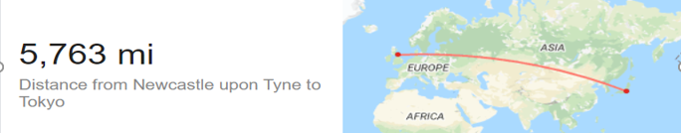

This Summer would have been the 29th Summer ‘Modern’ Olympics. Since 1896 the event has only ever been cancelled 3 times, 1916 (WW1) & 1940 & 44 (WW2)!
We have easily walked the length of Hadrian’s Wall several times over, a total distance of over 3,000 miles! Now can we beat that?
From the Opening Ceremony, which would have been on the 23rd July, we can achieve the 5,763 miles by running, walking or cycling to get to the Closing Ceremony on the 8th August in Tokyo, Japan, all the way from Newcastle!
To join us for this please use one of the below to keep a record of your daily miles, or devise one of your own. Then between the 8th and the 10th of August, then send in your results to the Northumberland School Games Facebook page via message. One of our SGO’s will tally the total for Northumberland to see if we can reach Tokyo.

Word document/Excel spreadsheet available on the link.
Steps can count too:
2,000 steps = 1 mile
10,000 steps = 5 miles
We would love to see your pictures of your own Closing Ceremony too!

