`

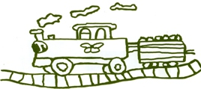

Welcome to this half terms Topic Information letter for Elm and Beech Classes.

**Elm:**

**Mrs Metcalfe, Miss Hepworth**

**Beech:**

**Miss Darlow, Mrs Borley and Mrs Swinney**

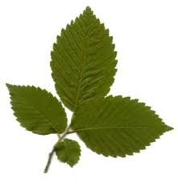





**Autumn 2 2018**

**Maths**

Following the National Curriculum and our mastery Maths approach this half term the children will be developing their learning in these strands:

Addition and Subtraction

Money

Multiplication

Shape

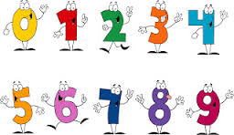

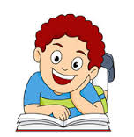

**English**

Within key stage 1 this half term we will continue our Read Write Inc Phonics groups arranged around the children’s needs and abilities. In keeping with our ‘Superheroes’ topic we will be reading lots of Superhero stories and comics and learning how to retell them through drama and story writing. We will be reading instruction books and recipe books too. Reading opportunities will take place both on a one to one, small group and whole class basis each week.

If you have any comics at home that you no longer want- School would be grateful for them.

**Art/DT**

This half term the children will look at a pop art. We will work with and explore different artist techniques inspired by Keith Haring and Andy Warhall. They will have a particular focus on self portraits in different styles.

**Music**

During the half term we will be listening to

and discussing the musical qualities of theme tunes before composing their own using vocal and a range of percussion instruments.

We will also be exploring lots of different songs linked with Christmas alongside sound effects.



**Science**

Our theme for science this half term focuses on humans.

In our learning we will be finding out about healthy diets and exercise.

They will also be looking closely at the human body and how we can look after it.

We will also be looking at seasonal changes and the weather.

****j0232522****

**RE** – In our religious education lessons the children will be exploring their own thoughts about creation and the birth of Jesus.

**Computing**

***E safety and Sock Puppets app***

Through our topic this half term we will be exploring how information can be shared with other people. As part of our work we will learn how to use and have fun with different Ipad apps including story creator, sock puppets and Daisy the Dino. Children will be also using ipads to create their own comics for our Superhero topic.

In terms of e-safety we will continue to improve out logging in skills

as well as developing our

understanding of how to

keep safe while using the

internet.

**PE**

**Elm: Monday & Wednesday**

**Beech: Wednesday & Friday**

PE will take place outside when the

weather allows and is based

on dance and gymnastics.

**Please make sure:**

**- full PE kits are always in school including trainers or sandshoes**

**- ensure no earrings, watches or rings are worn on PE and long hair is tied back.**

**- all your child’s clothing is clearly labelled with his/her name.**

**Geography, History**

This topic we will be looking at real life superheroes both now and in the past. We will be linking this in with Remembrance day and the heroes from WW1 and WW2.

**PSHE**

The theme this half term is being special

During circle time discussions they will be considering that the children are all different and have their own special talents. They will learn how to talk about themselves and what makes them special- as well as what makes others different.

**Homework  
Reading** – Children will be bringing home their home reading books during the week. It would be helpful if you could either write or sign the book to say you have heard them read, it helps us to avoid repeat reading the same pages and helps your children make progress. Many children are beginning to change their books themselves and as sometimes this does not go according to plan please let a teacher or teaching assistant know if there seems to have been a mistake. The large proportion of group and guided reading takes place within our Read Write Inc Phonics. Time is set aside for further reading tasks as appropriate.

**Spellings**

Please help your child at home learn their weekly spellings as these small assessments are extremely important to your child’s progress.

**Maths Homework**– Mathletics Maths homework is ready for them to access on line ready for each Friday. There are very few children unable to access this and arrangements are able to be made for those without internet connectivity. Children can play on Mathletics after they have completed their assigned activities. The more they access the program the more chance they will receive a certificate each week.

**Thanks for your help and continued support – Mrs Metcalfe and Miss Darlow**

**Parental Help/Resources**

We would very much appreciate your help/skills/resources that would link to any of our topics for this and the following half term throughout the year. If you feel that you could help us and your children out in any way please contact school and let us know.

Forest School

**Elm: Friday Beech: Wednesday**

We have waterproof trousers which we provide for each child but please ensure that their wellies and coat are in school so that are comfortable. Even when the weather is fine there can still be some muddy patches in our wildlife area.

**Home Time**

If you need to change the usual arrangements for picking up your child from school, please let school know as soon as possible. As you will understand we cannot allow children to leave the school premises unless we have permission from parents or carers.