`
Grange View C.E

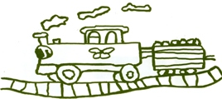

First School

Welcome to this half terms Topic Information letter for Willow Class

Mrs Chapman and Mrs Timmins
Miss Appleby and Miss Scott-Shirley
Mrs Cessford, Miss Carr and Miss Gray




]


Out of this world!

Summer Half Term (1)

Numeracy;
We will be continuing to looking at fractions of amounts and shapes and using all our multiplication and division work to help compare fraction s and find equivalence. We will also be learning the correct terminology. Later in the term we will be totalling money amounts as well as reading and analysing charts linked mainly to our Space work. To help at home please encourage your child to make amounts with money and in preparation for next term telling the time!

Science – Light, Shadow, Earth, Sun and Moon.
Our big theme this term is Space, so Science will be playing a large role in our curriculum learning. The children will be finding out about how shadows are formed and change throughout the day. We will be visiting the sundial in Widdrington to see how shadows help to tell the time. As part of our Space theme the children will learn about the solar system, the planets and how they orbit the sun and have astronaut training at the Centre for life!
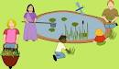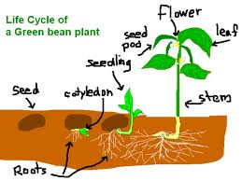

Throughout our Forest School learning, we will be pond dipping when we get appropriate weather in the forest area. As well as working in groups to get planting in our raised beds and grow some veggies and fruit!

Literacy
Reading
During this half term children will read in a variety of situations throughout the week at school in a shared whole class session, in a small group guided session, one to one with an adult and also independently. The children will look at a range of stories during carpet time as well as Non fiction books about the solar system.
Writing
The children will write in the following genres;
Plays: Learning how to use expression and stage directions to perform and the write their own plays.
We will also be using one of the Read, Write Perform units where they record a transmission as an astronaut in space!
Speaking & Listening
Children will be developing a lot of their skills during the residential at the end of term. Needing to listen and communicate with each other in team tasks.

Music – Djembe Drums Tuesdays
As part of our Music connections, the children have been learning to play the Djembe Drums. Since September, our percussion teacher has been coming into school each week and teaching us. We have learnt lots of rhythms as well as many facts about Africa. So watch this space for a show stopping performance in our school hall!
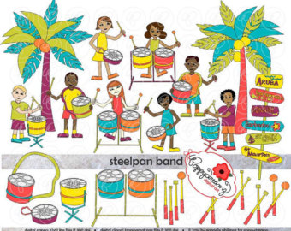

Art/DT

Children will be developing their skills to create recreations of earth and other planets. Using the medium of paint, oil pastels and charcoal. Additionally they will be designing their own rocket.

PE – Games
In preparation for the dance showcase at the end of last term we didn’t have many other PE sessions, therefore we will be building our confidence and balance skills on the big equipment for gymnastics this term

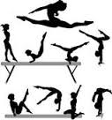
Swimming is taught by qualified swimming coaches at Morpeth Leisure Centre every Thursday morning, the children are always supervised by school staff.

RE – Prayers


Throughout this topic the children will be reading and investigating different types of prayers. Developing an understanding of their purpose for Christians, how they tend to be read and what their importance is. During this term we will also be doing our penultimate Eucharist lesson in preparation for the final summer term.

MFL – French – Les Planetes
As part of their language learning the children will be practising and revisiting their colour names in order to name and describe the planets in French. They will do a variety of games and group activities to learn and recite the vocabulary.

PSHE- ‘Relationships’.
During circle time discussions they will be learning about building relationships, how to share and control emotions and the best way to make and retain friends.
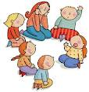
They will discuss feelings of guilt, how to make correct decisions and how to make amends from mistakes they make have made.

History/Geography

Having learnt all about space and exploration they children will then be finding out about what life was like in 1969 when man landed on the moon, watching video footage of the iconic event and researching the progress and discoveries NASA has made over the years.

As part of Geography they will be studying the land features of different planets, comparing them to Earth and reasoning why there is no life seen on other planets.

ICT –logo, control and Roamer
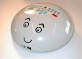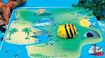
To link with their work in Numeracy on right angles and directions, the children will be working in and out of the computer suite to create instructions. These will command an electronic turtle or robot to move around a screen, on a space map or draw shapes.

Homework
Reading – Children will be bringing home their home reading books during the week. It would be helpful if you could either write or sign the book to say you have heard them read, it helps us to avoid repeat reading the same pages. Group Reading takes place each week in class, the children will be given a set number of pages to read for their next weekly session. Please sign their book once they have read them. Additionally the children may bring home a third book that they have taken out of the library on our Friday visit.
Spellings and Times Tables – Children will be given differentiated spellings to learn for their weekly spelling test on a Friday morning. Please help your child as much as possible learn these words as they will help with their confidence and fluency as both a reader and writer. They will also have a specific times table to focus on within Times Table Rock Stars – the participation so far has been excellent and shows great improvements in the pupils speed.
Maths / English Homework - Children will be given some Maths homework on Mathletics each Friday that needs to be completed by the following Friday morning for class dojo rewards. The maths homework is usually linked to the work they have done that week in Numeracy and should be appropriate for them to complete independently. Once a term they will also be given a short writing task to complete in their purple home writing books, the focus of which will be written in their books along with the date for it to be handed in. Usually they have about three weeks to do the writing. The thought process behind this writing, is for your child to work on their ideas and sentence construction with you, in the hope that they will learn new phrases and ideas which they can then use in their everyday writing in class.
Thanks for your help and continued support

Swimming
We would be grateful if you could please ensure your child’s clothes are clearly labelled with their name. This is especially helpful when we go swimming, as there are occasions when clothes do get mixed up, or are left in the changing rooms. Could parents also ensure they have their swimming hats, and pierced ears need to have the earrings removed. If you are available to help any Wednesday Afternoon with swimming please get in touch, the more helpers the better!

Home Time
If you need to change the usual arrangements for picking up your child from school, please let school know as soon as possible. As you will understand we cannot allow children to leave the school premises unless we have permission from parents or carers.

Forest School / PE Kits
Classes will be using the forest area whenever possible, we have waterproof trousers which we provide for each child but please ensure that their wellies and warm winter coat /hat / gloves are in school so that are comfortable.
We are intending to do PE on Thursday afternoons, so please ensure that they have their PE Kits as well as appropriate footwear in school on these days.

Diary Dates:
Friday 10th May – Year 3 Personal Best sporting event. Y4 ½ day water sports
Monday 13th May – Ford Castle Activity Day (leave 8am–return approx 5pm) - Packed lunch required
Thursday 23rd May – 10 pupils Y4 Tag Rugby pm
AFTER HALF TERM – 1st Day back Monday 3rd June – Centre for life trip - Packed lunch required
Wednesday 5th June – Y4 Quad Kids tournament - Packed lunch required
Thursday 6th June – Y4 countryside show – Packed lunch required

