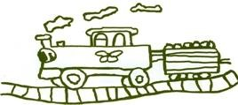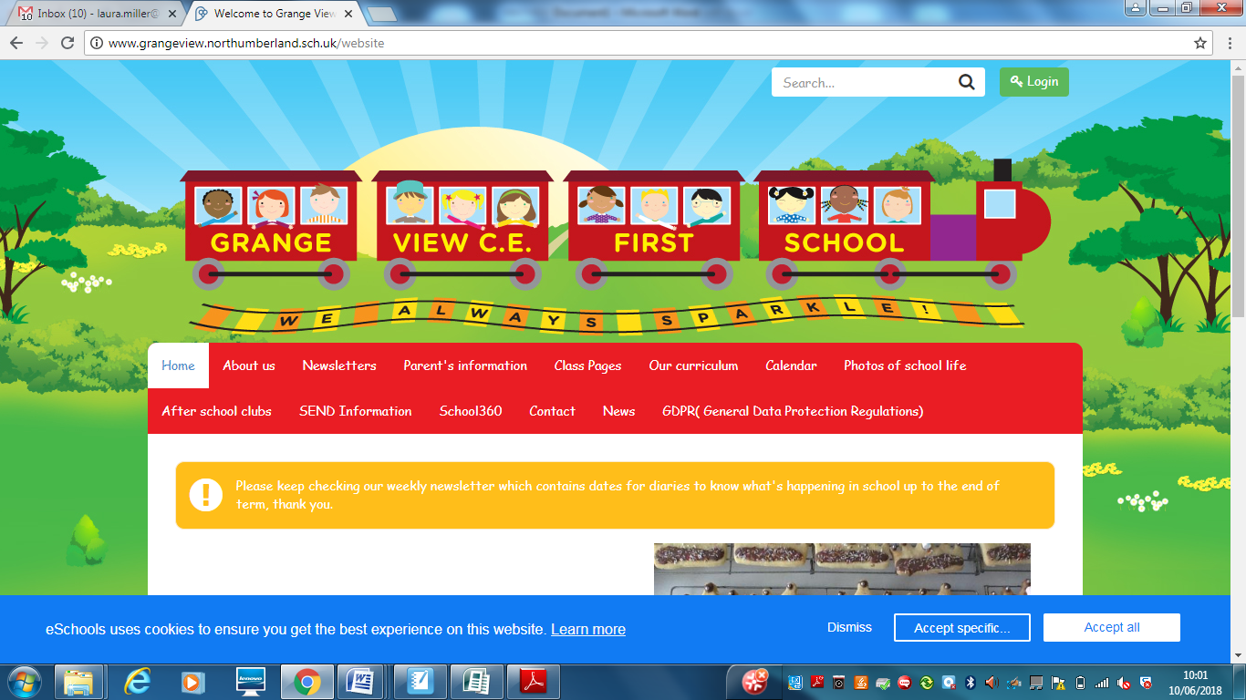

**Science at Grange View CE First School**

**This is a guide for anyone who is visiting Grange View C.E First School to explain our approach to Science in school. *Updated April May 2022***

**OUR INTENT: What our Science teaching Intent is:**

ur teaching of science for all children is to develop a curiosity and interest in the subject during their time with us and beyond.   It is about developing and challenging children’s scientific knowledge and conceptual understanding through the different disciplines.  Science teaches children to have care and concern for living and non-living things and promotes curiosity about the world they live in.

Through the Programme of Study for Science in the National Curriculum, children will develop knowledge, concepts, skills and a positive attitude, supported through engaging outdoor learning opportunities. Working scientifically is developed throughout their time at Grange View as they progress through each year group, building on their enquiry skills and subject knowledge. By developing these skills it allows them to have greater independence in planning and carrying out fair tests.  These tests will allow children to explain concepts using scientific language, build arguments and ask questions showing curiosity about the world. We believe every child can flourish and is encouraged to strive for success.

**Planning**

Our curriculum planning follows a two year rolling cycle in Early Years, Key Stage One and Two. The topics have been chosen based on the National Curriculum and ensuring the themes are engaging and interesting to the children.

The Science focus for each term is mapped out within Topics to ensure all areas of Science are covered.

**Skills progression:**

Skills progression from Early Years to Year 4 has been developed to ensure all areas of the Science curriculum are covered and to ensure clear progress throughout the year groups. This will also give staff the confidence to teach Science and know what needs to be achieved by the end of each year.

**Science resources**

We have a range of resources in school to help with the teaching of Science and to allow children to complete experiments in all year groups. These resources are checked by the subject leader and replenished and replaced when need be. Some of the resources include;

* Magnifying glasses
* Magnets
* Resources to complete basic electric circuits
* Thermometers
* Torches
* Pond dipping

**Assessment:**

At the end of every term, assessment sheets are created to match the areas of Science being taught for each year group, created by the subject leader. The assessment sheets cover the National curriculum expectations and the key skills to be observed. Three children of different attainments (low, middle and high) will have their work looked at to complete an assessment which will be used as representation for the whole class. The subject leader will keep these assessments and any examples of work for evidence of progress in Science.

**Science across the Curriculum**

Science is taught as part of topic time so it is relevant to what they are learning. It can be also taught as part of other subjects including Geography, outdoor learning, ICT, (recording data from experiments) Literacy, (writing scientifically) and Maths (Measurements, statistics etc). There is also a clear link to Relationships, Sex and Education which covers Human Science, lifecycles and Healthy living.