

**Grange View C.E. First School**   
Grange Road, Widdrington  
Morpeth, NE61 5LZ.

Telephone: 01670 790 686email: [admin@grangeview.northumberland.sch.uk](mailto:admin@grangeview.northumberland.sch.uk)

Headteacher: Mrs Louise Laskey

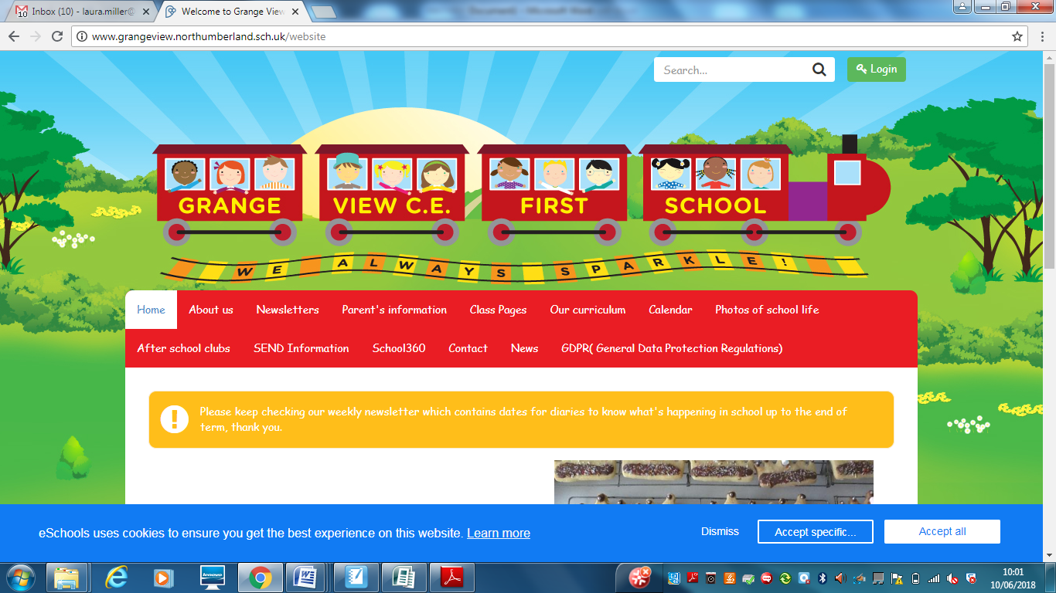

***We aim to SPARKLE!***

**Dear Parents / Carers, 16TH July 2021**

**What a Year!**

**A MASSIVE thankyou for everything you have supported us with and your child/ren with over the last year.**

**Everyone has ‘Sparkled’ during a difficult year. We have worked together to make sure that we have provided all our children with the BEST we can.**

**We would like to wish all our Year 4 Leavers the BEST OF LUCK at their new schools in September and know they will make us all proud.**

**We hope you all stay safe and have an amazing summer with your families and loved ones.**

**HAPPY SUMMER SAFE HOLIDAY TO YOU ALL!**

**The DFE and NCC have not issued new guidance or Risk assessments for our return on the 7th Sept so at the moment for the first week all systems for drop offs and pick up remains the same. As soon as we know what we can do we will consult with the staff, make the changes and let you all know asap through DOJO and emails.**

**Goodbye and Good luck**

**We say a sad farewell to a number of staff this week and wish them all the best of luck on their new adventures. Miss Gowland we thankyou for a splendid maternity cover in Elm class and send her best wishes for her new Year 6 teacher role in Northumberland . Mrs Metcalfe we thankyou for a wonderful 3 years working across the school and send her best wishes for her new KS2 teacher role in Northumberland. Miss Clapperton we wish the best of luck starting her foundation degree to become a teacher- you will be fab! Miss Hazell we wish the best of luck at your new school as a Teaching assistant. Mrs Young we send best wishes too, on the next chapter in her career.**

**Summer Reading Challenge**

The Summer Reading Challenge is from the Reading Agency, which encourages children to keep reading for pleasure over the school summer holidays. The theme this year is Wild World Heroes, and more information can be found here: https://summerreadingchallenge.org.uk/

This year we also have access to a digital presentation about the Summer Reading Challenge. The challenge is for ages 4yrs-11yrs.

PACKS have already been sent home with your child. Cathy is ready with lots of fun in the library for the summer holidays!

The link is: <https://www.youtube.com/watch?v=C6NDwIlQmbY&list=PL-d5RvdkfhkCvBq02kJiP3RMOBM5jWfvi&index=32>

**Volunteers**

We are looking for any parents who would like to support us with our swimming supervision in September. All being well Y3 and Y4 will be resuming swimming lessons 1.15pm- 2.15pm every Wednesday. You would need to be DBS / safeguarding checked. Just give us a ring if you or a grandparent is free on a Wednesday. Thankyou.

**Topic Reviews**

**Early Years Topic Review Summer 2**

It has been a brilliant half term for Early Years. They have learnt so much about our seaside topic. The children created their own beach café in the role play area and used pretend money to make purchases at the café. They wrote out shopping lists, recipes and took orders. The children have enjoyed learning about seaside’s past and

present. They have spent lots of time developing relationships, working on sharing, and talking about thoughts and feelings. The children have worked hard all together as a unit. During their Forest School sessions the children have been busy making dens, listening for sounds, and creating their own mini houses. The children used shells and stones to create their own beach themed pictures. They used the story ‘The Rainbow Fish’ to design their own rainbow fish paper plate craft. In Literacy, they have used Talk 4 Writing to write their own instructions for sandwiches based on ‘The Lighthouse Keeper’s Lunch’ and then they followed their own instructions when making a sandwich. They also used photographs to write wonderful setting descriptions. In Maths, the children have learnt to double and half, share out items and explore shapes. During this term, the children have very much enjoyed having Little Movers and YOGA. All of the children love our dough disco sessions to strengthen our fine motor skills. Such a fantastic half term

**KS1 Class Summary – This is Me!**

This has been a great topic to end the school year with, it has made so many links to their prior learning. We started with considering where they live and using google maps to find Widdrington and their house. They made links to last terms geography, using vocabulary like Northumberland, county, town and village to describe their location and learn about the United Kingdom. The topic was predominantly science based, considering ways to stay healthy and look after themselves. They designed a healthy mean, considering the different food groups and the Year 2s enjoyed reminiscing over their Warburton’s sandwich making workshop from last year. Coinciding with sports day, they considered ways that they can do exercise, they did an experiment measuring their heart rate and how their body changes when they do mild, moderate and intense exercise. Best of all, at the end of the term they created their own self-portraits by drawing over a photograph of themselves on acetate and adding tissue paper as a collage. In computing, both classes have had great fun using scratch to develop their programming skills and using the glockenspiels in music to confidently create a performance. Finally, in circle time discussions they have consider ways they can keep themselves calm and support their mental wellbeing, it is clear that their trip to Boulmer with Mudlarks was an memorable activity.

**Key Stage Two Topic Review – Rotten Romans**

Chestnut and Willow have thoroughly enjoyed the Rotten Romans topic this term and have shown high levels of enthusiasm and interest. Here are some of the things we have learnt;

•We learned about the Roman Soldiers clothing and the purpose of them being to protect them when in a battle.

•We designed and made a paper Mache Roman soldier helmet.

•We made a Roman soldier shield.

•We learned that Romans planted and grew their own herbs for medicine and we then enjoyed planting and growing our own herbs.

•We learned about Roman Mosaics and enjoyed designing and making our own.

•We learned the story of Romulus and Remus and identified them on a timeline.

•We learned about the three Ruling System of Rome and had a debate as to who we thought was the best ruling system.

•We learned about which areas were ruled by the Roman Empire and identified this on a map.

**Summer Holiday Events at Grange View (other providers)**

**26th- 29th Football Camp – Trident Football - contact school office to book your place.** 9.30am – 12.30pm.The Football camp runs for four days and the cost is £40, or £10 a day.

**2nd-5th Aug- Summer Activity Camp - NCC age 8 plus**

**\*\*\*\*New Diary Dates\*\*\*\***

Tuesday 7th Sept- School reopens with same drop offs and pick-ups for first week.

**September uniform**

Following our school uniform policy your child will be expected to wear the following:

A school sweatshirt / cardigan in the correct colour

Yellow polo shirt

Grey trousers / skirt / pinafore or yellow gingham dress

All black school shoes with no logos

A school PE t-shirt with black shorts or joggers.

We have lots of clean good second hand for anyone who needs it and we will keep spares for any child who turns up for school in the wrong uniform.

These supermarkets and shops store correct colours: Asda / Sainsbury’s / Matalan / Marks and Spencer’s and many others.

**JEWELLERY- NO EARRINGS.**

PE's Health and Safety guidance states- “Schools have a duty of care to ensure students are able to participate actively without unnecessarily endangering themselves or those working around them. A clear and consistently applied policy for the removal of personal effects should be in place. The Association for Physical Education (afPE)

strongly recommends the practice of removing all personal effects at the commencement of every lesson to establish a safe working environment. This applies to all ear and body piercings, including retainer and expander earrings.”

***Please ensure all jewellery is removed before all PE lessons at home or can your child remove them on their own.***

**E-safety-** Remember all you need is on our school website and Facebook page to support you at home with the internet and its use.

**http://www.grangeview.northumberland.sch.uk/website/esafety/102589**

**AFTER SCHOOL CLUBS AUTUMN 2021- All clubs from Sept will be £2 per session- PLACES BOOKING UP FAST!!!!!! – These will commence 13th September.**

**These are the clubs we are offering for the Autumn Term:**

**Mondays - Fun and games outdoors - Newcastle Thunder R- Y4**

**Tuesdays – CLUB with Miss McQuade – Theme to be confirmed –Y1-Y4**

**Wednesdays - Football Club- with Trident football and coaches R-Y4**

**Thursdays- Little Movers – Reception, Y1 and Y2 with Fiona**

**Shopping Link to support Grange View CE First School**

<https://smile.amazon.co.uk/ch/1049905-0>

This is the link to The Friends of Grange View Fundraising. It takes you to Amazon for any purchasing. Everything you buy raises funds for the school and generates extra funding to the PTA who in turn spends it on resources for your child and the school. Thankyou for supporting us with this as every penny counts.

*“This email is to notify you that Amazon has donated £22.71 to your organisation (Friends Of Grange View County First School) as a result of AmazonSmile programme activity between 1 January and 31 March, 2021. The donation has been deposited to your organisation's bank account on or before 19 May, 2021”*

**SIMS Online payments – COVID SAFE CASH FREE SYSTEM**

Thank you to all of those who have already signed up and are using it. We cannot accept cash and the SIMS system is what should be used. You should have received an activation code via email and it is very quick and easy to set up. Please follow the online instructions to set this up to make any future payments. Any issues please email or call the office. Thank you.

Please don’t hesitate to contact us if you have any questions or concerns at [admin@grangeview.northumberland.sch.uk](mailto:admin@grangeview.northumberland.sch.uk)

****Please note – no cash is to be brought into school unless we ask specifically (often for the Friends of Grange View events) All payments for school lunch, milk, uniform, trips etc. should all be made online. Due to Covid, we need to avoid handling cash as much as we can.*****

**Beech**

Merit – Bailey H & Ethan

Sparkle – Jayden S

**Chestnut**

Merit – Eva & Roseann

Sparkle – George

**Willow**

Merit – All of Willow & Mrs Cessford

Sparkle – Alexis

**Stars of the Week:**

**Acorn**

Merit – Neve & Hayden

Sparkle – Navneet

**Oak**

Merit – Harry & Lara-Lee

Sparkle – Marcie

**Elm**

Merit – Joseph & Maisie

Sparkle – Olivia

**ATTENDANCE**

**The most important message is children should be in school as much as possible as every day that a child misses school, for whatever reason, they miss out on vital learning.**

**AMAZING ATTENDANCE – thankyou to all our families for supporting getting your child in school everyday**

**This week’s attendance stars**

Well done to **WILLOW** Class who won with 99.5%

Acorn – 84.9% Oak – 91.9% Elm – 92.9% Beech – 95.5%

Chestnut – 0% Willow – 99.5%

TOTAL FOR THE WEEK 93.9%

Which is below our new school target which is 97%

**W/C: 12.07.2021**





Thank you once again for your support and patience during all of these changes. We hope you have a fantastic summer and stay safe please!

**We continue to follow the government message:**

**Hands- Face- Space- Fresh Air**

Louise Laskey – Headteacher





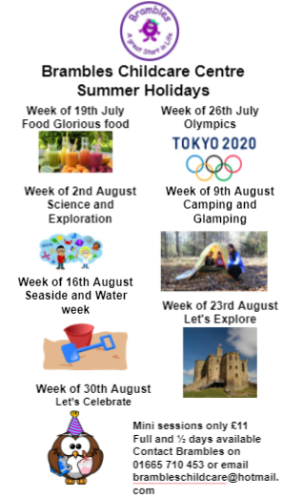



**Safe to Learn section**

This is a section on our newsletter where we will share and update any safeguarding information for all parents/carers to be aware of. Mrs Pat Treanor is our Chair of governors and safeguarding governor, Mrs Laskey and Mrs Chapman are our Designated Safeguarding lead staff.

 

Mrs Laskey- Head Mrs Chapman-Assistant Head

**OPERATION ENCOMPASS INFORMATION**

The original initiative was aimed at supporting children who are affected by domestic abuse. The next part of the project will help all children to learn about friendships, relationships, emotions and rules so that they can live and work together safely. Our Safeguarding liaison officer Karen Kirkbride will be in school this term delivering these workshops.

**Operation Endeavour**- This is an innovative project in which schools and colleges in Northumberland are participating, and which is run in partnership with Northumberland County Council and Northumbria Police.

Operation Endeavour commenced in November 2018, aims to support children and young people who go missing from home. Children who go missing from home are at risk of significant harm and they may be vulnerable to sexual exploitation, violent crime, gang exploitation, or to drug and alcohol misuse.

As a result, following any report of a child going missing to the Police, the Police will make contact with Children’s Social Care who will then communicate relevant and necessary information to nominated school staff.

Each school has members of staff (key adults) who have been fully trained in liaising with the Police and Children’s Social Care when required, and will ensure that the necessary support is made available to the child or young person following their return.

I believe that this project demonstrates our school’s commitment to working in partnership to safeguard and protect children, and to providing the best possible care and support for our pupils.

**Onecall**

Onecall is the number for all adult social care, children’s services and community health enquires in Northumberland. Helping the most vulnerable to keep safe and well 24-7.

**Telephone- 01670 536400**

