The Challenge:
Can you cycle or use your scooter
to complete a virtual distance of
8.74, 87.4 or even the entire 874
miles from John O’ Groats in
Scotland to the most southern point
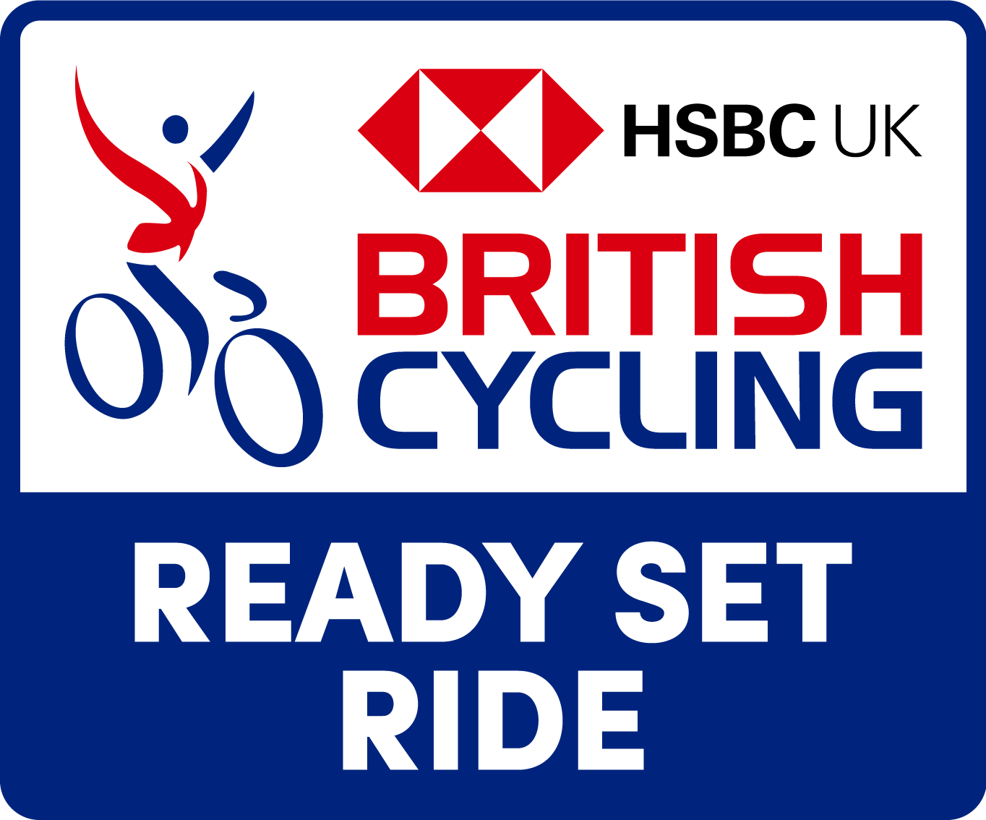
in England called Land’s End in
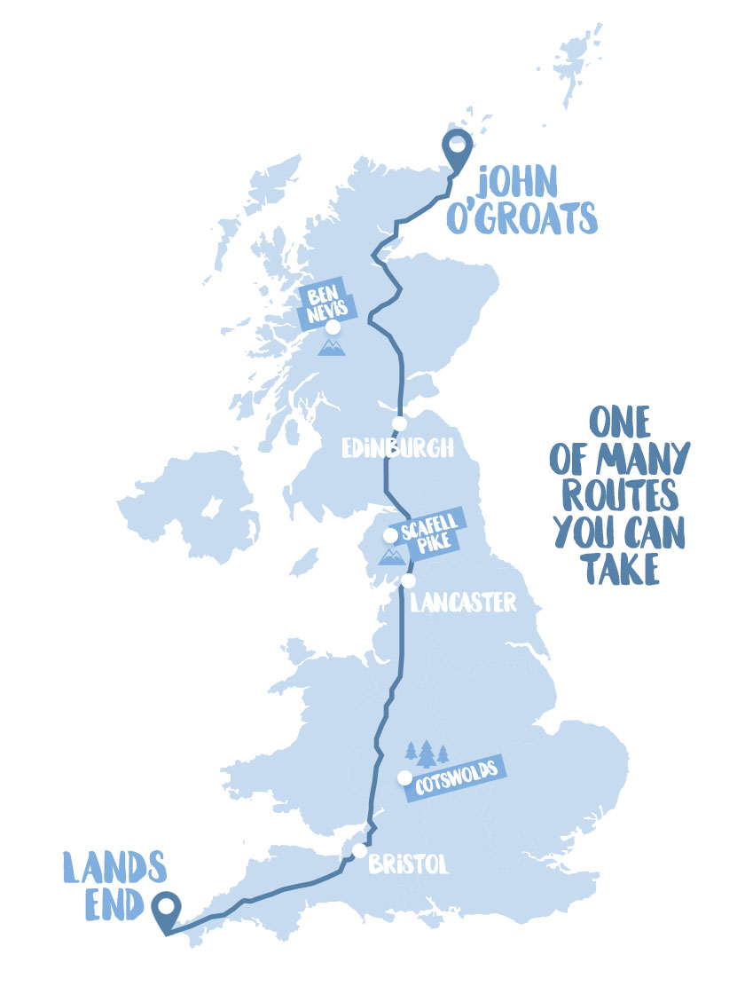
just one week, individually, as a
family or a school group?

The Map:

Score Card:
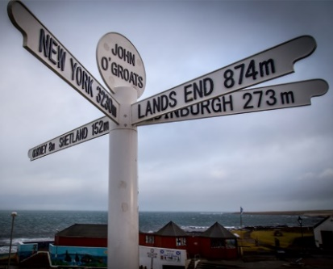
Day | Distance | Mode of Travel

