Grange View C.E. First School
Grange Road, Widdrington
Morpeth, NE61 5LZ.
Telephone: 01670 790 686
email: admin@grangeview.northumberland.sch.uk
Headteacher: Mrs Louise Laskey

We aim to SPARKLE!

Dear Parents /Carers 13th November 2020

MASKS
The governors and I along with other schools in the Coquet partnership have discussed WEARING FACE COVERINGS IN SCHOOL for any parents on site at any time. Cases of Covid-19 are unfortunately rising. Although children and staff in First Schools are not required to wear face coverings in school we are now asking that parents wear face coverings as they come on to the school site to the office if they need to see Mrs Brown. Nursery parents will be expected to wear a face mask when they drop off and pick up children.
We would also like to encourage this when waiting at the school gates but this is entirely up to you as it is not officially on school site.
All of the measures we are putting in place help reduce the overall number of contacts that people are exposed to and therefore help the national fight against the spread of Covid-19. Please help us to keep everyone as safe as possible by following the routines we have in place at drop off and pick up times including arriving within your allocated timeslots; this reduces the number of parents waiting at the school gates.

From the Friends PTA
We have been very busy behind the scenes creating some great fundraising and experiences for the children this term. The school lottery draw will now be drawn every Saturday - the more supporters we have the more the prize winner (and PTA) receive. Last week, one of our family members won £20. Please head to the school lottery page to buy your tickets if you would like to have a chance to win.
There will be extra information coming out from the friends PTA soon regarding our virtual Christmas raffle and 12 acts of kindness mission for Christmas. However we are delighted to share that the Friends have paid for a virtual pantomime for all the classes to watch with food and snacks and have another wonderful treat for the children. At the end of this newsletter, please read the flyer regarding how the Friends of Grange View have decided to celebrate birthdays within class bubbles since children’s parties aren’t going ahead at the moment due to Covid.

We would also like to say a very big ‘Thank You’ to T. Dawson Ltd – Electrical Contractor for their generous donation of £200 to help the Friends of Grange View in their fundraising.

New winter package to provide further support for children and families
Children and families will get extra support this winter, with councils given new funding to ensure vulnerable households do not go hungry or without essential items.

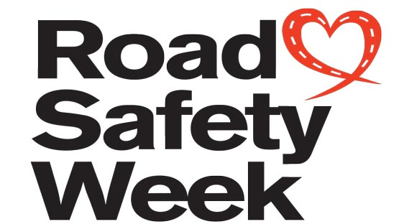
16-22nd November
Every year, thousands of schools, nurseries, colleges, community groups and organisations work together during the UK's biggest road safety event, raising awareness about road safety and helping save lives. For Road Safety Week in school we will talk about road safety to keep us safer on the local streets in Widdrington.

Class DOJO
THANKYOU to all our families who use class DOJO but please remember this is not a 24/7 answering service as the staff teach during the day and may not see your message until after school. I do not expect staff to answer any messages after 5pm as they go home to their families.
But please do check for messages that the staff schedule to send after school, thankyou.

Parent Questionnaires
Please support us further by getting in touch with myself or your child’s class teacher if we can help any of our families any further or if you have any suggestions that we can consider. Or even better complete the parent questionnaire online: https://parentview.ofsted.gov.uk/ THANKYOU
COVID TESTS
As a school we hold a small number of postal testing kits for any pupils and families who for exceptional circumstances cannot get to a local testing centre. Please call the office if you require a kit.

Remote learning plans
Every class is ready for any further lockdown or isolation periods that may happen in the future; we really hope that this is not the case. Every child will receive a learning pack and will also be set tasks on Class Dojo and through Mathletics.
Reception 2021 applications now open
Please use the following link to apply for your child’s place at their next school - https://www.northumberland.gov.uk/Education/Schools/School-admissions-places-appeals-1/Reception-entry-applications.aspx#receptionentryapplications

Dates for the diary:
Mon 16th – Anti- Bullying Week
Mon 23rd- Inter faith week (later than planned)
Fri 27th- NON Uniform for donations for Friends of Grange View Christmas raffle -
Early Years - Selection box.
KS1 – Food or Chocolates for a hamper
KS2 - Bottles
Mon 30th – Christmas Tree arrives!!!!
Mon 14th Dec- Christmas Events in bubbles in school all week.
Friday 18th Dec- School closes at 2pm for Christmas
Tuesday 5th Jan- School reopens.
Thurs 28th Jan- KS1 – Visiting artist in school

Jewellery
Please ensure all earrings are removed or taped up as staff cannot remove or cover them for any child. If this does not happen your child may miss their PE lesson.
PE- clothing
On your child’s PE day we ask you send them in school PE T-shirt with school sweatshirt and any dark sports bottoms with trainers. This supports with no changing during the day.
PE Days:
Oak- Thursday pm
Elm- Friday pm
Beech- Friday pm
Chestnut- Monday and Wed pm
Willow- Monday and Wed pm
On a normal day please send your child in school uniform with all black shoes or trainers as the new guidance states - Uniforms do not need to be cleaned any more often than usual, nor do they need to be cleaned using methods which are different from normal.

ATTENDANCE
The most important message is children should be in school as much as possible as every day that a child misses school, for whatever reason, they miss out on vital learning.
We will be continuing to monitor our classes’ attendance every week and individual class percentages will be published here each week. It is vital that children attend school every day possible to ensure that they are able to start catching up on learning that they may have missed during the school closure and holidays.
Children should not attend school if they are showing any Covid symptoms or if they are required to self-isolate as a result of being in contact with anyone who is showing symptoms.
Can my child go to school if they have a cold? The NHS advises that if a child has mild cold-like symptoms they should continue to go to school. Sore throats and blocked or runny noses are not symptoms of Coronavirus. We have routines in place should a child in school show symptoms of Coronavirus and will isolate the child and contact parents to collect them immediately, self -isolate and book a test.

This week’s attendance:
Well done to Chestnut Class who won with 99%
Acorn – 98.9% Oak – 91.8% Elm – 56.1% Beech –89.5%
Chestnut – 99% Willow – 98.2%
TOTAL FOR THE WEEK 89.1%
Which is below our new school target which is now 97%

W/C 09.11.2020

Stars of the Week:
Acorn
Merit – Lucas & Willow
Sparkle – Frankie

Oak
Merit – James & Evan
Sparkle – Harry

Elm
Merit – Alex & Maisie
Sparkle – Daisy

Beech
Merit – Liam & Harleigh
Sparkle – Bailey

Chestnut
Merit – Poppy & Mason
Sparkle – Angelo

Willow
Merit – Taylor & Logan
Sparkle – Katie

NO HOLIDAYS will be authorised in term time. Please remember your child has missed months of schooling this year and the staff are working hard to get every child up to speed.
We have Education Welfare Officer working with us this year who will be monitoring attendance very closely; especially any families who take holidays in term-time.

Children in Need

Thank you to everyone who donated to Children in Need, we raised a fantastic total of £109. The children looked fantastic in their Pudsey/yellow and spotty clothes.

Hands, Face, Space campaign
The ‘Hands, Face, Space’ campaign is urging the public to continue to wash their hands, cover their face and make space to control infection rates and avoid a second peak. Consistent adoption of these behaviours is particularly important in places outside of educational settings which do not implement the wider protective measures in the system of controls set out in our detailed guidance.
Coronavirus (COVID-19) is an easy virus to kill when it is on skin. It is essential that everyone washes their hands more often, using soap and water for at least 20 seconds. Schools and other education settings must ensure that staff and pupils clean their hands regularly, including when they arrive, when they return from breaks, when they change rooms and before and after eating.

Responding to those with coronavirus (COVID-19) symptoms
It is vital that educational settings only ask children or staff to self-isolate and recommend they get a test if they develop symptoms of coronavirus (COVID-19). Those sent home to self-isolate, having been in close contact with someone who has tested positive, should only get tested if they develop symptoms themselves. The symptoms of coronavirus (COVID-19) are a high temperature, a new, continuous cough, or a loss or change to your sense of smell or taste. The capacity of the NHS Test and Trace system must be protected for those with symptoms of the virus. Booking is essential for drive in and walk in test sites, and under 18’s must be accompanied by a parent or guardian.
NEW Risk Assessment (a copy of which is on the school website)
NURSERY
If you have a child or know a family where a child is turning 3 before December 31st please get an application for a place in our Nursery as spaces are limited from January.
Any parents who are not entitled to the free extra 15 hours childcare can now pay for extra regular sessions per week. The charge is £12 per afternoon session. Please call the office if you would like to use this provision.

SIMS Online payments – COIVID SAFE CASH FREE SYSTEM
Our new online payment system for any services in school is now active. Thank you to all of those who have already signed up and began using it. You should have received an activation code via email. Please follow the online instructions to set this up to make any future payments. Any issues please email or call the office. Thank you.
Please don’t hesitate to contact us if you have any questions or concerns at admin@grangeview.northumberland.sch.uk

Thank you once again for your support and patience during this different way of school life.
We continue to follow the government message: BY STAYING ALERT – AND FOLLOWING THE RULES- WE CAN CONTROL THE VIRUS

Louise Laskey – Headteacher

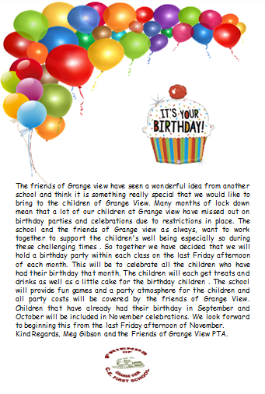

Safe to Learn section
This is a section on our newsletter where we will share and update any safeguarding information for all parents/carers to be aware of. Mrs Pat Treanor is our Chair of governors and safeguarding governor, Mrs Laskey and Mrs Chapman are our Designated Safeguarding lead staff.

Mrs Laskey- Head Mrs Chapman-Assistant Head

OPERATION ENCOMPASS INFORMATION
The original initiative was aimed at supporting children who are affected by domestic abuse. The next part of the project will help all children to learn about friendships, relationships, emotions and rules so that they can live and work together safely. Our Safeguarding liaison officer Karen Kirkbride will be in school this term delivering these workshops.

Operation Endeavour- This is an innovative project in which schools and colleges in Northumberland are participating, and which is run in partnership with Northumberland County Council and Northumbria Police.
Operation Endeavour commenced in November 2018, aims to support children and young people who go missing from home. Children who go missing from home are at risk of significant harm and they may be vulnerable to sexual exploitation, violent crime, gang exploitation, or to drug and alcohol misuse.
As a result, following any report of a child going missing to the Police, the Police will make contact with Children’s Social Care who will then communicate relevant and necessary information to nominated school staff.
Each school has members of staff (key adults) who have been fully trained in liaising with the Police and Children’s Social Care when required, and will ensure that the necessary support is made available to the child or young person following their return.
I believe that this project demonstrates our school’s commitment to working in partnership to safeguard and protect children, and to providing the best possible care and support for our pupils.

Onecall
Onecall is the number for all adult social care, children’s services and community health enquires in Northumberland. Helping the most vulnerable to keep safe and well 24-7.
Telephone- 01670 536400

