TopYa!
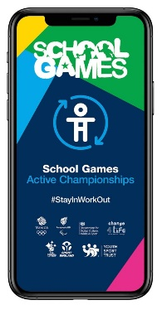
TopYa is a great app for your child / young person to challenge themselves with over the summer months. New challenges are set weekly, and every video is moderated before it is available online. Students will receive real feedback from a coach, and are able to give each other a virtual "high 5", but there is no other in-app communication. Here are some instructions to get you started…..

If you’d like more information there’s a parent tutorial here: https://vimeo.com/user25009636/download/423604569/9d5f1d7699

Good Luck and Have Fun!!

