

**Grange View C.E. First School**   
Grange Road, Widdrington  
Morpeth, NE61 5LZ.

Telephone: 01670 790 686email: [admin@grangeview.northumberland.sch.uk](mailto:admin@grangeview.northumberland.sch.uk)

Headteacher: Mrs Louise Laskey

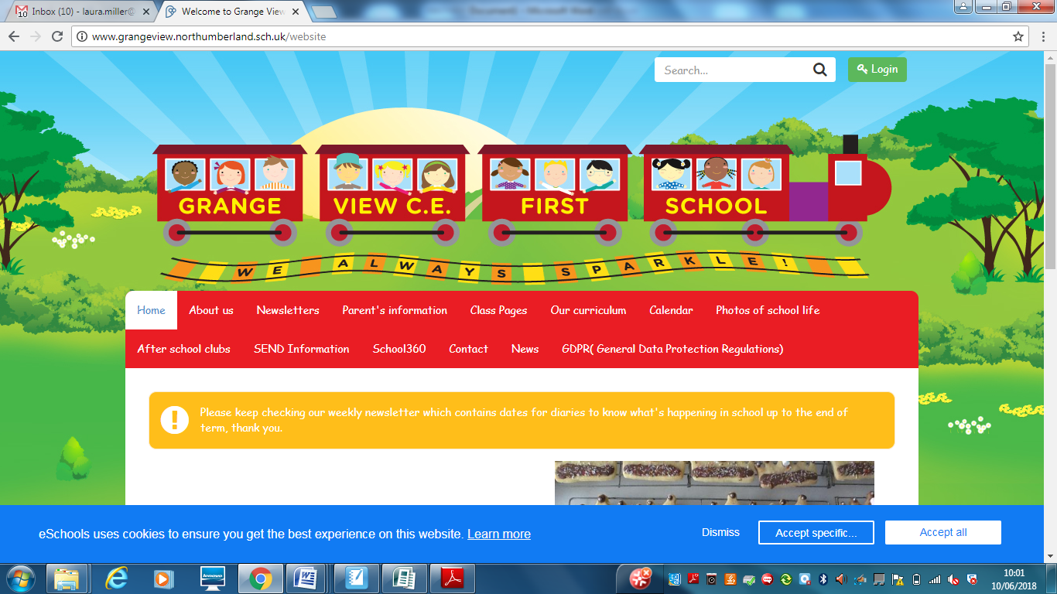

***We aim to SPARKLE!***

**Dear Parents / Carers, 9TH July 2021**

**Last Week of the Year!**

**Well we made it! (most of us did) and we just want to say a MASSIVE thankyou for everything you have supported us with and your child/ren with over the last year. We all pray that normal service will be resumed in September and will contact you all if we change our arrangements for first week back.**

**Classes September 2021**

**You should have all received a letter on Tuesday regarding your child’s new class for September. The children will be meeting their teachers on Tuesday morning next week. The staff will move around to meet the children at a social distance rather than whole bubbles moving around school. They will have a fun morning finding out about each other but are already familiar with all the staff.**

**Good news is that Miss Darlow returns on Monday 12th from her maternity leave and will be working with Miss Gowland on handing over Year 1 and getting up to speed ready for September 2021.**

**Reports- please return reply slips and arrange a phone call with your child’s class teacher if you need to speak.**

**Goodbye and Good luck**

**We say a sad farewell to a number of staff next week and wish them all the best of luck on their new adventures. Miss Gowland we thankyou for a splendid maternity cover in Elm class and send her best wishes for her new Year 6 teacher role in Northumberland . Mrs Metcalfe we thankyou for a wonderful 3 years working across the school and send her best wishes for her new KS2 teacher role in Northumberland. Miss Clapperton we wish the best of luck starting her foundation degree to become a teacher- you will be fab! Miss Hazell we wish the best of luck at your new school as a Teaching assistant. Mrs Young we send best wishes too, on the next chapter in her career.**

**Summer Reading Challenge**

The Summer Reading Challenge is from the Reading Agency, which encourages children to keep reading for pleasure over the school summer holidays. The theme this year is Wild World Heroes, and more information can be found here: https://summerreadingchallenge.org.uk/

This year we also have access to a digital presentation about the Summer Reading Challenge. The challenge is for ages 4yrs-11yrs.

The link is: <https://www.youtube.com/watch?v=C6NDwIlQmbY&list=PL-d5RvdkfhkCvBq02kJiP3RMOBM5jWfvi&index=32>

**Volunteers**

We are looking for any parents who would like to support us with our swimming supervision in September. All being well Y3 and Y4 will be resuming swimming lessons 1.15pm- 2.15pm every Wednesday. You would need to be DBS / safeguarding checked. Just give us a ring if you or a grandparent is free on a Wednesday. Thankyou.

**Summer Holiday Events at Grange View (other providers)**

**26th- 29th Football Camp – Trident Football - contact school office to book your place.** 9.30am – 12.30pm.The Football camp runs for four days and the cost is £40, or £10 a day.

**2nd-5th Aug- Summer Activity Camp - NCC age 8 plus (more info to follow)**

**\*\*\*\*YEAR 4 LEAVERS EVENTS\*\*\*\***

**Due to Covid, this year’s events are very restricted and different**

Tues13th July – Y4 afternoon Forest school pupils and staff only on school site. NO Lollo visit due to restrictions

Wed 14th July - ****5-6pm ****Y4 LEAVERS Celebration***** Awards + Pizza and refreshments. Sorry no parents due to restrictions continuing.

**\*\*\*\*New Diary Dates\*\*\*\***

Mon 12th July – 2.30pm Rev Joanna farewell tea on Field or in classrooms, weather dependent- children and staff only

Tues13th July – Y4 afternoon Forest school

Wed 14th July - ****5-6pm LEAVERS Celebration***** Pizza + refreshments

Fri 16th July - **School closes early - Oak - 1.15pm / Elm + Chestnut - 1.20pm / Beech and Willow - 1.30pm.**

**September uniform**

Following our school uniform policy your child will be expected to wear the following:

A school sweatshirt / cardigan in the correct colour

Yellow polo shirt

Grey trousers / skirt / pinafore or yellow gingham dress

All black school shoes with no logos

A school PE t-shirt with black shorts or joggers.

We have lots of clean good second hand for anyone who needs it and we will keep spares for any child who turns up for school in the wrong uniform.

These supermarkets and shops store correct colours: Asda / Sainsbury’s / Matalan / Marks and Spencer’s and many others.

**JEWELLERY- NO EARRINGS.**

PE's Health and Safety guidance states- “Schools have a duty of care to ensure students are able to participate actively without unnecessarily endangering themselves or those working around them. A clear and consistently applied policy for the removal of personal effects should be in place. The Association for Physical Education (afPE) strongly recommends the practice of removing all personal effects at the commencement of every lesson to establish a safe working environment. This applies to all ear and body piercings, including retainer and expander earrings.”

***Please ensure all jewellery is removed before all PE lessons at home or can your child remove them on their own.***

**Summer term attendance expectations for schools**

School attendance continues to be mandatory for all pupils and the usual rules on school attendance apply. This includes parents’ duty to ensure their child regularly attends school, and schools’ and local authorities’ ability to issue sanctions, including fixed penalty notices, for poor attendance.

We expect schools and local authorities to continue to communicate clear expectations around attendance to families, identify pupils at risk of disengagement and develop plans to re-engage them.

As restrictions begin to lift, we know some families may be looking to take holidays during term time. As usual, parents should plan their holidays around school breaks and avoid seeking permission to take their children out of school on holiday.

**E-safety-** Remember all you need is on our school website and Facebook page to support you at home with the internet and its use.

**http://www.grangeview.northumberland.sch.uk/website/esafety/102589**

**AFTER SCHOOL CLUBS AUTUMN 2021- All clubs from Sept will be £2 per session- PLACES BOOKING UP FAST!!!!!!**

**These are the clubs we are offering for the Autumn Term:**

**Mondays - Fun and games outdoors - Newcastle Thunder R- Y4**

**Tuesdays – CLUB with Miss McQuade – Theme to be confirmed –Y1-Y4**

**Wednesdays - Football Club- with Trident football and coaches R-Y4**

**Thursdays- Little Movers – Reception, Y1 and Y2 with Fiona**

**Shopping Link to support Grange View CE First School**

<https://smile.amazon.co.uk/ch/1049905-0>

This is the link to The Friends of Grange View Fundraising. It takes you to Amazon for any purchasing. Everything you buy raises funds for the school and generates extra funding to the PTA who in turn spends it on resources for your child and the school. Thankyou for supporting us with this as every penny counts.

*“This email is to notify you that Amazon has donated £22.71 to your organisation (Friends Of Grange View County First School) as a result of AmazonSmile programme activity between 1 January and 31 March, 2021. The donation has been deposited to your organisation's bank account on or before 19 May, 2021”*

**SIMS Online payments – COVID SAFE CASH FREE SYSTEM**

Thank you to all of those who have already signed up and are using it. We cannot accept cash and the SIMS system is what should be used. You should have received an activation code via email and it is very quick and easy to set up. Please follow the online instructions to set this up to make any future payments. Any issues please email or call the office. Thank you.

Please don’t hesitate to contact us if you have any questions or concerns at [admin@grangeview.northumberland.sch.uk](mailto:admin@grangeview.northumberland.sch.uk)

****Please note – no cash is to be brought into school unless we ask specifically (often for the Friends of Grange View events) All payments for school lunch, milk, uniform, trips etc. should all be made online. Due to Covid, we need to avoid handling cash as much as we can.*****

**Stars of the Week:**

**Acorn**

Merit – Theia G & Milly B

Sparkle – Lucas

**Oak**

Merit – Taylor & Mary-Jayne

Sparkle – Lara-Lee

**Elm**

Merit – Nicole B & Owen

Sparkle – Niamh

**Beech**

Merit – Jayce & Alfred

Sparkle – Alice

**Chestnut**

Merit – Lucie B & Heidi

Sparkle – Mason

**Willow**

Merit – Porscha & Riley

Sparkle – Logan

**ATTENDANCE**

**The most important message is children should be in school as much as possible as every day that a child misses school, for whatever reason, they miss out on vital learning.**

We will be continuing to monitor our classes’ attendance every week and individual class percentages will be published here each week. It is vital that children attend school every day possible to ensure that they are able to start catching up on learning that they may have missed during the school closure and holidays.

Children should not attend school if they are showing any Covid symptoms or if they are required to self-isolate as a result of being in contact with anyone who is showing symptoms.

**Can my child go to school if they have a cold?** The NHS advises that if a child has mild cold-like symptoms they

should continue to go to school. Sore throats and blocked or runny noses are not symptoms of Coronavirus. We have routines in place should a child in school show symptoms of Coronavirus and will isolate the child and contact parents to collect them immediately, self -isolate and book a test.

**AMAZING ATTENDANCE – thankyou to all our families for supporting getting your child in school everyday**

**This week’s attendance stars BEECH CLASS – HIGHEST % ATTEDANCE THIS YEAR!!! WELL DONE**

Well done to **BEECH** Class who won with 98.3%

Acorn – 91.7% Oak – 95.6% Elm – 97.6% Beech – 98.3%

Chestnut – 94.7% Willow – 95.2%

TOTAL FOR THE WEEK 95.8%

Which is below our new school target which is 97%

**W/C: 05.07.2021**





**Sparkling Afternoon Tea**

**4 wonderful Reception children joined Mrs Chapman last week – Marcie, Mark, Charlie B and Mary-Jane had treats and a chat for all their efforts last week in school.**

**COVID**

Schools and colleges continue to play an important role in contact tracing for pupils, students and staff. We recognise the challenges of this responsibility during holidays, but this remains vitally important in the continued national effort to limit the spread of the virus.

Where pupils, students or staff test positive for COVID-19 having developed symptoms within 2 days of being in school or college, you are asked to assist in identifying close contacts and advising self-isolation, as the individual may have been infectious whilst in school or college.

If, during the course of the school day, your child demonstrates any symptoms of COVID-19 (as outlined above), they will be isolated immediately and you will be contacted to collect them from school with immediate effect. Your child will be treated with care and compassion, but there is a process that we are required to follow and this may include the member of staff dealing with them using PPE kit to protect themselves (goggles, face mask and gloves) while they await collection if a distance of 2 metres cannot be maintained.

Any pupils who have been in close contact with them do not need to go home to self-isolate unless they develop symptoms themselves (in which case, they should arrange a test) or if the symptomatic person subsequently tests positive or they have been requested to do so by NHS Test & Trace.

**Remote education will still be provided where pupils are self-isolating or shielding.**

**Asymptomatic testing information for parents and adults in households with children at school or college**

NHS Test and Trace announced earlier this week, that all adults in households with school and college age children without symptoms can now access regular rapid coronavirus (COVID-19) testing.

Test kits can either be collected or ordered online, as set out below.

Undertaking regular, rapid coronavirus (COVID-19) testing helps reduce transmission of the virus. Parents and other adults in households with children at school or college, who do not have symptoms, can now access regular, rapid coronavirus (COVID-19) testing. This includes childcare and support bubbles.

Tests are fast, easy and completely free. There are [different ways](https://www.gov.uk/guidance/rapid-lateral-flow-testing-for-households-and-bubbles-of-school-pupils-and-staff) for a household, childcare or support bubble to collect their test to take at home, twice-weekly:

|  |
| --- |
| * **through your employer, if they offer testing to employees** * **by collecting a home test kit from a local test site – anyone aged 18 or over can collect 2 packs of 7 tests** * **by ordering a home test kit online – please do not order online if you can access testing through other routes, this frees up home delivery for those who need it most** |

If you have any queries about the tests, and you live in England, please call 119 (free from mobiles and landlines). Lines are open every day from 7am to 11pm.

Children of primary school age (and below) without symptoms are not being asked to take a test.

Testing is voluntary, but strongly recommended to all who are eligible. Alongside the vaccine, washing hands, wearing face coverings, and maintaining social distancing, rapid testing plays a vital role in reducing transmission rates. Getting into the habit of regular testing as part of our everyday lives will help us all to play our part and do what we can to protect each other.

Thank you once again for your support and patience during all of these changes.

**We continue to follow the government message:**

**Hands- Face- Space- Fresh Air**

Louise Laskey – Headteacher





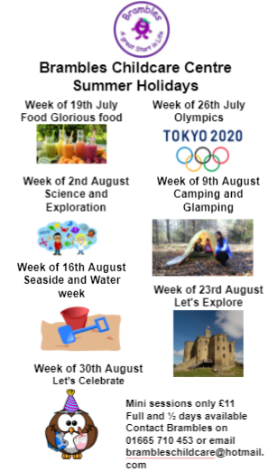



**Safe to Learn section**

This is a section on our newsletter where we will share and update any safeguarding information for all parents/carers to be aware of. Mrs Pat Treanor is our Chair of governors and safeguarding governor, Mrs Laskey and Mrs Chapman are our Designated Safeguarding lead staff.

 

Mrs Laskey- Head Mrs Chapman-Assistant Head

**OPERATION ENCOMPASS INFORMATION**

The original initiative was aimed at supporting children who are affected by domestic abuse. The next part of the project will help all children to learn about friendships, relationships, emotions and rules so that they can live and work together safely. Our Safeguarding liaison officer Karen Kirkbride will be in school this term delivering these workshops.

**Operation Endeavour**- This is an innovative project in which schools and colleges in Northumberland are participating, and which is run in partnership with Northumberland County Council and Northumbria Police.

Operation Endeavour commenced in November 2018, aims to support children and young people who go missing from home. Children who go missing from home are at risk of significant harm and they may be vulnerable to sexual exploitation, violent crime, gang exploitation, or to drug and alcohol misuse.

As a result, following any report of a child going missing to the Police, the Police will make contact with Children’s Social Care who will then communicate relevant and necessary information to nominated school staff.

Each school has members of staff (key adults) who have been fully trained in liaising with the Police and Children’s Social Care when required, and will ensure that the necessary support is made available to the child or young person following their return.

I believe that this project demonstrates our school’s commitment to working in partnership to safeguard and protect children, and to providing the best possible care and support for our pupils.

**Onecall**

Onecall is the number for all adult social care, children’s services and community health enquires in Northumberland. Helping the most vulnerable to keep safe and well 24-7.

**Telephone- 01670 536400**

