Grange View C.E. First School
Grange Road, Widdrington
Morpeth, NE61 5LZ.
Telephone: 01670 790 686
email: admin@grangeview.northumberland.sch.uk
Headteacher: Mrs Louise Laskey

We aim to SPARKLE!

Dear Parents /Carers 8th January 2021

Happy New Year to all our amazing and fabulous families, not that the New Year has been very happy so far. Thankyou again for all your kind messages to staff and Christmas treats and gifts, much appreciated!

Staffing Changes
Miss Gowland is now covering Miss Darlow in Elm class while she waits for her new baby to arrive in early February and hopes to be back at school by the Summer.
Mrs Timmins’ replacement for her maternity leave will be appointed this term, we will keep you posted and she is now working from home until further notice to keep her and the baby safe during this new lockdown.

LOCKDOWN 2- COVID SITUATION - Remote learning etc
A New Lockdown is now in place and this is the latest data from the news on Tuesday which is changing everyday was as follows:
1 in 50 now have the COVID virus
Now over 800 deaths per day
70% increase in virus spreading in the last 2 weeks in December
We are following new Government guidance released on 07/01/2021
Critical workers
Children with at least one parent or carer who is a critical worker can go to school if required. This includes parents who may be working from home. The School will speak to parents and carers to identify who needs to go to school. If it proves necessary, the school can ask for simple evidence that the parent in question is a critical worker, such as their work ID badge or pay slip. Parents and carers who are critical workers should keep their children at home if they can. This is because we are reducing overall social contact across areas and the country rather than individually by each institution.
Remote Learning:
Please ensure you check you emails and use Class Dojo for remote learning. Everything is changing on a daily basis but we continue to review Risk assessments and follow the government and NCC guidelines. We will always give you as much notice as possible if anything changes but please always read our letters and check your emails. Everything we can provide to help you all is on the school website in the COVD tab but we will keep in touch with you all through Class Dojo.
There are lots of extra links and downloadable resources in the COVID section on the school website. We need all our children to keep learning at home if they are not eligible to a key worker place in school or if a parent choses to keep their child at home. We understand it is very difficult and will support you with all you can do during the day at any time that is convenient to your individual situation. The teachers will be now be keeping a log of what is completed at home, which children they have seen on Zoom and will be in touch with families who need a little bit of extra help. Thankyou.
Devices:
We still have 3 reconditioned PC’s with keyboard, monitor and mouse available for £30 each for any family who needs another device. We are also waiting for the Department of Education to release additional devices for disadvantaged families who have no access to remote learning; from 15th Jan we will be able to order these. Please ensure you let school know if you need further support.
Risk Assessment - (a copy of which is on the school website)

BAGS to SCHOOL
If you have had a clear out over Christmas – please see the bags to school information below on this newsletter and bring in all your unwanted items to the school office by Friday 22nd Jan so we can quarantine everything before bagging it up for ‘Bags to school’.

Reception 2021 applications CLOSES 15th JANUARY – You must apply for your child’s place
Please use the following link to apply for your child’s place at their next school - https://www.northumberland.gov.uk/Education/Schools/School-admissions-places-appeals-1/Reception-entry-applications.aspx#receptionentryapplications

BIG BIRD WATCH-29-31 January
https://www.rspb.org.uk/get-involved/activities/birdwatch/
We have registered for this year’s Big Garden Bird Watch and we will be involving the school with this at the end of January. Please have a look at the website for further ideas and suggestions to help all the birds in your gardens.

Dates for the diary:.
- Thurs 28th Jan- KS1 – Visiting artist in school- postponed
- Friday 5th Feb – NSPCC number day
- Tuesday 9th Feb – Safer Internet Day (SID)
- Fri 12th Feb- Half term

NEW- Shopping Link to support Grange View CE First School
https://smile.amazon.co.uk/ch/1049905-0
This is the link to The Friends of Grange View Fundraising. It takes you to Amazon for any purchasing. Everything you buy raises funds for the school and generates extra funding to the PTA who in turn spend it on resources for your child and the school. Thankyou for supporting us with this as every penny counts.

Do you have a child AGE 3 or under?
We need you to let us know ASAP for our limited Nursery places.
We are also investigating if we can offer 2 year old provision from Sept 2021 if we have enough families wanting a place.
Just give the office a call and we can help complete an application over the phone. THANKYOU
WE NEED YOU!!!!

If you have a child or know a family where a child is turned 3 by December 31st please get an application for a place in our Nursery as spaces are always limited. Any parents who are not entitled to the free extra 15 hours childcare can now pay for extra regular sessions per week. The charge is £12 per afternoon session. Please call the office if you would like to use this provision.

ABSENCES
Please can everyone ensure they call Mrs Brown in the office to report an absence of any kind. Thankyou.

Co-op
We are over the moon we have been chosen for fundraising with our local Co-op. The Co-op Local Community Fund supports projects across the UK that their members care about.
Every time you buy selected Co-op branded products and services, you raise funds for our school. They also give all money raised from shopping bag sales to our cause, to help even more. WE LOVE THE CO-OP!!!!!!

ATTENDANCE
Can my child go to school if they have a cold? The NHS advises that if a child has mild cold-like symptoms they should continue to go to school. Sore throats and blocked or runny noses are not symptoms of Coronavirus. We have routines in place should a child in school show symptoms of Coronavirus and will isolate the child and contact parents to collect them immediately, self -isolate and book a test.

Beech
Merit – Jayce & Tyler
Sparkle –Georgie

Chestnut
Merit – Angelo & Mason
Sparkle – Arron

Willow
Merit – Harry & Alexis
Sparkle –Katie

Acorn
Merit – Ella & Neve
Sparkle - Lucas

Oak
Merit – Bella-Rose & Robson
Sparkle – Harry

Elm
Merit – Freya & Nicole
Sparkle – Logan

Stars of the Week:

SIMS Online payments – COIVID SAFE CASH FREE SYSTEM
Our new online payment system for any services in school is now active. Thank you to all of those who have already signed up and began using it. You should have received an activation code via email. Please follow the online instructions to set this up to make any future payments. Any issues please email or call the office. Thank you.
Please don’t hesitate to contact us if you have any questions or concerns at admin@grangeview.northumberland.sch.uk

****Please note – no cash is to be brought into school unless we ask specifically (often for the Friends of Grange View events) All payments for school lunch, milk, uniform, trips etc. should all be made online. Due to Covid, we need to avoid handling cash as much as we can.*****

Thank you once again for your support and patience during this different way of school life.
We continue to follow the government message: BY STAYING ALERT – AND FOLLOWING THE RULES- WE CAN CONTROL THE VIRUS

Louise Laskey – Headteacher
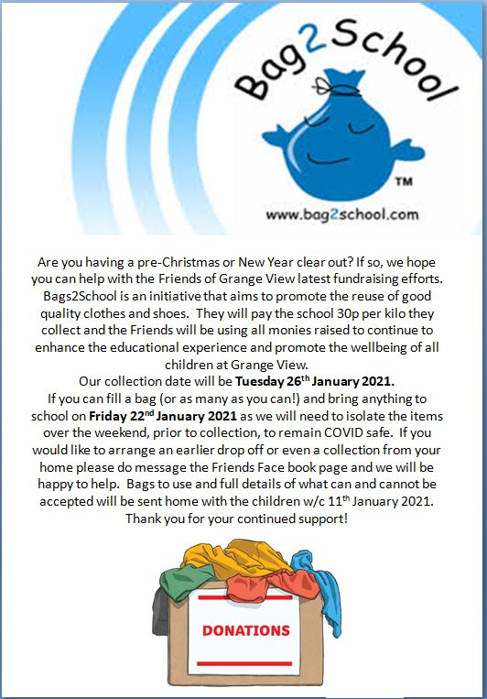

Safe to Learn section
This is a section on our newsletter where we will share and update any safeguarding information for all parents/carers to be aware of. Mrs Pat Treanor is our Chair of governors and safeguarding governor, Mrs Laskey and Mrs Chapman are our Designated Safeguarding lead staff.

Mrs Laskey- Head Mrs Chapman-Assistant Head

OPERATION ENCOMPASS INFORMATION
The original initiative was aimed at supporting children who are affected by domestic abuse. The next part of the project will help all children to learn about friendships, relationships, emotions and rules so that they can live and work together safely. Our Safeguarding liaison officer Karen Kirkbride will be in school this term delivering these workshops.

Operation Endeavour- This is an innovative project in which schools and colleges in Northumberland are participating, and which is run in partnership with Northumberland County Council and Northumbria Police.
Operation Endeavour commenced in November 2018, aims to support children and young people who go missing from home. Children who go missing from home are at risk of significant harm and they may be vulnerable to sexual exploitation, violent crime, gang exploitation, or to drug and alcohol misuse.
As a result, following any report of a child going missing to the Police, the Police will make contact with Children’s Social Care who will then communicate relevant and necessary information to nominated school staff.
Each school has members of staff (key adults) who have been fully trained in liaising with the Police and Children’s Social Care when required, and will ensure that the necessary support is made available to the child or young person following their return.
I believe that this project demonstrates our school’s commitment to working in partnership to safeguard and protect children, and to providing the best possible care and support for our pupils.

Onecall
Onecall is the number for all adult social care, children’s services and community health enquires in Northumberland. Helping the most vulnerable to keep safe and well 24-7.
Telephone- 01670 536400

