

**Grange View C.E. First School**   
Grange Road, Widdrington  
Morpeth, NE61 5LZ.

Telephone: 01670 790 686email: [admin@grangeview.northumberland.sch.uk](mailto:admin@grangeview.northumberland.sch.uk)

Headteacher: Mrs Louise Laskey

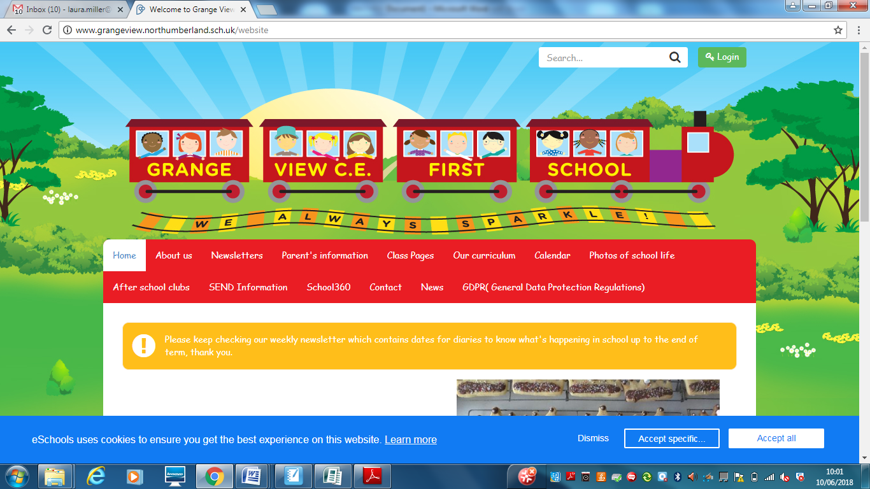

***We aim to SPARKLE!***

**Dear Parents / Carers 26 February 2021**

**Good news!**

**Welcome back to you all after half term. We hope you all and a rest from school work! We can’t wait to see all our children back on 8th March. Please ensure you have read the latest Return to school letter with all the details of arrangements as some times may have changed.**

**New staff- We welcome Miss Heather McQuade in Year 4 from the 8th March who will be covering Mrs Timmins as she continues to work from home safely until her baby arrives at Easter. Miss McQuade has been teaching for a number of years and can’t wait to join our Grange View Team.**

**WORLD BOOK DAY- This will take place in school and at home on Thursday 4th March. We will be bringing in our favourite bedtime stories and wearing our comfy pyjamas and enjoying lots of stories together. If in school we ask your child to wear sensible shoes and something warm underneath your PJs**



**Visit https://www.worldbookday.com/ for more fun ideas to encourage reading. https://www.worldbookday.com/ share-a-story-corner/ https://www.worldbookday.com/resources/ Download a variety of resources with these fun activity packs.**

..



**FREE Library books-** eLibrary Service. We are very excited to have access to an online eLibrary service allowing you to loan eBooks at home. Each child will be sent their own individual username and password on Class Dojo to log in to this service and Mrs Timmins will be uploading a video onto Class Dojo and the school website with a step-by-step guide on how to download the app and access the books. Please get in contact if you need any assistance using the service and we will do our best to help.

***Dates for the diary:***

* **World Book Day- Thurs 4th March**
* **RETURN TO SCHOOL – Mon 8th March**
* **Non uniform day 19th March – Easter Raffle Donations – Acorns/Oak/Elm/Beech- Easter Eggs please. Chestnut and Willow Class- Bottle donations. Watch out for news from the Friends of Grange View**
* **Easter Lunch- Wed 24th March- order with the school office.**
* **Friday 26th March- Break up for Easter**
* **Mon 12th April- TT day, children return on Tues 13th April with same staggered drop off etc.**

**Shopping Link to support Grange View CE First School**

<https://smile.amazon.co.uk/ch/1049905-0>

This is the link to The Friends of Grange View Fundraising. It takes you to Amazon for any purchasing. Everything you buy raises funds for the school and generates extra funding to the PTA who in turn spend it on resources for your child and the school. Thankyou for supporting us with this as every penny counts.

**SIMS Online payments – COIVID SAFE CASH FREE SYSTEM**

Our new online payment system for any services in school is now active. Thank you to all of those who have already signed up and began using it. You should have received an activation code via email. Please follow the online instructions to set this up to make any future payments. Any issues please email or call the office. Thank you.

Please don’t hesitate to contact us if you have any questions or concerns at [admin@grangeview.northumberland.sch.uk](mailto:admin@grangeview.northumberland.sch.uk)

****Please note – no cash is to be brought into school unless we ask specifically (often for the Friends of Grange View events) All payments for school lunch, milk, uniform, trips etc. should all be made online. Due to Covid, we need to avoid handling cash as much as we can.*****

**Acorn**

Merit – Rosie & Hayden

Sparkle - Lily

**Oak**

Merit – Mark & Nicole

Sparkle - Archie

**Elm**

Merit – Domenica & Niamh

Sparkle - Maisie

**Beech**

Merit – Alfred & Harley

Sparkle - Alice

**Chestnut**

Merit – Thomas & Izzie

Sparkle - Elliott

**Willow**

Merit – Evie & Jayden

Sparkle - Joshua

**Stars of the Week:**

**COVID Update**

**COVID STAFF TESTING**

**Staff testing continues.** Any staff who test postive will then have to follow government guidelines and isolate for 10 days as well as booking another PCR TEST through 119 . Therefore this may obviously have an impact on any children who are in the same bubble as that member of staff and the bubble will also have to close until the PCR Test results come back. If the postive test is confirmed then the whole bubble will isolate for the recommended 10 day period. If the result comes back negative then the bubble will reopen.

We hope you can understand that this a postive move to stop any further transmission of the virus and we will continue to keep all staff and children as safe as possible.

**Attendance**

**School attendance is mandatory again from 8th March. It is essential that your child is in school to give them the very best chance of success. Non-attendance will be followed up immediately by the school and education welfare officer if required.**

**All primary children are expected to attend school from 8th March.**

**It is essential that your child returns to school unless they have symptoms or are isolating with you at home. We will need to ask you to follow the government guidelines and seek a test and share the results to allow us to keep everyone safe.**

However, pupils, staff and other adults should not come into school if they have coronavirus (COVID-19) symptoms, or have tested positive. Anyone developing those symptoms during the school day will be sent home.

This includes any of the following symptoms:

● New and persistent cough

● Fever / temperature

● Loss of sense of taste and / or smell

They will be advised to follow ‘stay at home: guidance for households with possible or confirmed coronavirus (COVID-19) infection’, which sets out that they must self-isolate for at 10 days and should arrange to have a test to see if they have coronavirus (COVID-19). Other members of their household (including any siblings) should self-isolate for 10 days from when the symptomatic person first had symptoms.

If, during the course of the school day, your child demonstrates any symptoms of COVID-19 (as outlined above), they will be isolated immediately and you will be contacted to collect them from school with immediate effect. Your child will be treated with care and compassion, but there is a process that we are required to follow and this may include the member of staff dealing with them using PPE kit to protect themselves (goggles, face mask and gloves) while they await collection if a distance of 2 metres cannot be maintained.

Any pupils who have been in close contact with them do not need to go home to self-isolate unless they develop symptoms themselves (in which case, they should arrange a test) or if the symptomatic person subsequently tests positive or they have been requested to do so by NHS Test & Trace.

**Remote education will still be provided where pupils are self-isolating or shielding.**

**Chromebooks**

Please could all Chromebooks that were loaned out during the last few months be returned on the 8th March. Thank you.

**Remote Learning Questionnaire:**

A big thank you to all of those who took the time to complete our google questionnaire. We received some lovely positive comments. Here are a few that we received:

“Keep up with the good work.”

“I would like to say a huge thank you to all the Team at Grange View for all the amazing efforts that have gone into home learning. My daughter has been engaged and I have felt like she has really been developing and keeping up with learning from what has been set. Great support and explanations for parents and the little extras like video round up and Zooms have been brilliant. From the point of view of my daughter in school she is happy, thriving and I am confident she’s safe which is absolutely amazing. Thank you Mrs Chapman!”

“The support from school has been outstanding!”

“The teachers are doing a brilliant job.”

“The class teachers have been wonderful, we look forward to their messages and daily videos once work has been sent in, always a great reply and it helps with keeping my daughter motivated to do the work as she enjoys hearing what they have said.”

Thank you once again for your support and patience during this different way of school life.

**We continue to follow the government message:**

**STAY HOME – PROTECT THE NHS- SAVE LIVES**

Louise Laskey – Headteacher



**Safe to Learn section**

This is a section on our newsletter where we will share and update any safeguarding information for all parents/carers to be aware of. Mrs Pat Treanor is our Chair of governors and safeguarding governor, Mrs Laskey and Mrs Chapman are our Designated Safeguarding lead staff.

 

Mrs Laskey- Head Mrs Chapman-Assistant Head

**OPERATION ENCOMPASS INFORMATION**

The original initiative was aimed at supporting children who are affected by domestic abuse. The next part of the project will help all children to learn about friendships, relationships, emotions and rules so that they can live and work together safely. Our Safeguarding liaison officer Karen Kirkbride will be in school this term delivering these workshops.

**Operation Endeavour**- This is an innovative project in which schools and colleges in Northumberland are participating, and which is run in partnership with Northumberland County Council and Northumbria Police.

Operation Endeavour commenced in November 2018, aims to support children and young people who go missing from home. Children who go missing from home are at risk of significant harm and they may be vulnerable to sexual exploitation, violent crime, gang exploitation, or to drug and alcohol misuse.

As a result, following any report of a child going missing to the Police, the Police will make contact with Children’s Social Care who will then communicate relevant and necessary information to nominated school staff.

Each school has members of staff (key adults) who have been fully trained in liaising with the Police and Children’s Social Care when required, and will ensure that the necessary support is made available to the child or young person following their return.

I believe that this project demonstrates our school’s commitment to working in partnership to safeguard and protect children, and to providing the best possible care and support for our pupils.

**Onecall**

Onecall is the number for all adult social care, children’s services and community health enquires in Northumberland. Helping the most vulnerable to keep safe and well 24-7.

**Telephone- 01670 536400**

