

**Grange View C.E. First School**   
Grange Road, Widdrington  
Morpeth, NE61 5LZ.

Telephone: 01670 790 686email: [admin@grangeview.northumberland.sch.uk](mailto:admin@grangeview.northumberland.sch.uk)

Headteacher: Mrs Louise Laskey

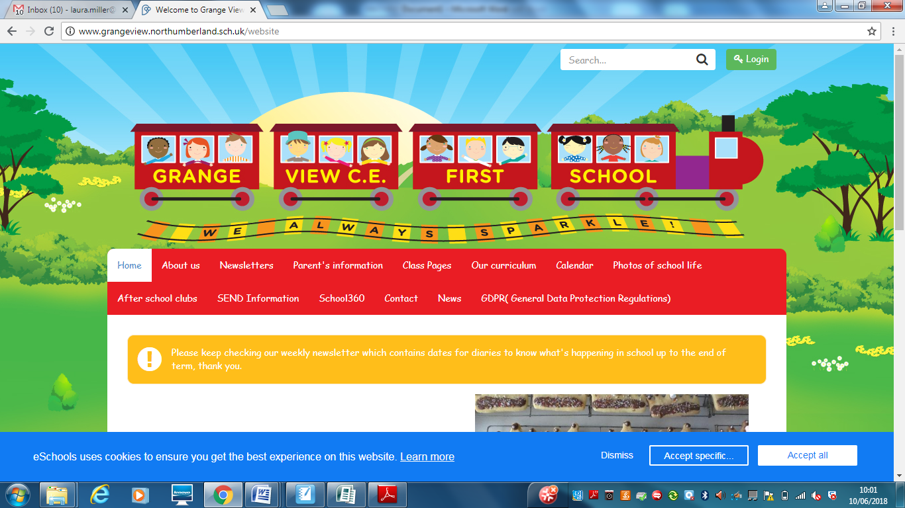

***We aim to SPARKLE!***

**Dear Parents / Carers, 3rd Dec 2021**

**SANTA DASH**

**We will be taking part in the annual Santa dash in school on Friday 10th Dec, this will be part of our daily mile and Early Years will deliver their own event. Please send your child into school with a festive hat of any description to make it lots more fun. Thankyou**

**Widdy Welcomes.**

Christmas Craft Activity on Wednesday 8th December

Two sessions available

Booking essential on a first come basis as spaces are limited.

Please contact Gemma McAlpine 07359107460 to book a place.

**and**

Last Pop Up Cafe before Christmas will be Thursday 9 December

Open 8.45am till 12 noon.

Pop up will reopen Thursday 13th January 2022- Merry Christmas and a Happy and Healthy New Year!!

**BREAKFAST CLUB NEWS**

**We are currently running this childcare facility with extremely low numbers meaning that it is not sustainable. As a gesture of goodwill siblings of Nursery children have been able to access the childcare from 8.30am free of charge but unfortunately we cannot afford to pay staff and continue to do this.**

**Therefore in January any parents wishing to drop any older sibling off at Breakfast club when they drop off for Nursery will need to pay £1( half price) to use this childcare provision. Please pay on SIMS and book places with the office if you need to use this childcare provision. Thankyou.**

**NEW CO2 monitors**

The DFE have provided each class with a monitor to check each classroom is well ventilated to support keeping the children and staff safe from COVID. Although these are working well please can we remind parents that windows do stay open no matter how cold it is outside. The heating is on but please can we also encourage your child to wear layers under their uniform. Thankyou

**PARENT GOVERNOR ELECTION**

Are you are professional? Do you work for the NHS or a local business? Do you have HR or finance experience? If so we are looking for a new parent governor to join our team. Rebecca Griffin who is our chair is happy to chat to anyone who may be interested in the role to support our school. A separate letter was emailed home this week to all families.

**SANTA VISIT!**

**Please see separate letter and complete the reply slip is you wish your child to visit Santa on Monday 13th December. Reply slips must be returned by Monday 6th Dec for organisational purposes. Thankyou**

**SCHOOL UNIFORM**

We have mountains of second hand good quality uniform FREE to anyone who needs a couple of extra sweatshirts . Please let the office know if you need anything.

After Christmas we will be moving to online ordering direct with MAPAC who is our supplier. More information to follow in the new year.

**Nursery places**

We are filling up fast for future years and need to know which families need a place as we do not want to turn anyone away. Instead we would hope to employ additional staff to allow every child a place in the next 3 years.

Please share this information with anyone who has a child coming up to the age of 3. All information is on the school website or call the office and we are happy to help. Thankyou.

**BREAKFAST CLUB**

**Please can all families who access this provision please bring their child to the main door as you do not need to wait at the gate anymore.**

Our Breakfast club provides childcare every morning from 8am for only £2 per session and reduced rates for families in receipt of any benefits. This is value for money in comparison to other providers. We would like to continue providing this valuable service to families but we need parents to use it please.

**PE Uniform**

Please can all parents ensure your child has the correct school PE kit, we have plenty in stock and spares for children to use if needed. NOT your child’s favourite tracksuit no matter how much they moan at you! Thankyou

**Packed Lunches**

Please can we remind parents that we are a healthy school and encourage healthy packed lunches through our packed lunch policy. This includes a savoury sandwich or pasta pot, fruit, yoghurts, water, savoury snacks and one biscuit/cake treat please. No nut based product including chocolate spread that may contain nuts and please

remember to avoid choking hazards by cutting all grapes and large fruit up.

**FREE SCHOOL MEALS -Please** apply for Free school meals if you think you meet the criteria as this would entitle your child to a free school lunch, free milk and many more other benefits in school.

The link to apply is: https://www.northumberland.gov.uk/Education/Schools/Meals.aspx

**\*\*\*\*New Diary Dates- more to follow\*\*\*\***

**Thurs 9th Dec–Year 1 to Y4 Panto visit to Whitley Bay – A drink and snack will be provided.**

Fri 10th Dec – Early Years Panto in school – The Greedy Elf (Reception and Nursery only ).

**RAFFLE tickets go on sale from Friends for Christmas and draw on 15th Dec.**

Tues 14th – Christmas party - Early Years am-

Wed 15th Dec- Flu Jab morning Reception- Year 4- NEW DATE!

Thurs Dec 16th – Christmas Jumper and lunch day

**\*\*\*\*\*\* NEW ****** 11am for Nursery and 2.45pm for rest of school Christmas songs outside classrooms in yard to come along to hear us sing. Refreshments available too**

Fri Dec 17th – Y1/2 party and Y3/4 Parties am. School closes at 1.30pm

Wed 5th Jan – School reopens

20th Jan BAGS to school collected please drop off by 17th Jan

Training Days 2022- 4th Jan and 28th February

**Applying for your RECEPTION CLASS School place: DEADLINE is 15th January!**

It's that time of year again where the admissions portal is open for the 2022 admissions round.

The Reception application Portal will open on 1st November and closes on 15th January 2022.

**JEWELLERY- NO EARRINGS.**

**No Jewellery for swimming lessons for health and safety reasons.**

***Please ensure all jewellery is removed before all PE lessons at home or can your child remove them on their own. We would strongly encourage no jewellery whatsoever to keep your child safe. Thankyou***

**E-safety-** Remember all you need is on our school website and Facebook page to support you at home with the internet and its use.

**http://www.grangeview.northumberland.sch.uk/website/esafety/102589**

**AFTER SCHOOL CLUBS Spring 2022 - All clubs £2 per session - Please collect all your children from the main gate at 4.15pm. Must be paid up front please a week in advance on SIMS**

**These are the clubs we are offering for the Spring Term:**

**Mondays - Fun and games outdoors - Newcastle Thunder - R- Y4**

**Tuesdays – TBC – clubs with staff**

**Wednesdays - Football Club - with Trident football and coaches R-Y4**

**Thursdays - Little Movers – Reception, Y1 and Y2 with Fiona**

**Inclement weather**

During these cold and rainy mornings the school drop off and pick up times remain the same. So we encourage you to

arrive on time.

If you arrive early you may get wet and cold! Children will be escorted into school as usual by the class teacher, so please don’t try to come into school early. Doors will only open at 8.45am in severe weather.

In the case of school closure due to severe weather please always check school website, Face Book page, Northumberland County Council Website and listen to Radio Newcastle. The school will also use the Text2Parents Messaging Service.



THE THRIVE APPROACH- Mrs Tait is our recently qualified Thrive trained member of staff. The Thrive approach is to support the well-being of all pupils and we have been using it for a number of years. A leaflet for parents has been emailed home to explain what it is all about.

**Shopping Link to support Grange View CE First School**

<https://smile.amazon.co.uk/ch/1049905-0>

This is the link to The Friends of Grange View Fundraising. It takes you to Amazon for any purchasing. Everything you buy raises funds for the school and generates extra funding to the PTA who in turn spends it on resources for your child and the school. Thankyou for supporting us with this as every penny counts.

**SIMS Online payments – COVID SAFE CASH FREE SYSTEM**

Thank you to all of those who have already signed up and are using it. We cannot accept cash and the SIMS system is what should be used. You should have received an activation code via email and it is very quick and easy to set up. Please follow the online instructions to set this up to make any future payments. Any issues please email or call the office. Thank you.

Please don’t hesitate to contact us if you have any questions or concerns at [admin@grangeview.northumberland.sch.uk](mailto:admin@grangeview.northumberland.sch.uk)

****Please note – no cash is to be brought into school unless we ask specifically (often for the Friends of Grange View events) All payments for school lunch, milk, uniform, trips etc. should all be made online. Due to Covid, we need to avoid handling cash as much as we can.*****

**Stars of the Week:**

**Beech**

Merit – Harley J & Bailey R

Sparkle – Olivia

**Willow**

Merit – Roseann & Mason

Sparkle – Zack

**Acorns**

Merits- Daisy & Olivia

Sparkle- Ben

**Oak**

Merits- Jacob & Millie B

Sparkle- Rose

**Elm**

Merits- Charlotte & Charlie H

Sparkle- Robson

**ATTENDANCE**

**The most important message is children should be in school as much as possible as every day that a child misses school, for whatever reason, they miss out on vital learning.**

**AMAZING ATTENDANCE – thankyou to all our families for supporting getting your child in school everyday**

**Week ending: 03.12.2021**

Well done to Willow Class who won again this week with 100%

Percentages –

03.12.21- Acorns 68.2% ☹ Oak 90.4% ☹ Elm 92% ☹ Beech- 94.4% ☹ Willow-100% ☺

Our school target which is 97% which was well below at 90.1% ☹



**COVID Updates:**

Coronavirus hasn’t gone away so there will still be a need for schools, pupils and students to follow basic measures to avoid the spread of the virus:

What if someone tests positive or has symptoms? Do they need to isolate?

Self-isolate straight away and get a PCR test (a test that is sent to the lab) on GOV.UK as soon as possible if you

have any of these 3 symptoms of COVID-19, even if they are mild:

a high temperature

a new, continuous cough

a loss or change to your sense of smell or taste.

You should also self-isolate straight away if:

You've tested positive for COVID-19 either according to a PCR test or a lateral flow device test – this means you have the virus. If you get a positive LFD test you should book a PCR test.

A negative PCR test will override a positive LFD test.

If someone you live with has symptoms or tested positive (unless you are not required to self-isolate – see below if this applies to you) you've been told to self-isolate following contact with someone who tested positive – find out what to do if you're told to self-isolate by NHS Test and Trace or the NHS COVID-19 app.

Pupils should only self-isolate if they have symptoms or if they get a positive PCR or Lateral Flow Device (LFD) test.

If they develop symptoms or get a positive LFD test they should book a PCR test. A positive PCR test cannot be overridden.

And what will happen for people who have been in contact with positive cases?

Individuals are not required to self-isolate if they live in the same household as someone with COVID-19, or are a close contact of someone with COVID-19, and any of the following apply:

they are fully vaccinated

they are below the age of 18 years and 6 months

they have taken part in or are currently part of an approved COVID-19 vaccine trial

they are not able to get vaccinated for medical reasons.

Instead, they will be contacted by NHS Test and Trace, informed they have been in close contact with a positive case

and advised to take a PCR test. They do not need to isolate while awaiting the PCR test. We would encourage all individuals to take a PCR test if advised to do so.

Staff who do not need to isolate, and children and young people aged under 18 years 6 months who usually attend school, and have been identified as a close contact, should continue to attend school as normal.

If none of the above applies, people should self-isolate as per the instructions from NHS Test and Trace.

Thank you once again for your support and patience during all of these changes.

**Regards,**

Louise Laskey- Head Teacher



**Safe to Learn section**

This is a section on our newsletter where we will share and update any safeguarding information for all parents/carers to be aware of. Mrs Pat Treanor is our Chair of governors and safeguarding governor, Mrs Laskey and Mrs Chapman are our Designated Safeguarding lead staff.

 

Mrs Laskey- Head Mrs Chapman-Assistant Head

**OPERATION ENCOMPASS INFORMATION**

The original initiative was aimed at supporting children who are affected by domestic abuse. The next part of the project will help all children to learn about friendships, relationships, emotions and rules so that they can live and work together safely.

**Operation Endeavour**- This is an innovative project in which schools and colleges in Northumberland are participating, and which is run in partnership with Northumberland County Council and Northumbria Police.

Operation Endeavour commenced in November 2018, aims to support children and young people who go missing from home. Children who go missing from home are at risk of significant harm and they may be vulnerable to sexual exploitation, violent crime, gang exploitation, or to drug and alcohol misuse.

As a result, following any report of a child going missing to the Police, the Police will make contact with Children’s Social Care who will then communicate relevant and necessary information to nominated school staff.

Each school has members of staff (key adults) who have been fully trained in liaising with the Police and Children’s Social Care when required, and will ensure that the necessary support is made available to the child or young person following their return.

I believe that this project demonstrates our school’s commitment to working in partnership to safeguard and protect children, and to providing the best possible care and support for our pupils.

**Onecall**

Onecall is the number for all adult social care, children’s services and community health enquires in Northumberland. Helping the most vulnerable to keep safe and well 24-7.

**Telephone- 01670 536400**

