RWI e-books and parent resources
- https://www.oxfordowl.co.uk/
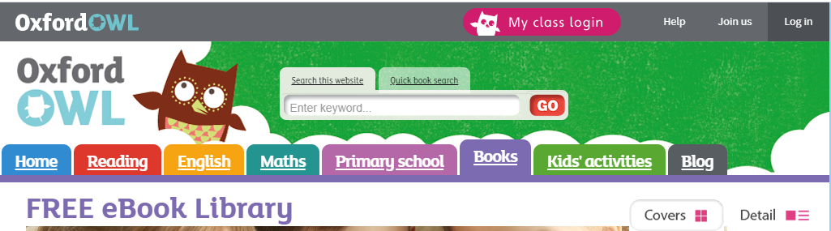
- Login by clicking on the My Class login button (see image below)

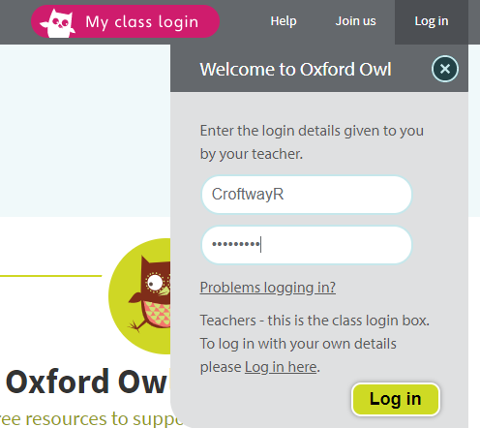
- Enter the username and password shared with you
(sent as a text message)

- Access the free e-books- if possible encourage your child to read the RWI e-books which are in the colour band that your child is in at school (this information will be available in your child’s reading diary. You do this by selecting RWI from the series menu. You then select the colour book which matches your child’s RWI group colour.
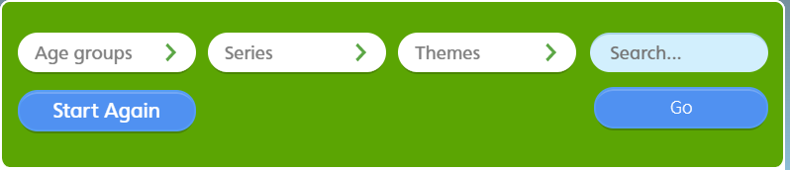
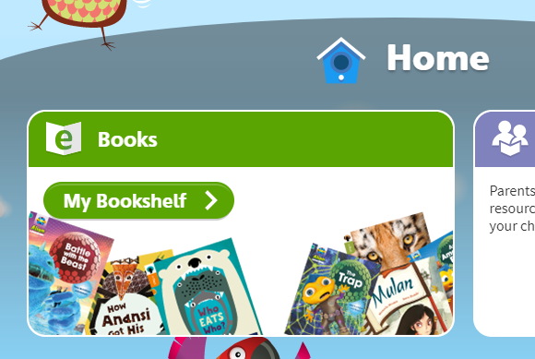

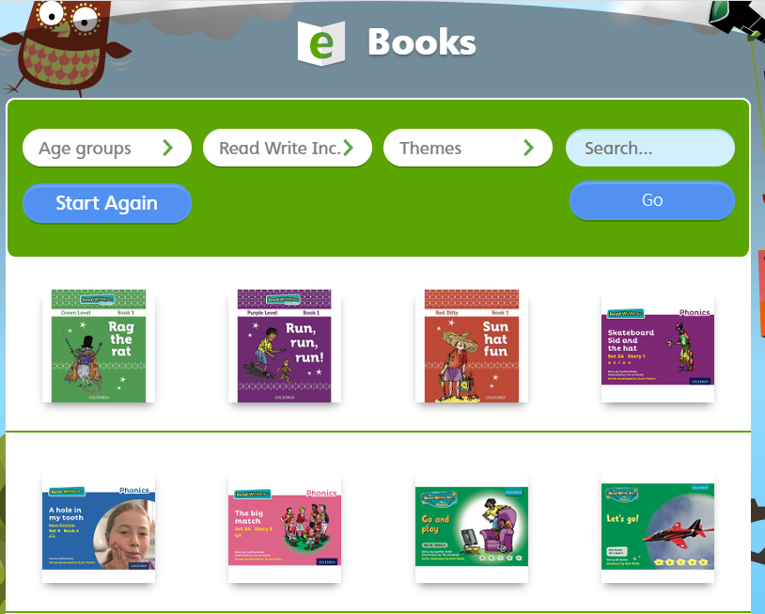

- Access the other learning resources available on the Oxford Owls website.
