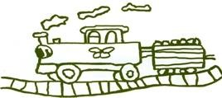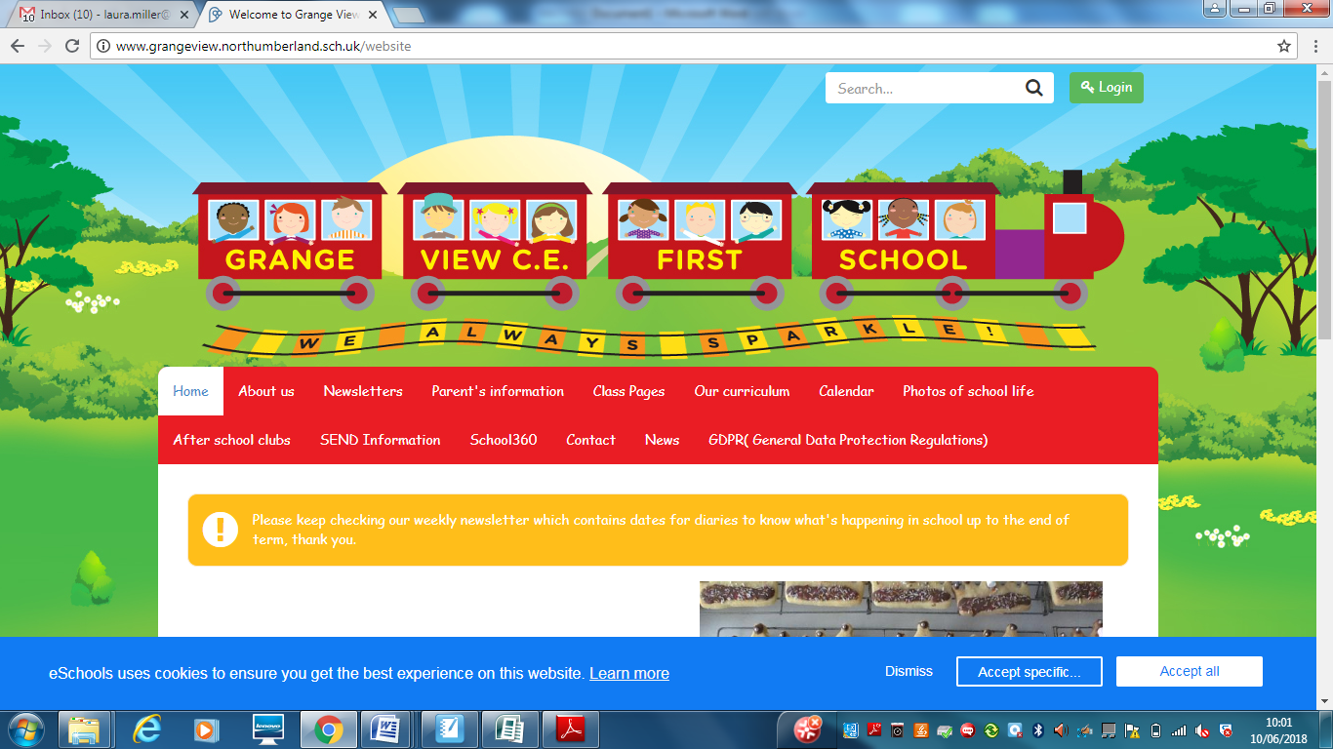

**RHSE at Grange View CE First School**

**This is a guide for anyone who is visiting Grange View C.E First School to explain our approach to Relationships, Health and Sex education (RHSE). (Updated October 2022)**

**OUR INTENT: What our RHSE teaching Intent is:**

At Grange View First School, the RHSE curriculum covers subject knowledge, skills and understanding in Relationships, sex and Health education which will prepare children to become healthy and responsible members of society currently and in their future lives.

It will support them with the development of their social and personal skills and tackle many of the moral, social and cultural issues that are part of growing up. We provide children with opportunities to learn about their rights and responsibilities and appreciate being a member of a diverse society. We encourage our children to be open and honest about their feelings and emotions, to create a secure environment within which mental health can be supported and discussed. Effective communication will be encouraged for all the children by ensuring all views are listened to and respected.

All of the children at Grange View First School will be supported in developing their self-worth by playing arole in contributing to school and the wider community. We strive for all our children to leave Grange View having a secure sense of self, how to be safe and how to care for others.

Sex and Relationship Education

Sex education is taught in the context of healthy growing bodies, relationships, RE and the statutory requirements of the science national curriculum. Parents have the right to withdraw their child from any part of sex education that is outside the compulsory requirements of the curriculum. We invite you to discuss this with the headteacher.

**RHSE across the Curriculum**

There is a clear link between RHSE and Science including human science E.G body parts and keeping healthy. PE is also linked to RHSE in terms of the importance of keeping fit and healthy. Alongside this, 1 lesson per week is dedicated to the solitary teaching of RHSE.

**Assessment:**

Children are assessed through ‘draw and write.’ Prior to starting a unit in PSHE the children are asked to draw and write what they know about this. This will then be repeated at the end of the unit to show progression of knowledge and skills.

**Planning**

The planning of RHSE follows a yearly overview covering all areas of RHSE for each year group. It covers all of the required expectations and is regularly monitored by the subject leader.

**Skills progression:**

Skills progression from Early Years to Year 4 has been developed to ensure all areas of RHSE are covered and to ensure clear progress throughout the year groups. This will also give staff the confidence to teach RHSE and know what needs to be achieved by the end of each year.

**RHSE resources**

Here are some of the resources we currently have available to help with the teaching of RHSE.

* PSHE Jigsaw – This is the current scheme we follow in school
* PSHE Association – resources and support with planning
* Operation Encompass workshops – support to help with the teaching of Healthy relationships