

**Grange View C.E. First School**   
Grange Road, Widdrington  
Morpeth, NE61 5LZ.

Telephone: 01670 790 686email: [admin@grangeview.northumberland.sch.uk](mailto:admin@grangeview.northumberland.sch.uk)

Headteacher: Mrs Louise Laskey

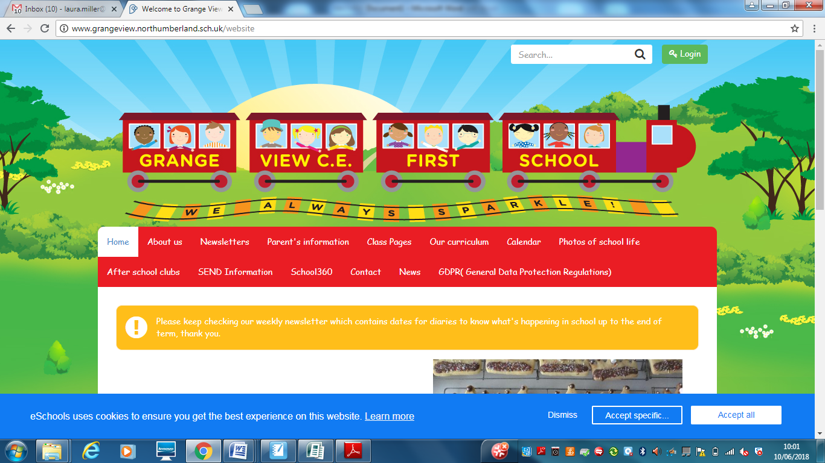

***We aim to SPARKLE!***

**Dear Parents / Carers 26 March 2021**

**Thankyou for all your Easter Raffle donations and you raised a MASSIVE £451 for the Friends on Grange View. THANKYOU!!!!!! We hope you all have a wonderful Easter with your family.**

**C:\Program Files (x86)\Microsoft Office\MEDIA\CAGCAT10\j0304933.wmf**

**Grange View C of E First School - Easter 2021**

**Easter Egg or Garden Competition- Dojo holiday challenge:**

**We would like you all to participate in the Easter Egg and Garden Competition this year at home.**

**Please choose one section to enter with your child and make and decorate your egg or garden at home then share a photo on Class Dojo. There will be prize for every class and every family who enters.**

**The Easter Garden may be made as a 3D collage in a shallow tray or shoe box lid or as a living garden in something like an ice-cream tub. It should include: a cross, a cave, bright colours, other features of a garden (paths, lawn, flowers - these can be drawn, crafted or planted). The all entries should be labelled with the pupils’ name and class. All entries must be submitted on Class Dojo by Tues 6th April. The winners will be informed in school on Tues 13th April when school reopens.**

**Sad News**

We are sad to announce the retirement of Rev Joanna from 1st August 2021.

We will all miss her so much and would like to thank her for everything she has done over the years in both parishes. We have all shared some really special times together and we will make sure we give her a big send off in the summer term. Best of luck Reverend Joanna!

**TOPIC REVIEWS**

What a busy 3 weeks this has been with all the classes, new topics and finding out what they have learned at home and back in school.

**Early Years Spring 2 Topic Review**

We have enjoyed settling back in to our school routines and seeing all of our lovely friends. We have spent lots of time working on building up our relationships, working on sharing, and talking about our thoughts and feelings. The children have worked hard all together as a unit. We enjoyed our topic Growth & Change, we have got our own class caterpillars and we loved watching them grown and turn into butterflies. In our PE lessons we have focused on yoga and mindfulness. All of the children love our dough disco sessions to strengthen our fine motor skills. We have used the stories The Very Hungry Caterpillar and Jasper’s Beanstalk as our core books for this half term. The children have enjoyed using their Talk for Writing skills to retell the stories. We have enjoyed a variety of craft activities, where we used pom-poms to paint caterpillars, and used symmetry to make butterflies. We created our own musical instruments and learnt and performed the song ‘There’s a Tiny Caterpillar on a Leaf’. We have planted sunflowers into soil and carried out an experiment with butter beans.

**KS1 Class Summary – Green Grangers**

How wonderful it has been to have the children all back for the end of term, following on from their home learning tasks we dived straight into understanding how plants grow. The children had great fun investigating the parts of plants and monitoring the stages of the beans growing in the window bags. We focussed a lot on the importance of bees, acting out how pollination happens and making our own bee friendly homes for our garden in Y2 and searching for minibeasts in Y1 – we particularly liked the bees waggle dance. Alongside our topic work, we celebrated all things related to science and engineering with a wonderful STEM week, the children learnt about lots of STEM related jobs through zoom and had great fun using their senses to taste with funny coloured porridge and wonky fruit and veg.

Finally, the large proportion of our final days in school have been building the children’s understanding of Easter and why it is celebrated. They studied in detail the main events of the Easter story, having discussion and giving their opinions on the importance of the events. Best of all was making their lovely Mother’s day and Easter cards and getting creative on the last week to create their own version of Van Gogh’s Sunflowers. What a busy three weeks it has been!

**KS2 Topic Review – Green Grangers**

Chestnut and Willow class have settled back into school well over the 3 weeks of term. In our first week we focused on the British STEM week where both classes focused on food and how our body deals with it. Their week culminated in creating a model gut to show the process of digestion.

We have also enjoyed getting to know orang-utans and their rainforest habitat through poetry, films, ICT research and our library text books. As part of our topic literacy work we have been learning about the devastation of deforestation and its impact on our world. Our forest school area has given the classes an outdoor space to help them experience forest areas and how things grow.

We have been impressed with all the children’s efforts as they have returned to school. They have settled into their routines well, moving around the class and school sensibly and remembering to wash and sanitize throughout the day. Well done to Chestnut and Willow class!

**NUT ALLERGIES**

Please can we remind you that we have children in school with NUT ALLERGIES and NO products containing all nut ingredients must be sent into school in lunch boxes. Thankyou.

**AFTER SCHOOL CLUBS**

We are resuming after school club provision after Easter with our professional coaches.

We need to know how many pupils wish to join certain clubs as we will be remaining in Key stage Bubbles for all our clubs.

These are the clubs we are able to offer for the Summer Term:

Mondays- Fun and games outdoors- Y3 and Y4 with Bear and coaches from Cramlington Rockets

Tuesdays - Football Club- Y1 and Y2 with Ryan from Trident football and coaches

Tuesdays- Craft club through story- Reception with Miss Adams and Mrs Tait

Thursdays- Little Movers - Y1 and Y2 with Fiona

Please can you let the office know asap if you would like a place for your child.

These clubs are FREE; there is no charge for any of these clubs for the Summer Term to support all our families and the children's well-being.

**Dates for the diary:**

* Tues 13th School reopens normal staggered arrival and pick up times.
* Thurs 15th April- 1.30pm - Y2 Time capsule visit to Gleeson homes
* Mon 2nd May- Bank holiday- school closed
* Fri 7th May NSPCC Numbers Day in your diary
* Mon 24th May – KS2 KINGSWOOD ACTVITY DAY – To be confirmed
* Fri 28th May – Half term- school closes normal time
* Mon 7th June- School reopens

**Shopping Link to support Grange View CE First School**

<https://smile.amazon.co.uk/ch/1049905-0>

This is the link to The Friends of Grange View Fundraising. It takes you to Amazon for any purchasing. Everything you buy raises funds for the school and generates extra funding to the PTA who in turn spend it on resources for your child and the school. Thankyou for supporting us with this as every penny counts.

**SIMS Online payments – COIVID SAFE CASH FREE SYSTEM**

Our new online payment system for any services in school is now active. Thank you to all of those who have already signed up and began using it. You should have received an activation code via email. Please follow the online instructions to set this up to make any future payments. Any issues please email or call the office. Thank you.

Please don’t hesitate to contact us if you have any questions or concerns at [admin@grangeview.northumberland.sch.uk](mailto:admin@grangeview.northumberland.sch.uk)

****Please note – no cash is to be brought into school unless we ask specifically (often for the Friends of Grange View events) All payments for school lunch, milk, uniform, trips etc. should all be made online. Due to Covid, we need to avoid handling cash as much as we can.*****

**ATTENDANCE**

**The most important message is children should be in school as much as possible as every day that a child misses school, for whatever reason, they miss out on vital learning.**

We will be continuing to monitor our classes’ attendance every week and individual class percentages will be published here each week. It is vital that children attend school every day possible to ensure that they are able to start catching up on learning that they may have missed during the school closure and holidays.

Children should not attend school if they are showing any Covid symptoms or if they are required to self-isolate as a result of being in contact with anyone who is showing symptoms.

**Can my child go to school if they have a cold?** The NHS advises that if a child has mild cold-like symptoms they should continue to go to school. Sore throats and blocked or runny noses are not symptoms of Coronavirus. We have routines in place should a child in school show symptoms of Coronavirus and will isolate the child and contact parents to collect them immediately, self -isolate and book a test.

**This week’s attendance stars**

Well done to Willow & Beech Class who won with 99%

Acorn – 91.8% Oak – 97.5% Elm – 95% Beech – 99%

Chestnut – 97.3% Willow – 99%

TOTAL FOR THE WEEK 97.2%

Which is exactly our new school target which is now 97% ☺

**W/C: 22.03.2021**



**COVID Update:**

**COVID STAFF TESTING**

**Staff testing continues.** Any staff who test postive will then have to follow government guidelines and isolate for 10 days as well as booking another PCR TEST through 119 . Therefore this may obviously have an impact on any children who are in the same bubble as that member of staff and the bubble will also have to close until the PCR Test results come back. If the postive test is confirmed then the whole bubble will isolate for the recommended 10 day period. If the result comes back negative then the bubble will reopen.

We hope you can understand that this a postive move to stop any further transmission of the virus and we will continue to keep all staff and children as safe as possible.

**Attendance**

**School attendance is mandatory. It is essential that your child is in school to give them the very best chance of success. Non-attendance will be followed up immediately by the school and education welfare officer if required.**

**All primary children are expected to attend school.**

**It is essential that your child returns to school unless they have symptoms or are isolating with you at home. We will need to ask you to follow the government guidelines and seek a test and share the results to allow us to keep everyone safe.**

However, pupils, staff and other adults should not come into school if they have coronavirus (COVID-19) symptoms, or have tested positive. Anyone developing those symptoms during the school day will be sent home.

This includes any of the following symptoms:

● New and persistent cough

● Fever / temperature

● Loss of sense of taste and / or smell

They will be advised to follow ‘stay at home: guidance for households with possible or confirmed coronavirus (COVID-19) infection’, which sets out that they must self-isolate for at 10 days and should arrange to have a test to see if they have coronavirus (COVID-19). Other members of their household (including any siblings) should self-isolate for 10 days from when the symptomatic person first had symptoms.

If, during the course of the school day, your child demonstrates any symptoms of COVID-19 (as outlined above), they will be isolated immediately and you will be contacted to collect them from school with immediate effect. Your child will be treated with care and compassion, but there is a process that we are required to follow and this may include the member of staff dealing with them using PPE kit to protect themselves (goggles, face mask and gloves) while they await collection if a distance of 2 metres cannot be maintained.

Any pupils who have been in close contact with them do not need to go home to self-isolate unless they develop symptoms themselves (in which case, they should arrange a test) or if the symptomatic person subsequently tests positive or they have been requested to do so by NHS Test & Trace.

**Remote education will still be provided where pupils are self-isolating or shielding.**

**Asymptomatic testing information for parents and adults in households with children at school or college**

NHS Test and Trace announced earlier this week, that all adults in households with school and college age children without symptoms can now access regular rapid coronavirus (COVID-19) testing.

Test kits can either be collected or ordered online, as set out below.

Undertaking regular, rapid coronavirus (COVID-19) testing helps reduce transmission of the virus. Parents and other adults in households with children at school or college, who do not have symptoms, can now access regular, rapid coronavirus (COVID-19) testing. This includes childcare and support bubbles.

Tests are fast, easy and completely free. There are [different ways](https://www.gov.uk/guidance/rapid-lateral-flow-testing-for-households-and-bubbles-of-school-pupils-and-staff) for a household, childcare or support bubble to collect their test to take at home, twice-weekly:

|  |
| --- |
| * **through your employer, if they offer testing to employees** * **by collecting a home test kit from a local test site – anyone aged 18 or over can collect 2 packs of 7 tests** * **by ordering a home test kit online – please do not order online if you can access testing through other routes, this frees up home delivery for those who need it most** |

If you have any queries about the tests, and you live in England, please call 119 (free from mobiles and landlines). Lines are open every day from 7am to 11pm.

Children of primary school age (and below) without symptoms are not being asked to take a test.

Testing is voluntary, but strongly recommended to all who are eligible. Alongside the vaccine, washing hands, wearing face coverings, and maintaining social distancing, rapid testing plays a vital role in reducing transmission rates. Getting into the habit of regular testing as part of our everyday lives will help us all to play our part and do what we can to protect each other.

**Test and Trace support payments**- Parents and carers of children who have been asked to self-isolate can now claim financial support through the Test and Trace Support Payment Scheme [Claiming financial support under the Test and Trace Support Payment scheme - GOV.UK (www.gov.uk)](https://www.gov.uk/government/publications/test-and-trace-support-payment-scheme-claiming-financial-support/claiming-financial-support-under-the-test-and-trace-support-payment-scheme?utm_source=22%20March%202021%20C19&utm_medium=Daily%20Email%20C19&utm_campaign=DfE%20C19).  The guidance also includes the information around staff claiming financial support. These details have been circulated previously.

Thank you once again for your support and patience during all of these changes.

**We continue to follow the government message:**

**STAY HOME – PROTECT THE NHS- SAVE LIVES**

Louise Laskey – Headteacher

**Safe to Learn section**

This is a section on our newsletter where we will share and update any safeguarding information for all parents/carers to be aware of. Mrs Pat Treanor is our Chair of governors and safeguarding governor, Mrs Laskey and Mrs Chapman are our Designated Safeguarding lead staff.

 

Mrs Laskey- Head Mrs Chapman-Assistant Head

**OPERATION ENCOMPASS INFORMATION**

The original initiative was aimed at supporting children who are affected by domestic abuse. The next part of the project will help all children to learn about friendships, relationships, emotions and rules so that they can live and work together safely. Our Safeguarding liaison officer Karen Kirkbride will be in school this term delivering these workshops.

**Operation Endeavour**- This is an innovative project in which schools and colleges in Northumberland are participating, and which is run in partnership with Northumberland County Council and Northumbria Police.

Operation Endeavour commenced in November 2018, aims to support children and young people who go missing from home. Children who go missing from home are at risk of significant harm and they may be vulnerable to sexual exploitation, violent crime, gang exploitation, or to drug and alcohol misuse.

As a result, following any report of a child going missing to the Police, the Police will make contact with Children’s Social Care who will then communicate relevant and necessary information to nominated school staff.

Each school has members of staff (key adults) who have been fully trained in liaising with the Police and Children’s Social Care when required, and will ensure that the necessary support is made available to the child or young person following their return.

I believe that this project demonstrates our school’s commitment to working in partnership to safeguard and protect children, and to providing the best possible care and support for our pupils.

**Onecall**

Onecall is the number for all adult social care, children’s services and community health enquires in Northumberland. Helping the most vulnerable to keep safe and well 24-7.

**Telephone- 01670 536400**

