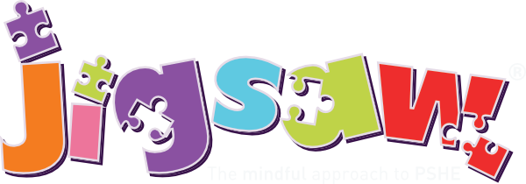 RHSE overview 2022-2023
At Grange View First School, we follow the PSHE Jigsaw scheme which connects Personal, Social, Health and well-being. It is taught at age appropriate level and allows for progression throughout their time in our school.
Autumn 1 | Autumn 2 | Spring 1 | Spring 2 | Summer 1 | Summer 2
Being me in the world  Caring friendships  Respectful relationships  Online relationships  Mental well-being | Celebrating Difference  Caring friendships  Respectful relationships  Online relationships  Being safe  Internet safety and harms | Dreams and Goals  Respectful relationships  Mental wellbeing | Healthy Me  Being safe  Mental wellbeing  Physical health and fitness  Healthy eating  Drugs and alcohol  Health and prevention  First Aid | Relationships  Families and the people who care for me  Caring friendships  Respectful relationships  Online relationships  Being safe  Mental – wellbeing  Internet safety and harm | Changing me  Families and the people who care for me  Caring friendships  Respectful relationships  Online relationships  Being safe  Mental wellbeing

