


GRANGE VIEW CHURCH of ENGLAND FIRST SCHOOL

School Prospectus
2017-2018

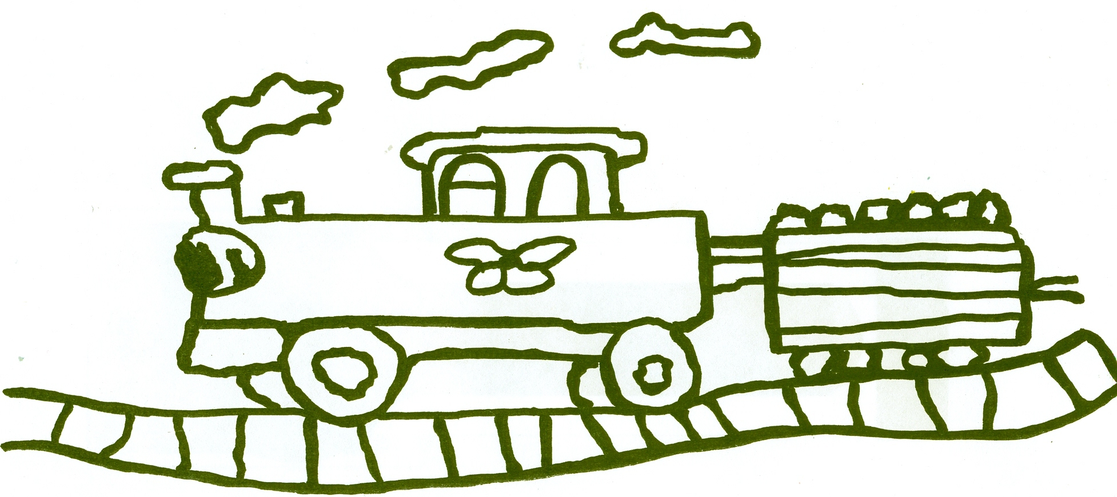

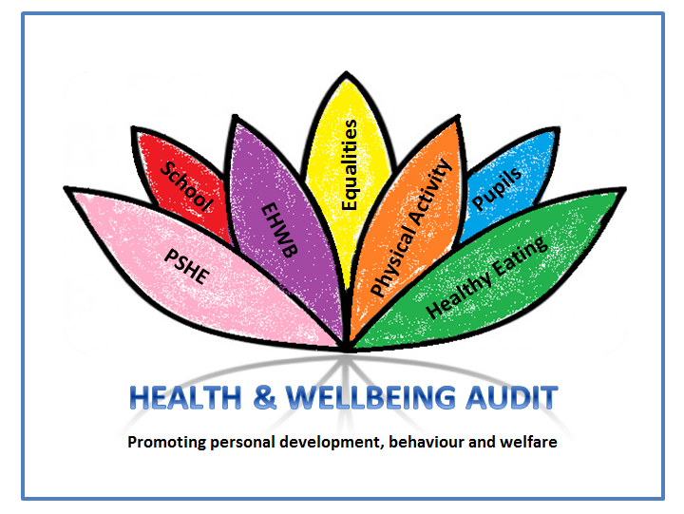


Grange View C.E. First School
Grange Road, Widdrington
Morpeth, NE61 5LZ.
Telephone: 01670 790 686
email: admin@grangeview.northumberland.sch.uk
Headteacher: Mrs Louise Laskey



Dear Parents

It’s my pleasure to share with you some of the unique qualities which make up Grange View Church of England First School. Our school is much more than words on a page; it’s about people and most of all about our children. If this is your first contact, we encourage you and your child to visit us and to find out more about us.
We put children first; they are at the heart of what we’re about. Every child is special. We want your child to feel happy about coming to school, to feel valued and to experience success. All our children are encouraged to take responsibility and to care for others.
You as parents are our partners and we want you to be proud of your school. Many of our parents become involved in school or support us in other ways. Some of our past parents and grandparents continue to be active in school life. The fact is we couldn’t do it without you. If our children go forward with confidence and look back on their time at Grange View knowing it made a positive difference then we as partners have succeeded.
As your child moves through the school, they will be supported and challenged to meet their potential. We place a high priority on effective teaching and learning and enjoy what we do. We teach our children, we learn with them, we talk with them and work hard to make sure that each child knows success, so that school is a positive experience.

Please visit us and you’ll experience first hand the happy, inclusive ethos and excitement for learning that abounds in our school community. I look forward to meeting you and hope you enjoy being part of our school. If this brochure does not answer the questions you want to ask, or you have any concerns then please contact school and I’ll be happy to arrange to see you.

Best wishes,
Louise Laskey
Headteacher

Introduction

This prospectus provides information concerning the school as required by the 1980 Education Act, for parents of pupils who are expected to enter the school from within the catchment area, and also for other parents who wish to know about the opportunities available.

Northumberland Education Committee is responsible for the Education Service in the County of Northumberland, which has a population of some 304,000. Much of the County consists of rural countryside, including high moorland to the west, in which lies the Northumberland National Park and the Kielder Forest, rich agricultural land in the valleys and the coastal plain and an unspoilt coast line of over 50 miles in length. There are also some medium sized market and industrial towns, most other industry being confined to the South-East of the County. Schools in Northumberland are currently organised on a three tier basis of First, Middle and High Schools with pupils aged from 3 - 9, 9 - 13 and 13 - 18 respectively. The school belongs to the Coquet Partnership and children normally transfer at 9+ to Druridge Bay Middle School in South Broomhill and thence to Coquet High School in Amble.

Widdrington Station is an expanding ex-mining village close to the beautiful North-East coast of England and about 80 miles from the Scottish border. The main east coast railway line passes through the village. It is within easy travelling distance of the market town of Morpeth and the conurbations of South East Northumberland and Tyneside. The village is changing rapidly with many new houses and more planned.

The original community school was at Stobswood and the present building was opened in September 1974. It was subsequently extended in 1993 additionally an Early Years Unit was created with DFEE funding. The school has a large hall, spacious classrooms, a library/computer suite, music and resource base, as well as extensive grounds including an adventure play area. Located next to the library, the community centre and the new Health Centre, Grange View is at the heart of the village.

GRANGE VIEW C.E. FIRST SCHOOL

Our Vision – for children and adults to be happy, confident, responsible individuals who enjoy personal success and love learning.

Our Mission

- To provide a welcoming, stimulating and secure environment for all regardless of faith and culture.
- To value all students and staff as individuals and support them to reach their full potential.
- To provide a broad, balanced and stimulating curriculum that meets the needs of all.
- To deepen and enrich the schools relationship with Governors, parents, Community and church.
- To cherish and nurture responsibility for the environment.
- To provide high quality collective worship and opportunities for spiritual development.
- To strive for excellence in all we do.

Our Values

- The ethos of the school is underpinned by Christian values such as honesty, openness, friendliness, trust and respect.

- We aim to SPARKLE!

School Organisation
Our school is organised into three Key Stages

FOUNDATION STAGE Early Years Ages 3 – 4 Reception Ages 4 – 5

KEY STAGE ONE Year 1 Ages 5 – 6
Year 2 Ages 6 – 7

KEY STAGE 2 Year 3 Ages 7 – 8
Year 4 Ages 8 – 9

Chair of Governors  Headteacher  Assistant Headteacher | Ms P Treanor  Mrs L Laskey  Mrs J Herron
Teaching Staff | Mrs J Herron, Miss L Conroy  Miss S Charlton, Mrs L Miller  Miss O Belk, Mrs L Chapman
Office Manager  Higher Level Teaching Assts Teaching Assistants  Teaching Assistant Apprentice  Lunchtime Supervisor  School Kitchen  Caretaker  Cleaner | Mrs T McQuillen  Mrs H Cessford, Mrs R Skinner  Miss M Gray, Miss S Baxter, Mrs G Borley,  Ms R Hepworth, Mrs S Swinney  Miss I Carr  Miss H Jeffrey  Mrs T Palmer, Mrs A Beginn  Mr J Millican  Mrs A Beginn
The school is grouped for the academic year 2017 -2018 in the following way:
Key stage One
Miss Charlton
Mrs Miller
Mrs Borley
Ms Hepworth
Mrs Swinney

School Hours
Early Years
8.45 – 11.45am
12.15-3.15pm
Oak Class
8.50 – 12.00
1.00pm – 3.15pm
Key Stage 1
8.50 – 12.00
1.00 - 3.15p.m.
Key Stage 2
8.55 – 12.10p.m.
1.00 – 3.15p.m.

Early Years
Mrs Herron
Mrs Skinner

Reception
Miss Conroy
Miss Baxter
Key Stage Two
Mrs Chapman
Miss Belk
Mrs Cessford
Miss Gray
Miss Carr

SCHEDULE OF SCHOOL HOLIDAYS FOR THE SCHOOL YEAR 2017/18

HOLIDAY OR OCCASION OF CLOSURE | DATE ON WHICH SCHOOL WILL CLOSE | DATE ON WHICH SCHOOL WILL REASSEMBLE
Teacher Day | Monday 4 September 2017
Summer 2017 | Friday 21 July 2017 | Tuesday 5 September 2017
October Mid-Term 2017 | Friday 20 October 2017 | Tuesday 31 October 2017
Teacher Day | FRIDAY 27 October 2017
Teacher Day | monday 30 October 2017
Christmas/New Year 2017/2018 | Friday 22 December 2017 | Tuesday 9 January 2018
Teacher Day | monDAY 8 january 2018
Spring Mid-Term 2018 | Friday 9 February 2018 | Monday 19 February 2018
Teacher Day | FRIDAY 16 FEBRUARY 2018
Easter 2018 | Thursday 29 March 2018 | 16 April 2018
May Day | Monday 7 May 2018
Summer Mid-Term 2018 | Friday 25 May 2018 | Monday 4 June 2018
Summer 2018 | Friday 20 July 2018 | Tuesday 4 September 2018
Teacher Day | Monday 3 September 2018

Important Information
Research suggests that children who are absent from School may never catch up on the learning they have missed, which may ultimately affect exam and test results. As a parent/carer you can demonstrate your commitment to your child’s education by not allowing your child to miss school for anything other than an exceptional and unavoidable reason.
The Education Act (1996) requires parents to ensure their child attends school regularly. The Education (Pupil Registration) (England)(Amendment) Regulations 2013 states that Headteachers may not grant leave of absence during term time unless:
- An application has been made in advance to the Headteacher by a parent with whom the pupil normally lives with: and
- The proprietor (Headteacher) or person authorised by the Headteacher considers that leave of absence should be granted due to the exceptional circumstances relating to that application.

The Head Teacher must be satisfied that there are exceptional circumstances to justify an authorised absence. It is the parents’ responsibility when submitting the request to provide all the information and evidence to prove this.
GRANGE VIEW FIRST SCHOOL DOES NOT AUTHORISE ANY HOLIDAYS DURING TERM TIME.
The request for authorised Leave of Absence must be made at least two weeks in advance and the Head Teacher may invite the parent/carer(s) into school to discuss the request before a decision is made.
If the Head Teacher authorises the Leave of Absence it is expected that the child’s attendance will be of a satisfactory level both prior and after the date covered by the request.
If the Head Teacher refuses Leave of Absence and the absence is recorded as unauthorised, the Head Teacher may refer the matter to the Local Authority requesting that a Penalty Notice be issued.
All schools in the Coquet Partnership have agreed that if an unauthorised leave of absence is taken during term time and the pupil’s attendance in the 12 month period leading up to the leave of absence is less than 90% (the equivalent of nearly 4 weeks of school)
Children who attend school every day:
- Have the best chance of achieving well
- Are more settled
- Develop good work habits for the future
- Are better prepared for learning often enjoy school more.
Children who often miss school or are late:
- Miss important learning
- Can feel left out
- Develop poor work habits
- Suffer from low self esteem
- Are often unsettled
- Can find it hard to catch up
- Find it hard to be prepared for learning.
- Miss key concepts, special events, trips and visits.

Why Choose our School
Quotes from OFSTED
“Pupils are happy, feel secure and respond well to the work they are given. Their behaviour is good, they are sensitive to others and their sense of community is bolstered by their involvement within the school and locality”

“The forest School Activity is instilling in pupils a healthy respect for the environment”

“All groups of pupils, including those with special educational needs and/or disabilities achieve equally well”

“Good curricular experiences and the pervasive Christian ethos give pupils a sense of belonging and raise their self-esteem, thus benefiting their spiritual development.”

We offer a Broad and Balanced Curriculum

The school provides a broad and balanced curriculum focusing on the development of the whole child and equipping them with the skills needed to succeed in the global community we now live in. The curriculum is planned and delivered through a creative approach, maximising opportunities for independent learning and development of key skills.
Every opportunity is taken to enhance the curriculum

Curriculum Provision and Agreements for Pupils with Special Educational Needs
We aim to create a positive environment for learning and we provide individual differences within the classroom, adapting our teaching methods through careful selection of a range of teaching materials.
Where particular learning difficulties are identified, the children are placed on our Special Educational Needs register. Parents are informed and asked to visit the school to discuss their child and the provision which will be made for him/her within the classroom.
Individual Education Plans are drawn up with the co-operation of parents. Specific targets are set and reviewed regularly as laid down by the Code of Practice.
If it is thought necessary, parents’ permission will be sought to involve outside agencies such as the Educational Psychologist, Speech Therapist or other medical services. If a formal assessment is required to be made, parental consultation takes place at every stage.
Religious Education and Collective Worship
Grange View C of E Primary School is a Church of England Voluntary Aided School. The Religious Education Syllabus is taken from the Northumberland Syllabus as well as aspects of the Newcastle Diocese Syllabus.
All parents have the right to withdraw their children from religious education. If you wish to withdraw your child please contact the Head Teacher so that alternative arrangements can be made.
The legal basis for Collective Worship is in accordance with the principles and practices of the Church of England and fulfils the requirements of the 1988 Education Act. In our school Collective Worship is placed at the centre of the school’s daily life. Worship is organised and led by staff, visitors and pupils. All parents have the right to withdraw their child from Collective Worship; if you wish to withdraw your child please contact the Head Teacher so that alternative arrangements can be made.
Withdrawing a child from Religious Education or Collective Worship cannot guarantee exclusion from the religious character of the school, and the Governors hope that in choosing a church school, parents are thereby committing themselves to their child’s participation in the religious life of the school.
Relationship and Sex Education
The 1998 Education Act requires Governing bodies to decide whether sex education should be part of the curriculum and to make and keep up to date a written policy. The Governing Body of this school passed a resolution to include sex education within the curriculum of this school. Section 241 of the Education Act 1993 gives parents the right to withdraw their children from any part or all of the School’s programme of sex education, other than those elements which are required by the National Curriculum Science Order.

Admissions

Arrangements for Admissions and Induction

Children starting school for the first time are admitted in the term of third birthday falls, providing places are available. The Early Years currently have places fifty two pupils.
Children then move into our Reception class in September (in the school year in which they reach five years old). In the case of over subscription to the school the admissions criteria will be applied. Please see our website for full details of the admission procedure, criteria and appeals process.

Arrangements for Pupils with a Disability

At Grange View we welcome applications for school places from any interested party.
No pupil will be refused admission to the school purely on grounds of disability, unless it was thought the school could not provide the best educational environment for the child, following discussions with the Diocese, the Local Authority and all parties concerned.
Grange View C. of E. First School is a single storey building. Disabled toilets and showers are available. We have an Equal Opportunities policy, which is in place and reflected throughout the school. The school’s accessibility plan details future plans for increasing access to the school by pupils with disabilities.

Children moving through the school
Reception and Year 1 teachers work closely together on a structured induction programme to ensure a smooth transition between Foundation Stage and Key Stage 1. This will involve staff from Reception and Year 1 meeting and working with the children.
Year 2 and Year 3 teachers work closely together on a structured induction programme to ensure a smooth transition between Key Stage 1 and Key Stage 2. This will involve staff from Year 2, 3 and 4 meeting and working with the children.

Children transferring to and from other schools
Parents moving into or out of the area should notify the Head Teacher as soon as possible so that arrangements can be made for the children to visit their new school and for transfer of books and records.
Year 4 follow a structured transition programme which includes a visit from the head of Year 5 and a one day visit to their chosen Middle school.

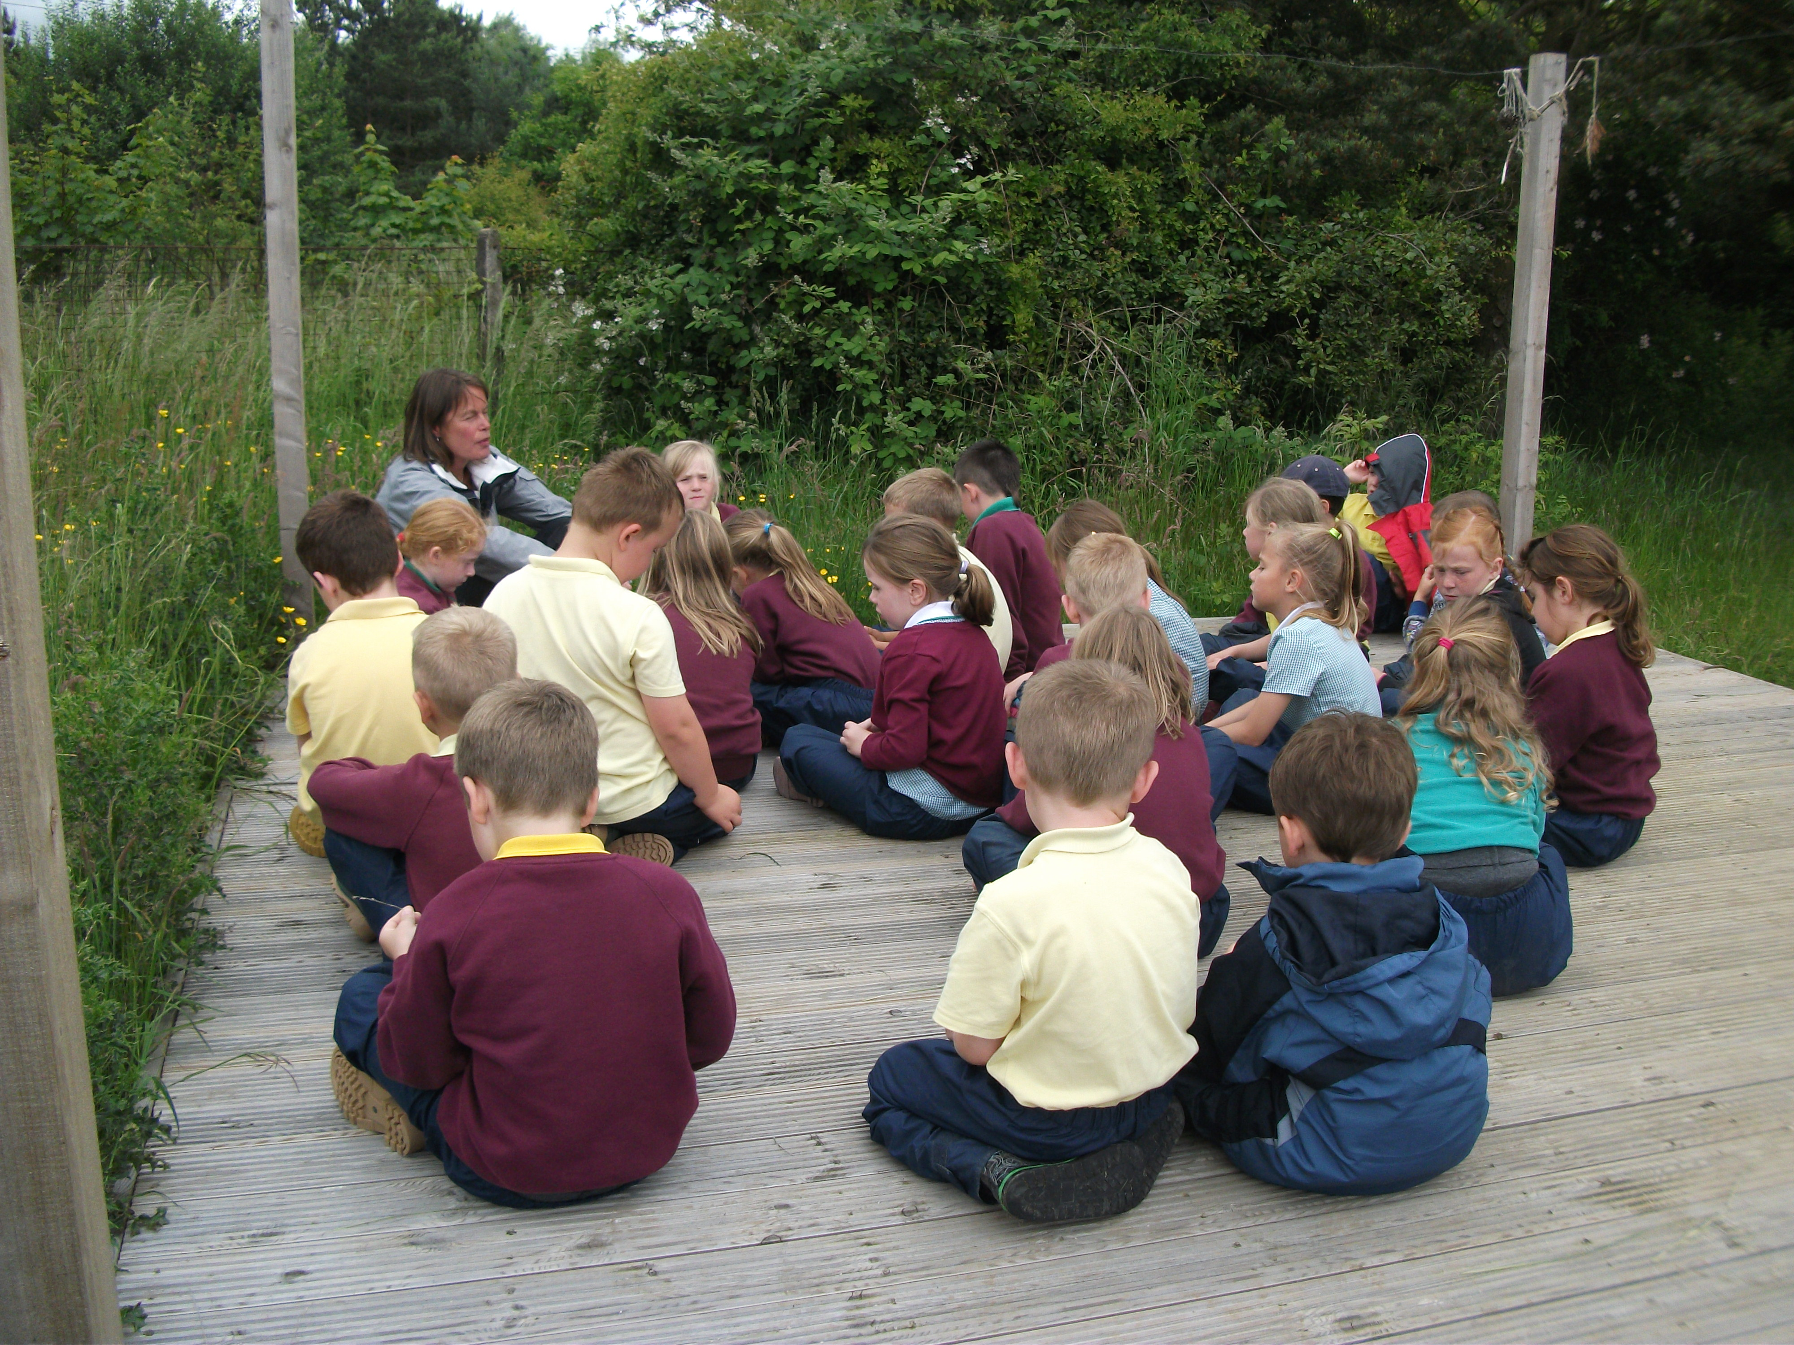
Our Learning Environment

Grange View First School has undergone quite a transformation over the past 5 years. Extensive refurbishment and reorganisation both inside and out means we have excellent and spacious facilities.

The Foundation Stage area overlooks the playing fields and wildlife garden. There is an enclosed quadrangle and a more extensive fenced area for outdoor learning and play. More recently we have developed an outdoor play area and have a new purpose built climbing frame and sand pit.

There are 3 classroom bases for children in years 1 to 4, a resource base which is used for music tuition and other lessons. The new well stocked library area and ICT suite are situated just off the hall.

Administration and staff areas are close to the school main entrance. A new and safer entrance to the Early Years area of the school has been created. Security is high on our list of priorities.

We have a cycle/scooter canopy. Many of our families cycle to school. We also have an adventure playground facility.

We make good use of the environment outside the school enhancing the learning opportunities for children. We have a Forest School and all classes access the Forest area on a weekly basis.

Class Organisation

We currently organise the school as such:
- Early Years – Nursery
- Oak – Reception
- Key stage one – Y1 and Y2
- Key stage two- Y3 and Y4
- These are the registration classes.

The children mostly stay in their class groupings except for some creativity sessions and sporting activities.
Foundation Stage (age 3-5)

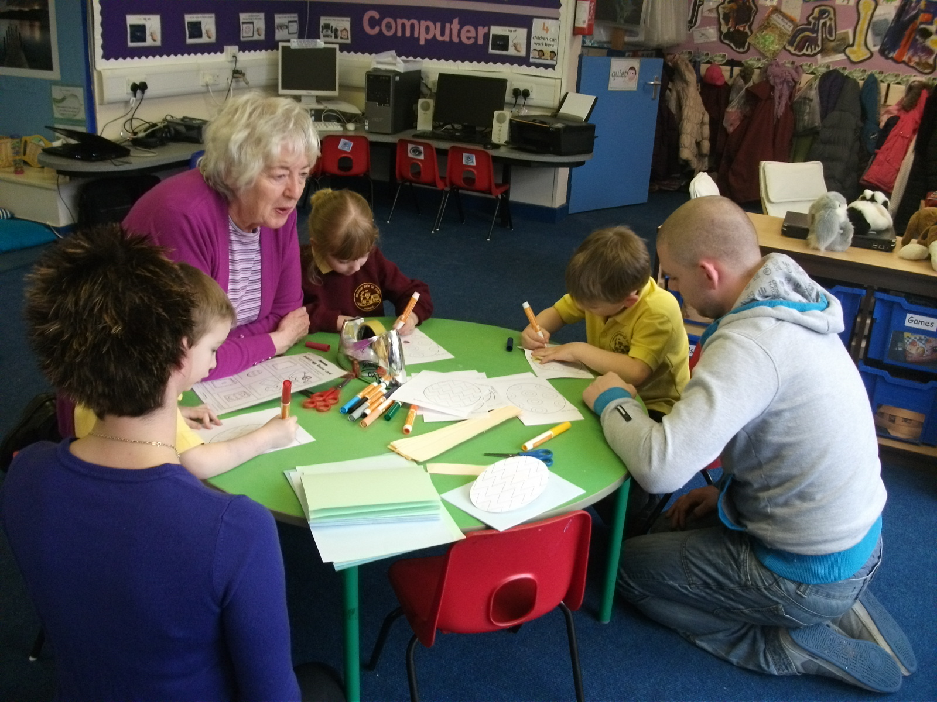
Children are usually admitted to our Early Years Unit the term of their 3rd birthday. We work closely with parents and carers in deciding the best options for individual children. Most children attend five half day sessions. In the September of the school year in which children will reach their 5th birthday, they attend full time.

Our Early Years Unit is staffed by two teachers a Higher Level Teaching Assistant and Teaching Assistants with the appropriate ratios of staff to children. Additional support is provided for children with special needs. Our support staff are very well qualified, partaking of our own professional development programme as well as accessing national training. They plan and assess closely with our teachers and local authority support staff. We place a high priority on providing a good adult / child ratio and take pride in the quality and breadth of support we provide for our children and each other.
The Foundation Stage Curriculum is organised into seven areas of learning:

- Personal, social and emotional development
- Communication and language literacy
- Mathematical development
- Literacy
- Physical development
- Creative development
- Knowledge and understanding of the world

Our Early Years Team
- plan and resource a challenging environment extend and support children’s spontaneous play
- extend and develop children’s language and communication in their play
- support children’s learning through planned play activity

We are very proud of our approach to Early Years education. Please see our separate Early Years brochure.

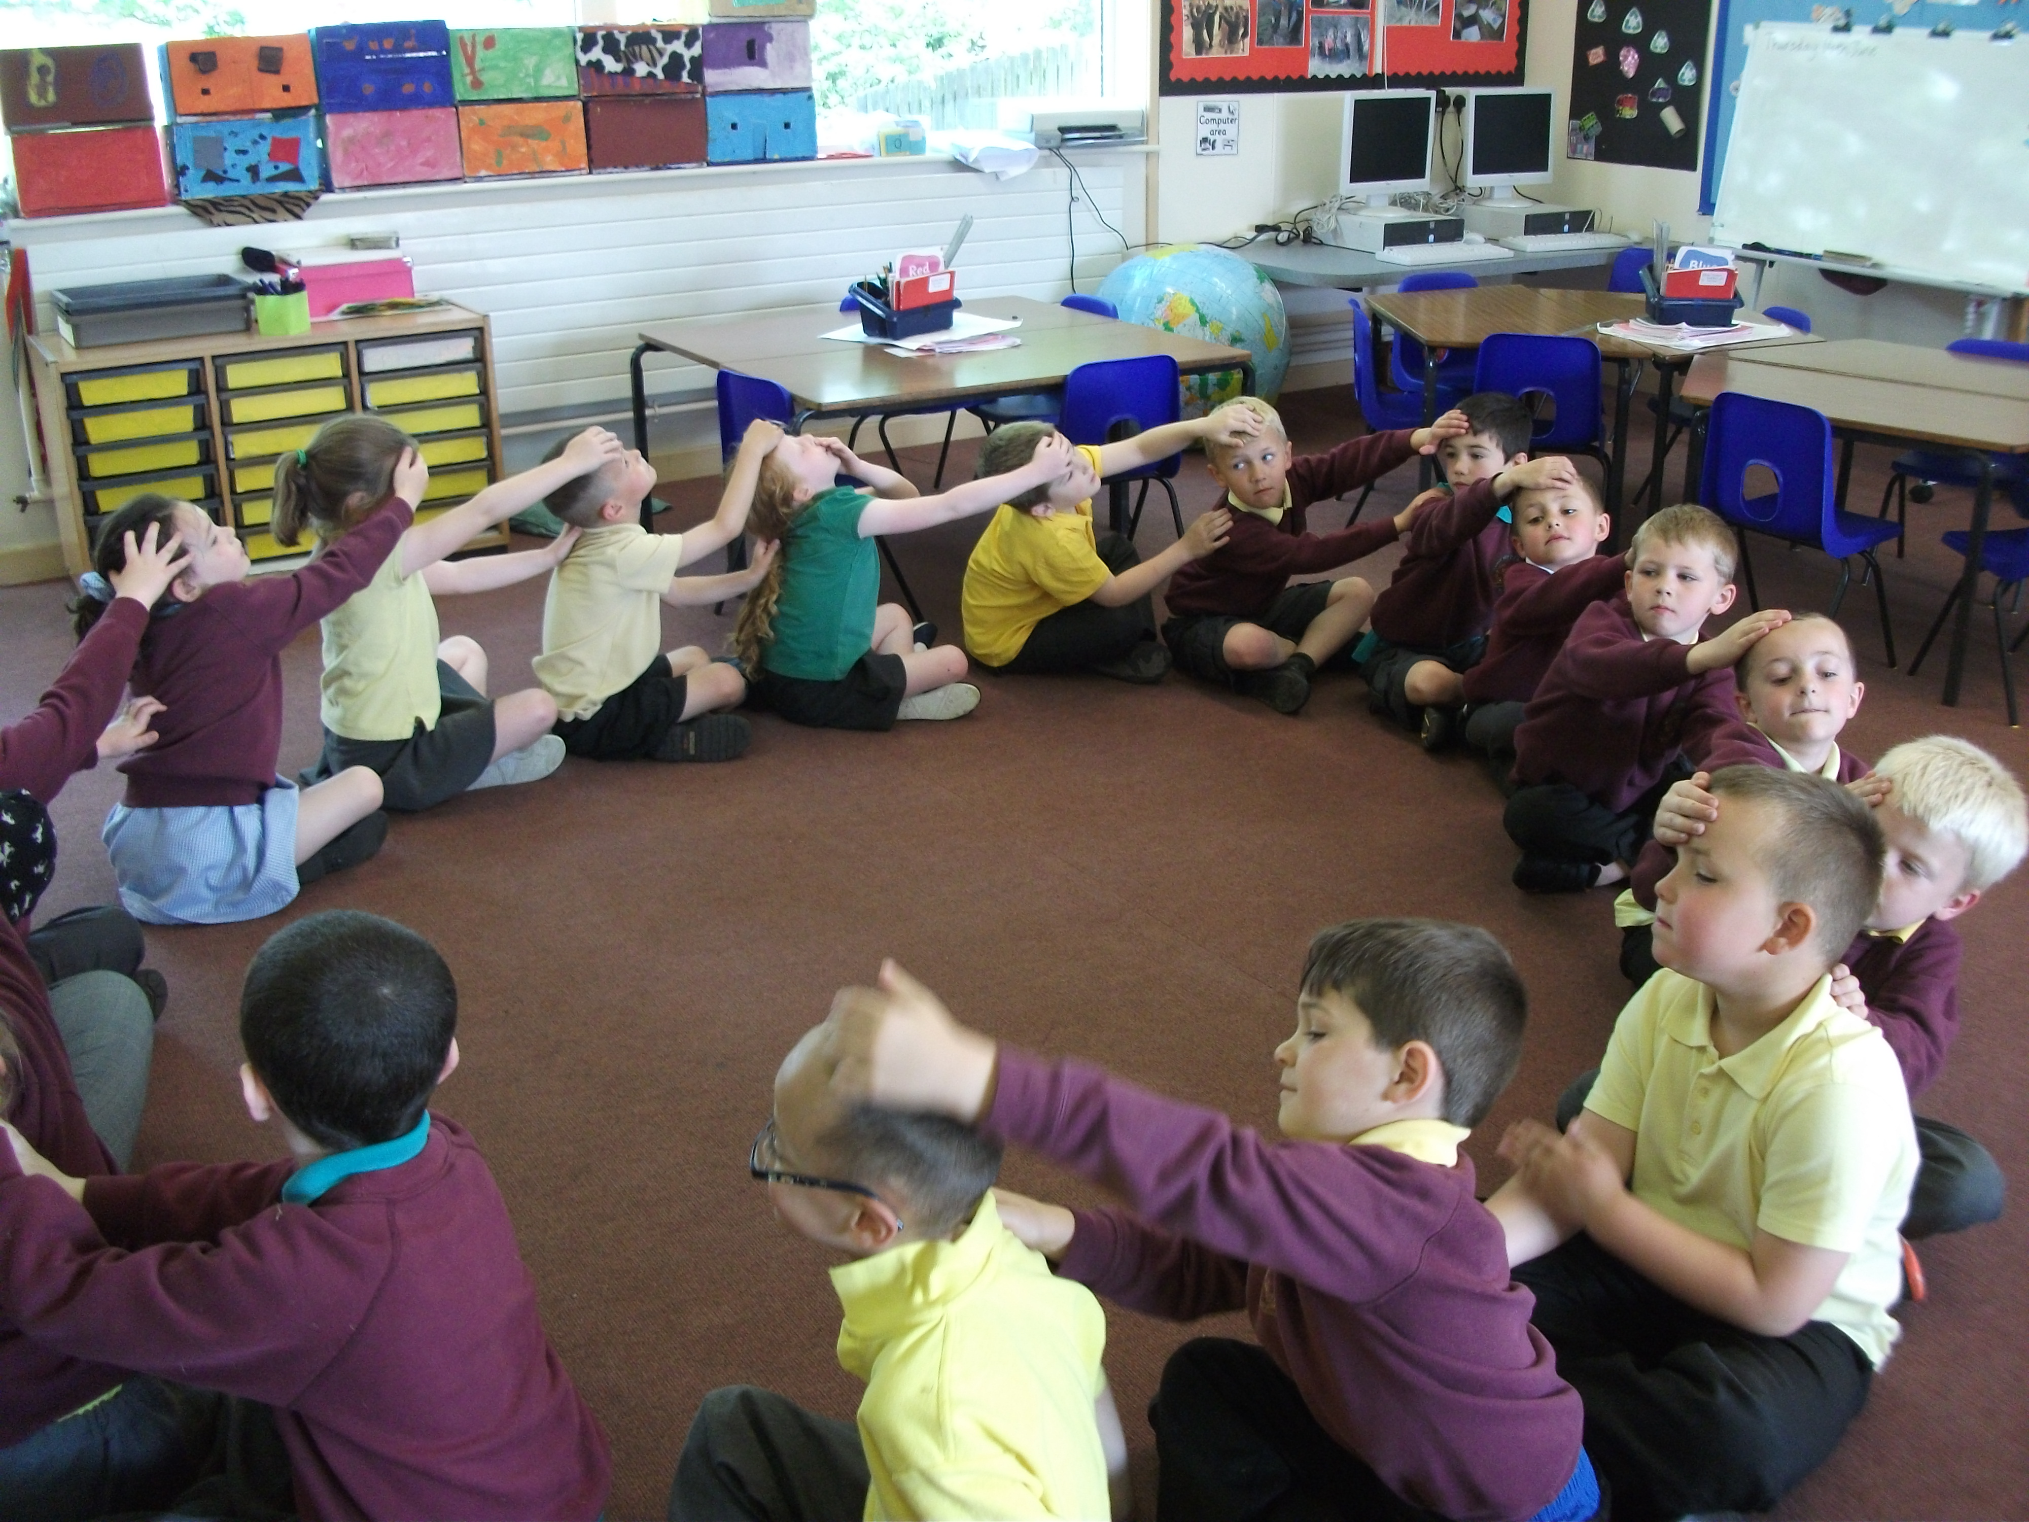
Key Stage 1(age 5-7)
And
Key Stage 2(age 7-9)

The Foundation Stage Curriculum prepares
children for the next steps – that is The
National Curriculum at Key Stages 1 and 2.
Teachers in all three key stages work together
on learning and teaching developments, ensuring
a shared approach and consistency of practice. We
plan for transition between classes and key stages. Staff working across key stages and whole school times ensure children are secure with school layout as well as the adults in school. We also work closely with local services and our feeder school, James Calvert Spence College.

The Curriculum

Grange View First School delivers the core subjects of English, mathematics and science in addition to the foundation subjects, history, geography, physical education, art and design, music, design technology, information and communication technology (ICT) and religious education. These are taught in line with the statutory requirements of the New National Curriculum 2014. We have currently revised our whole school curriculum in line with the guidance from the Department of Education.

We engage children through a curriculum that takes account of their learning needs; one which challenges and excites their imaginations whilst developing sound basic skills. Through constant monitoring we ensure the curriculum is broad and balanced, relevant, inclusive and well planned. We encourage creativity, and plan in a cross curricular way so that learning is more memorable, this includes themed days.

In school you will see children learning through enquiry, through play, indoors and outdoors, in whole class and small groups, through sport, music, drama and art and through using computers. In all cases teachers set clear learning objectives which are shared with the children, allowing each child to experience success and setting the foundations for life-long learning.

At the heart of our curriculum are the core skills of literacy and numeracy.
English

Our language is our most important means of communication and runs across the curriculum. We teach and support our children in developing skills in speaking and listening, reading and writing. We help them to express themselves imaginatively and to communicate effectively.

We want our children to read well, to be enthusiastic and critical readers of stories, poetry, drama and non-fiction texts. In this way they can feel confident about their learning and get pleasure from the world of books. In the past two consecutive years we have won the Reading Challenge in association with the Library Service.

From the earliest stages of beginning writing children’s efforts are valued and we plan carefully to move them towards independence. A clear and legible cursive style of handwriting is taught, and children are given opportunities to write for a range of audiences in a variety contexts, including both fiction and non-fiction. Spelling and punctuation are taught specifically and in context.

Mathematics

Our approach to mathematics helps children to develop and use their knowledge and skills to problem solve. From their earliest days in school children develop their mathematical knowledge and understanding through practical activity, exploration and discussion.
As they progress through the school, children experience an increasing range of mathematical situations in different contexts.


Science

Science and scientific ways of thinking are directly relevant to us all and help us to make sense of our everyday lives. We make science as ‘hands on’ as possible with practical activities relating to materials, sound, light, electricity and living things. Across the school, children are encouraged to ask questions, to plan investigations and to talk about and record their observations, moving towards drawing conclusions from their findings. Sometimes these investigations take place outside in the school grounds or on field trips.


Information / Communication Technology

I.C.T. equips children with the vital skills to take part in a rapidly changing and increasingly technological world. Children use a range of I.C.T. tools to find, explore, analyse, exchange and present information and communicate ideas in different forms. ICT is taught separately and is embedded in other curriculum subjects. Each classroom has a designated area with computers, appropriate software and internet connections and an interactive white board.

In the library is our ICT suite which is accessed by all children. We have several interactive whiteboards as well as digital cameras, i-pads and have just invested in a set of 15 new laptops to use across the school.

Geography

Geography helps us to find out about the natural and human world. We use an enquiry approach to study people, places and environments. The children explore through first hand experience and observation whenever possible, developing a range of skills including mapping and problem solving skills. This approach helps children to make sense of their surroundings and the wider world. They develop a responsible attitude to our role in the world as well as to environmental issues.

History

A study of history helps children understanding of how the past has shaped the present in which they live. They learn of ways in which the past is different to the present and about important events and people as well as local history. As they do this they develop an understanding of time, customs, beliefs and traditions, initially through looking at their own development and that of their family. We take full opportunity of the rich heritage that surrounds us by organising educational visits.

Art and Design

Art and design is about stimulating creativity and imagination. It provides a range of experiences and a unique way of responding to the world. Children communicate what they see, feel and think, using colour, form, texture and pattern in many materials and two or three dimensions. The work of artists, craftspeople and designers is studied and appraised. Children are encouraged to reflect upon their own work. We have also had extensive input from an Artist in Residence.

Music
Music promotes concentration and memory and helps with the development of co-ordination. Singing songs and word patterns are known to increase reading facility in young children. All the children take an active part in music making as composers, performers and listeners; they sing, dance and move, improvise, record, notate and talk about their own and other people’s music.

Design Technology

“Design technology is about making things that people want and that work well”. – James Dyson
We encourage children to look for needs and to respond creatively. They solve problems individually and as part of a group and are taught to use equipment correctly and safely. We equip them with the practical skills they need to implement their ideas.

Physical Education

We place a significant emphasis in school on promoting physical health and well-being, through the P.E. curriculum, extra curricular activities and after school opportunities. We aim to provide children with as wide an experience of sporting activities as possible. We have recently been awarded the PE Active Mark, and as a member of a Sports Partnership we access expert tuition and support. We offer a curriculum that includes at varying times gymnastics, dance, games athletics and swimming. Such activities promote the development of skills, control and co-ordination.

Personal, Social and Health Education and Citizenship

The development of children’s self esteem and emotional well-being is an integral part of our school ethos. We help our children to develop confidence in their relationships as well as the knowledge, skills and understanding they need to lead confident, healthy, independent lives. We encourage them to make the most of their abilities and to be responsible citizens within the school and their community.

Sex and Relationship Education

Sex education is taught in the context of healthy growing bodies, relationships, RE and the statutory requirements of the science national curriculum. Parents have the right to withdraw their child from any part of sex education that is outside the compulsory requirements of the curriculum. We invite you to discuss this with the headteacher.

Special Educational Needs

All children at Grange View have the right to a broad, balanced, differentiated and relevant curriculum, regardless of gender, race or educational ability and we encourage each individual to achieve success. We define a child as having Special Educational Needs when his/her learning, emotional, behavioural or physical needs are significantly different from those of the majority at any given time.

The Code of Practice has been developed to identify and assess Special Educational Needs. It gives clear guidelines on the identification, assessment and provision for Special Educational Needs and through this children’s special needs are identified at the earliest opportunity. Individual programmes are devised which may involve working individually or in small groups within the class or other parts of the school. Children’s progress is carefully monitored.

We have excellent working partnership with a range of other professionals including the Educational Psychologist, Speech and Language Therapist, School Nurse and Health Visitor. We ensure that procedures and practice for statement/EHCP pupils satisfy statutory requirements and parents / carers are consulted at every level.

Pastoral Care: Grange View Buddies

We’re really proud of our Buddies. All Year 4 children can apply and go through the interview process to become a buddy: their role is to assist other children in building up friendships. We support our children in developing the skills they can use to promote positive relationships and solve conflict at play and lunch times.

Assessment and Recording
The school keeps records for all pupils. Children are continually assessed by the class teacher in terms of their learning and personal development and at key times of the year children are tested in each year group. Children are assessed on entry to nursery and at the end of the Foundation Stage using the new Early Years Foundation Stage Profile. Statutory national testing takes place at the end of Year 2 as well as Phonics screening on Year One. Results of tests and ongoing assessments are used to plan future learning, to ensure children are making expected progress and to identify those needing extra support or extension. This information is available in school for parents to view and of course is discussed at length in parent interviews.

Reporting to Parents

Individual parent interviews are offered in the Autumn and Spring terms, and reports are sent home yearly in the summer term. In Year 2 these include the results of national tests (SATs). At interviews we share with you your child’s learning targets and keep you up to date with progress towards these targets. Parents are however invited to consult teachers about their child’s progress whenever they feel the need. In addition each year we offer parents the opportunity to join us to find out about what we are in more detail. We also host parenting workshops and open days where parents have the opportunity to see their child’s work and classroom.

Home / School Links and Homework

We value our relationship with parents and believe that by working together we will develop a home school partnership that will enhance children’s learning. Children learn best when home and school work together and we keep parents / carers informed about the work going on in school. We have a homework policy in place and parents are consulted regularly for their opinion.

How you can get involved
We have lots of “helpers” in school, but we’re always ready to welcome anyone who feels they have something to offer. Most are parents /carers, although we also have community members, and grandparents who often started helping when they had their own family members in school, but have stayed on.

Helping can be what you want it to be – in the classroom, supporting groups or individual children, reading, changing books, doing craft work, joining with school trips and visits. Not everyone is able to help in school time and some parents help with fundraising, or sewing and decorating.

All helpers have to have Criminal Records Clearance. Please see the office manager if you would like to apply for clearance.

Friends of Grange View

The “Friends Association” is a way that community members as well as parents can be involved in supporting the school. We have been pleased to receive extra funds through their very hard work, people support us in many different ways. In recent years we’ve had extremely successful Christmas Summer and Easter Fairs, Film Clubs and Discos. As a result we have provided craft equipment, a lockable computer trolley, a themed bin and we have been able to subsidise trips out of school and pay for a performance in school by a Theatre Group.

Uniform

All children are expected to wear our school uniform, as it is both practical and inexpensive, and gives the children a sense of belonging. Items can be ordered and purchased from the school office.
Our uniform consists of:

- maroon sweatshirt, cardigan or fleece Maroon T.shirt for PE
- yellow polo shirt
- dark grey trousers, skirt, pinafore
- Yellow gingham dresses in summer
Children are expected to wear sensible shoes at all times

P.E. Kits

All children must bring a a P.E. Kit to school. This should include sandshoes, a t-shirt and jogging bottoms/ shorts. Trainers for outdoor use and a sweatshirt are also useful.

Jewellery

Jewellery is not permitted to be worn in school for Health and Safety reasons, with the exception of Stud earrings if the ears have been recently pierced. If this is the case, the earrings must be covered up to avoid accidents on days when there is P.E.
Earrings must be removed for swimming before the child comes to school. The school does not accept responsibility for any damage or loss of jewellery.

Photographs

After consultation with Parents, we do not allow photographs to be taken of children in school, or at school organised events other than by staff or authorized persons. Parents have the opportunity to withdraw their child from having any photographs taken in school. We have a photograph policy in place.

After School Clubs

The School offers a variety of After School Clubs during the school term. These include:
- Drama
- Football
- Dance
- Singing
- Karate
- Messy Church

Swimming

Every week, throughout the school year, Years 3 and 4 are taken for swimming lessons to Morpeth Leisure Centre.

School Meals

We have an excellent catering service in school, all food is prepared on site and healthy eating is encouraged. Children who stay for lunch are supervised by the supervisory assistants during the lunchtime period.
Pupils who choose to have a school meal should pay for these on a MONDAY MORNING. We accept cash or cheques. Those families in receipt of Income Support are entitled to Free School Meals. Application forms are available from the school office.
Parents/Carers are regularly invited across the year to sample our school meals. Menus are available on the school website and theme days area regular event.

Fresh Fruit And Milk

All pupils in KS1 receive a piece of fruit each day. Milk is available to all pupils at a small charge, and free to those in receipt of free school meals and under 5’s.
Safeguarding

The school takes its responsibility to “Safeguard the Child” very seriously. We work in close partnership with other agencies. If we ever have a concern regarding a child’s well-being, we will log that concern in school, talk to parents and possibly refer the concern to another agency such as Children’s Services.
Should parents ever have any worries about a child in school, they should talk about them with the Headteacher.

E-Safety

Children should be encouraged to use the internet as much as possible but at all times in a safe way. Parents are asked if they agree to their child using the internet. Pupils must never be left unattended whilst online and teachers should ensure that this does not happen. If teachers know of misuse, either by a teacher or child the issue should be reported to the Headteacher without delay. As Child Protection Officer the Headteacher has overall responsibility for internet safety.

Complaints Procedure

It is the aim of the Governors and staff of the school to provide the best possible education we can for the children in our school. Any concerns should be discussed with the Headteacher in the first instance. The school operates a complaints procedure, details of which can be obtained from the office.

Helpful Addresses & Community Contacts

Chair of Governors: Ms P Treanor
c/o Grange View CE First School, Grange Road, Widdrington, Morpeth NE61 5LZ

Clerk to the Governors:
Director of Education, Northumberland County Council, County Hall, Morpeth, Northumberland, NE61 2EF. Tel. 0845 600 6400

Widdrington Library:

Grange Road, Widdrington, Tel: 01670 791548

Area Training and Activity Centre:

David Mather House, Mile Road, Widdrington, Tel: 01670 791808

Widdrington Clinic:

Grange Road, Widdrington, Tel: 01670 790229

Health Visitor:

Bryony Trafford Tel: 01670 790316

The details in this booklet are correct at the time of publication

