

**Grange View C.E. First School**   
Grange Road, Widdrington  
Morpeth, NE61 5LZ.

Telephone: 01670 790 686email: [admin@grangeview.northumberland.sch.uk](mailto:admin@grangeview.northumberland.sch.uk)

Headteacher: Mrs Louise Laskey

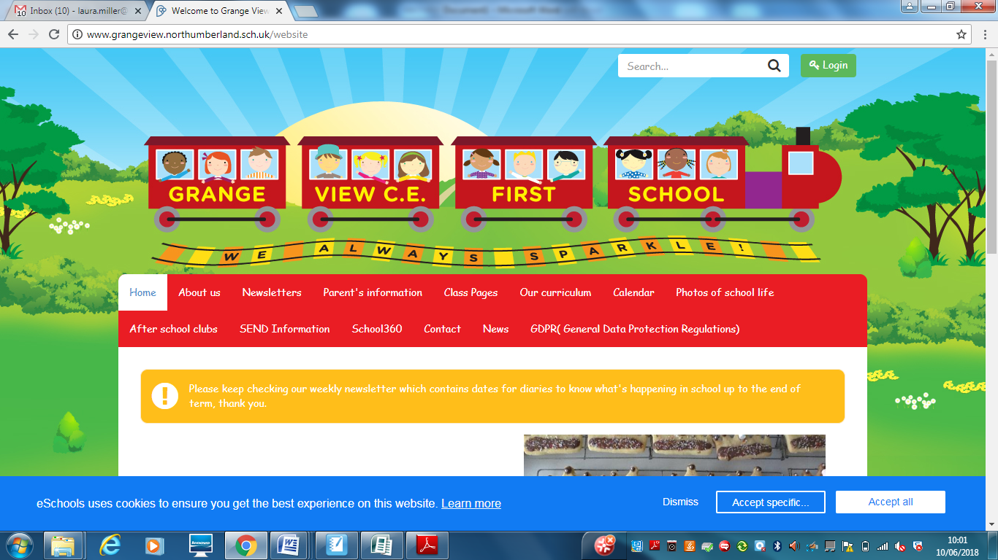

***We aim to SPARKLE!***

**Dear Parents / Carers, 8th Oct 2021**

**WEEK beginning 18th Oct**

**We would like to welcome back parents on to the playground to drop off and pick up. (8.50am & 3.10pm)**

**All parents to maintain social distance while dropping off and picking up. You are all welcome to wear a mask on school site during this time if you feel safer doing so.**

* Nursery normal drop off and pick up at Acorn doors (8.30am & 11.30am)
* Oak class meet Miss Adams and Mrs Tait on main yard and line up together
* Elm meet Miss Darlow on main yard and line up together
* Beech meet Mrs Chapman on main yard and line up together
* Willow meet Miss McQuade/Mrs Timmins on main yard and line up together

Parents please stay with youngest sibling while lining up on arrival Mrs Laskey and Mrs Cessford will circulate to support. Parents to pick up youngest sibling first and then collect any older brothers and sisters last.

**All Parent to collect from the class doors. Elm class door around side of school next to old outdoor play area**

**Vacancies**

<https://www.northeastjobs.org.uk/job/Office_Manager_Administrator_Grange_View_C_E_First_School/214026>

<https://www.northeastjobs.org.uk/job/Teaching_Assistant_Level_3_Band_4_/213420>

**HARVEST**

Our Harvest Service in school was amazing and we would like to thank you all for the kind donations for the local Widdrington Food Bank. Please see school Facebook page for photos. Thankyou.

**Trident Soccer – October Half Term – Alnmouth**

Trident Soccer is running a half term holiday club in Alnmouth. If anyone is interested please let the office know and a form will be sent home.

**PE Uniform**

Please can all parents ensure your child has the correct school PE kit, we have plenty in stock and spares for children to use if needed. Thankyou

**PTA- The Friends of Grange View NEED YOU !**

The Friends of Grange View desperately need your help and support to run, organise and think of new fund raising ideas and events for the school. Mr Guy and Mrs Chapman cannot do it all on their own. Please let us know if you can spare some time to help us.

On Friday 22nd Oct the Friends will be holding a NON Uniform day for donations of sweets and bottles for the Christmas Raffle.

**WALK TO SCHOOL MONTH**

This October is International Walk to School Month – an opportunity for children to join hundreds of thousands of pupils across the globe celebrating the walk to school. Please support this by walking to and from school every day in October. Thankyou

**School Individual Photos**

We have managed to secure a photographer to take individual school photos ready for Christmas presents this year. Thursday morning 21st Oct they will be in school to take every child’s photo. They will ensure all siblings in school are taken together as well. Please can you let us know if you would like your child photographed with their younger/older sibling who doesn’t attend this school and this will be from 8.30am.

**Water Bottles**

Please can we remind all parents that we are a heathy school and only plain water is allowed in your child’s water bottles in the classroom. If your child brings a packed lunch they can bring juice or flavoured still water at lunchtimes.

**School Lunches**

Thankyou to all the parents have signed up to the school meal service. Mrs Palmer serves 3 roast lunches each week plus Pizza, Pasta, chicken curry (which the children love) plus many more meals. We are happy to be flexible for you and if you would like your child to have school lunch on another day each week then Mrs Palmer is happy to serve this. So you could choose to give your child a school lunch every Friday. It is £11 per week or £2.20 per day. Reception, Year 1 and 2 receive universal free meals.

****Please apply for Free school meals if you think you meet the criteria as this would entitle your child to a free school lunch, free milk and many more other benefits in school.

The link to apply is: https://www.northumberland.gov.uk/Education/Schools/Meals.aspx

**Morrisons -"It's Good to Grow"**

They are giving away free gardening equipment for schools and nurseries.

On Monday 6th September they will launch "It's Good to Grow". The programme aims to encourage children to get outdoors and get growing, helping them to understand where their food comes from and how to grow their own fruit and vegetables, in order to make healthier food choices now and in the future.

To take part, customers just need to have a My Morrisons account and everytime they swipe when they shop they'll collect Grow Tokens.

How does this work?

● Between Monday 6th September and Sunday 24th October for every £10 spent in store or online, customers

will get 1 Grow Token which they can donate to their chosen school or nursery

● Customers will use their My Morrisons app or card when paying to collect their Grow Tokens

● Customers can select the school or nursery they’d like to donate their tokens to within their My Morrisons account

● From 1st November schools will be able to redeem their Grow Tokens against a wide variety of gardening equipment

● Schools will start receiving their order between the end of January and the end of March.

**PLEASE SUPPORT US WITH THIS CAMPAIGN- THANKYOU.** We would like the children to help maintain our school garden every Friday afternoon and grow our own fruit and vegetables again.

**\*\*\*\*New Diary Dates- more to follow\*\*\*\***

Mon Oct 11th - Parents consultation calls over 2 weeks

Thurs 21st – School Photographs

Fri 22nd Oct- NON UNIFORM for Sweet and Bottle donations please

Fri Oct 22nd – Half term

Mon Nov 1st – School reopens

Fri 12th Nov – Children in Need – info to follow

Wed 8th Dec- NO SWIMMING –Reception to Y4 Panto visit

Fri 10th Dec – Early Years Panto

Tues 14th – Christmas party - Early Years am

Wed 15th Dec- Flu Jab morning Reception- Year 4- NEW DATE!

Thurs Dec 16th – Christmas Jumper and lunch day

Fri Dec 17th – Y1/2 party and Y3/4 Parties am. School closes at 1.30pm

Training Days 2022- 4th Jan and 28th February

**Applying for your Middle School place:**

It's that time of year again where the admissions portal is open for the 2022 admissions round. The Portal will open on Sunday 12th September for all Secondary, Middle and High Phase changes.  The deadline for applications is the 31st of October. It is very important you make your application on time.

**Reception applications:**

The Reception application Portal will open on 1st November and close on 15th January 2022.

**September uniform**

Following our school uniform policy your child will be expected to wear the following:

A school sweatshirt / cardigan in the correct colour

Yellow polo shirt

Grey trousers / skirt / pinafore or yellow gingham dress

All black school shoes with no logos

A school PE t-shirt with black shorts or joggers.

We have lots of clean good second hand for anyone who needs it and we will keep spares for any child who turns up for school in the wrong uniform.

**JEWELLERY- NO EARRINGS.**

**No Jewellery for swimming lessons for health and safety reasons .**

PE's Health and Safety guidance states- “Schools have a duty of care to ensure students are able to participate actively without unnecessarily endangering themselves or those working around them. A clear and consistently applied policy for the removal of personal effects should be in place. The Association for Physical Education (afPE) strongly recommends the practice of removing all personal effects at the commencement of every lesson to establish a safe working environment. This applies to all ear and body piercings, including retainer and expander earrings.”

***Please ensure all jewellery is removed before all PE lessons at home or can your child remove them on their own. We would strongly encourage no jewellery whatsoever to keep your child safe. Thankyou***

**E-safety-** Remember all you need is on our school website and Facebook page to support you at home with the internet and its use.

**http://www.grangeview.northumberland.sch.uk/website/esafety/102589**

**AFTER SCHOOL CLUBS AUTUMN 2021- All clubs from Sept will be £2 per session - Please collect all your children from the main gate at 4.15pm.**

**These are the clubs we are offering for the Autumn Term:**

**Mondays - Fun and games outdoors - Newcastle Thunder - R- Y4**

**Tuesdays – Craft CLUB with Miss McQuade – Y2-Y4**

**Wednesdays - Football Club - with Trident football and coaches R-Y4**

**Thursdays - Little Movers – Reception, Y1 and Y2 with Fiona**

**Shopping Link to support Grange View CE First School**

<https://smile.amazon.co.uk/ch/1049905-0>

This is the link to The Friends of Grange View Fundraising. It takes you to Amazon for any purchasing. Everything you buy raises funds for the school and generates extra funding to the PTA who in turn spends it on resources for your child and the school. Thankyou for supporting us with this as every penny counts.

**SIMS Online payments – COVID SAFE CASH FREE SYSTEM**

Thank you to all of those who have already signed up and are using it. We cannot accept cash and the SIMS system is what should be used. You should have received an activation code via email and it is very quick and easy to set up. Please follow the online instructions to set this up to make any future payments. Any issues please email or call the office. Thank you.

Please don’t hesitate to contact us if you have any questions or concerns at [admin@grangeview.northumberland.sch.uk](mailto:admin@grangeview.northumberland.sch.uk)

****Please note – no cash is to be brought into school unless we ask specifically (often for the Friends of Grange View events) All payments for school lunch, milk, uniform, trips etc. should all be made online. Due to Covid, we need to avoid handling cash as much as we can.*****

**ATTENDANCE**

**The most important message is children should be in school as much as possible as every day that a child misses school, for whatever reason, they miss out on vital learning.**

**AMAZING ATTENDANCE – thankyou to all our families for supporting getting your child in school everyday**

Well done to **BEECH** Class who won with 98.4%

Acorn – 95.2% Oak – 87.1% Elm 93.2%

Beech – 98.4% Willow – 92.3%

TOTAL FOR THE WEEK 93.8%

Which is well below our new school target which is 97%

**W/C: 04.10.2021**





**COVID Updates:**

Coronavirus hasn’t gone away so there will still be a need for schools, pupils and students to follow basic measures to avoid the spread of the virus:

Testing remains important in reducing the risk of transmission of infection within all schools.

Ensuring good hygiene including frequent and thorough hand cleaning and the ‘catch it, bin it, kill it’ approach.

Maintaining appropriate cleaning regimes.

Keeping occupied spaces well ventilated.

Following public health advice on testing, self-isolation and managing confirmed cases of COVID-19.

Our priority is we are able to deliver high-quality, face-to-face education to all pupils and to ensure all pupils receive the education they deserve with minimal disruption.

What if someone tests positive or has symptoms? Do they need to isolate?

Self-isolate straight away and get a PCR test (a test that is sent to the lab) on GOV.UK as soon as possible if you have any of these 3 symptoms of COVID-19, even if they are mild:

a high temperature

a new, continuous cough

a loss or change to your sense of smell or taste.

You should also self-isolate straight away if:

You've tested positive for COVID-19 either according to a PCR test or a lateral flow device test – this means you have the virus. If you get a positive LFD test you should book a PCR test.

A negative PCR test will override a positive LFD test.

If someone you live with has symptoms or tested positive (unless you are not required to self-isolate – see below if this applies to you) you've been told to self-isolate following contact with someone who tested positive – find out what to do if you're told to self-isolate by NHS Test and Trace or the NHS COVID-19 app.

Pupils should only self-isolate if they have symptoms or if they get a positive PCR or Lateral Flow Device (LFD) test.

If they develop symptoms or get a positive LFD test they should book a PCR test. A positive PCR test cannot be overridden. If a pupil is asked to get a PCR test as a result of contact with a positive case they may continue to attend education until they get the result of their PCR back.

And what will happen for people who have been in contact with positive cases?

Individuals are not required to self-isolate if they live in the same household as someone with COVID-19, or are a close contact of someone with COVID-19, and any of the following apply:

they are fully vaccinated

they are below the age of 18 years and 6 months

they have taken part in or are currently part of an approved COVID-19 vaccine trial

they are not able to get vaccinated for medical reasons.

Instead, they will be contacted by NHS Test and Trace, informed they have been in close contact with a positive case and advised to take a PCR test. They do not need to isolate while awaiting the PCR test. We would encourage all individuals to take a PCR test if advised to do so.

Staff who do not need to isolate, and children and young people aged under 18 years 6 months who usually attend school, and have been identified as a close contact, should continue to attend school as normal.

If none of the above applies, people should self-isolate as per the instructions from NHS Test and Trace.

Thank you once again for your support and patience during all of these changes.

**Regards,**

Louise Laskey- Head Teacher







**Safe to Learn section**

This is a section on our newsletter where we will share and update any safeguarding information for all parents/carers to be aware of. Mrs Pat Treanor is our Chair of governors and safeguarding governor, Mrs Laskey and Mrs Chapman are our Designated Safeguarding lead staff.

 

Mrs Laskey- Head Mrs Chapman-Assistant Head

**OPERATION ENCOMPASS INFORMATION**

The original initiative was aimed at supporting children who are affected by domestic abuse. The next part of the project will help all children to learn about friendships, relationships, emotions and rules so that they can live and work together safely.

**Operation Endeavour**- This is an innovative project in which schools and colleges in Northumberland are participating, and which is run in partnership with Northumberland County Council and Northumbria Police.

Operation Endeavour commenced in November 2018, aims to support children and young people who go missing from home. Children who go missing from home are at risk of significant harm and they may be vulnerable to sexual exploitation, violent crime, gang exploitation, or to drug and alcohol misuse.

As a result, following any report of a child going missing to the Police, the Police will make contact with Children’s Social Care who will then communicate relevant and necessary information to nominated school staff.

Each school has members of staff (key adults) who have been fully trained in liaising with the Police and Children’s Social Care when required, and will ensure that the necessary support is made available to the child or young person following their return.

I believe that this project demonstrates our school’s commitment to working in partnership to safeguard and protect children, and to providing the best possible care and support for our pupils.

**Onecall**

Onecall is the number for all adult social care, children’s services and community health enquires in Northumberland. Helping the most vulnerable to keep safe and well 24-7.

**Telephone- 01670 536400**