

**Grange View C.E. First School**   
Grange Road, Widdrington  
Morpeth, NE61 5LZ.

Telephone: 01670 790 686email: [admin@grangeview.northumberland.sch.uk](mailto:admin@grangeview.northumberland.sch.uk)

Headteacher: Mrs Louise Laskey

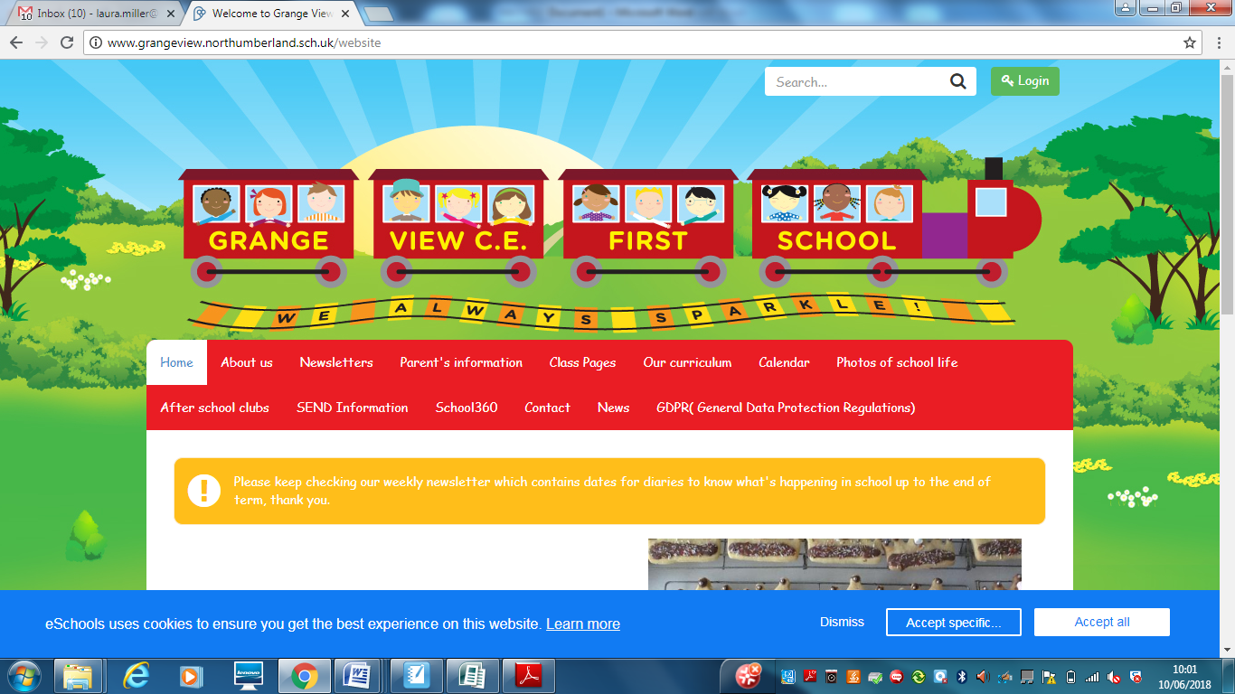

***We aim to SPARKLE!***

**Dear Parents / Carers 12 February 2021**

**Good news!**

**Miss Darlow gave birth this week to a beautiful baby boy – Benjamin Michael Elliott – 8lb 3oz. Both well and we have sent all our best wishes to the family. We hope we can meet Benjamin soon when it is safe to do so.**

**Home learning – You are all still doing an AMAZING job at home with your children. Please keep in touch on class Dojo but have a rest over half term and enjoy some fun with your families at home.**

**A google Remote Learning questionnaire has been emailed home to you all, please support the Grange View**

**Team by providing your feedback. Thankyou.**

**LOCKDOWN 2- ***COVID NEW Information\*\*\*\***

**Spring Term 2**

We are looking forward to news from the government on 22nd February in regards to how schools return staggered from 8th March onwards. In the meantime we will remain open to key worker and nursery children where parents choose to send them to school.

We will be in touch as soon as we have any news about how we can get all our children back to school .

**STAFF TESTING**

**Staff testing continues.** Any staff who test postive will then have to follow government guidelines and isolate for 10 days as well as booking another PCR TEST through 119 . Therefore this may obviously have an impact on any children who are in the same bubble as that member of staff and the bubble will also have to close until the PCR Test results come back. If the postive test is confirmed then the whole bubble will isolate for the recommended 10 day period. If the result comes back negative then the bubble will reopen.

We hope you can understand that this a postive move to stop any further transmission of the virus and we will continue to keep all staff and children as safe as possible.

**Bubbles/Pods**

**Our Nursery and key worker bubbles continue to remain open. Please give the office a weeks notice if you need a place for your child to return to enable us to sort staffing.**

Key Workers - The guidance on critical workers has been updated to add a line saying the following **“but parents and carers should keep their children at home if they can”**

<https://www.gov.uk/government/publications/coronavirus-covid-19-maintaining-educational-provision/guidance-for-schools-colleges-and-local-authorities-on-maintaining-educational-provision>

The guidance to parents and carers in turn now says the following:-

“Children and young people are eligible to attend school or college if:

**‘At least one parent or carer is a critical worker, and they can’t keep their child at home. Critical workers are those whose work is critical to the coronavirus (COVID- 19) and EU transition response’**

**To avoid further transmission of the virus we ask you only send your child into school when there is an absolute need. We are happy to be flexible to fit around individual working patterns to support all our families.**

**Any children of Key workers who have been in school up until today if they develop any symptoms they must report it to school immediately via email to enable us to take the appropriate action e.g. close bubbles and isolate for 10 days.**

**Remote Learning Update:**

Parents and Carer please ensure you are sharing all learning online as much as you can. This is to ensure we know your children are safe at home and engaging. The Education Welfare officer calls school every week to ask if we have any worries or concerns and then will be in touch direct.

**FREE Library books-** eLibrary Service. We are very excited to have access to an online eLibrary service allowing you to loan eBooks at home. Each child will be sent their own individual username and password on Class Dojo to log in to this service and Mrs Timmins will be uploading a video onto Class Dojo and the school website with a step-by-step guide on how to download the app and access the books. Please get in contact if you need any assistance using the service and we will do our best to help.



**FREE PC’s – we have 2 remaining reconditioned PC’s for any family, first come first served with the office please.**

**Zoom Sessions-** Daily Summaries with class teacher in each day via Dojo.

**Zoom stories/sessions -** These continue every week and it’s great to see all our classes attending and Zoom Curriculum/game sessions every week**.**

**Emails/Texts-** please check your emails and texts for regular updates in relation to school.

**Phone Calls-** teachers will give all parents a supportive call if they are worried about Remote learning**.**

**Devices –** A small number of extra devices through the Department of Education are in school, please get in touch with your class teacher/office if you need one**.**

There are lots of extra links and downloadable resources in the COVID section on the school website. We need all our children to keep learning at home if they are not eligible to a key worker place in school or a parent chooses to keep their child at home. We understand it is very difficult and will support you with all you can do during the day at any time that is convenient to your individual situation. The teachers will be now be keeping a log of what is completed at home, which children they have seen on Zoom and will be in touch with families who need a little bit of extra help. Thankyou.

**NEW Risk Assessment Version 5.2 - (a copy of which is on the school website)**

**FREE SCHOOL MEALS- we are continuing to use the Huggg system to provide vouchers for FSM families. During half term this will continue and will be funded through the government Winter Funding Plan.**

***Dates for the diary:***

* **Tuesday 9th Feb – Safer Internet Day (SID)- watch out on Class Dojo**
* **Fri 12th Feb- Half term – School closed for half term**
* **Mon 22nd Feb- School open to Nursey( who have informed school) Key worker and Vulnerable children return (at the moment until further notice from the Government)**
* **\*\*\* New date***- Parent consultations to be confirmed for after Easter.**

**NEW- Shopping Link to support Grange View CE First School**

<https://smile.amazon.co.uk/ch/1049905-0>

This is the link to The Friends of Grange View Fundraising. It takes you to Amazon for any purchasing. Everything you buy raises funds for the school and generates extra funding to the PTA who in turn spend it on resources for your child and the school. Thankyou for supporting us with this as every penny counts.

**ABSENCES**

Please can everyone ensure they call Mrs Brown in the office to report an absence of any kind. Thankyou.

**ATTENDANCE**

**Can my child go to school if they have a cold?** The NHS advises that if a child has mild cold-like symptoms they should continue to go to school. Sore throats and blocked or runny noses are not symptoms of Coronavirus. We have routines in place should a child in school show symptoms of Coronavirus and will isolate the child and contact parents to collect them immediately, self -isolate and book a test.

**SIMS Online payments – COIVID SAFE CASH FREE SYSTEM**

Our new online payment system for any services in school is now active. Thank you to all of those who have already signed up and began using it. You should have received an activation code via email. Please follow the online instructions to set this up to make any future payments. Any issues please email or call the office. Thank you.

Please don’t hesitate to contact us if you have any questions or concerns at [admin@grangeview.northumberland.sch.uk](mailto:admin@grangeview.northumberland.sch.uk)

****Please note – no cash is to be brought into school unless we ask specifically (often for the Friends of Grange View events) All payments for school lunch, milk, uniform, trips etc. should all be made online. Due to Covid, we need to avoid handling cash as much as we can.*****

**Beech**

Merit – Korey & Avneet

Sparkle - Noah

**Chestnut**

Merit – Lucy F & Kristian

Sparkle - Amelia

**Willow**

Merit – Riley & Amelia

Sparkle - Dillon

**Acorn**

Merit – Theia & Ella

Sparkle - Rose

**Oak**

Merit – Mark & Charlotte

Sparkle – Mary-Jayne

**Elm**

Merit – Freya & Alex

Sparkle - Owen

**Stars of the Week:**

Thank you once again for your support and patience during this different way of school life.

**We continue to follow the government message: BY STAYING ALERT – AND FOLLOWING THE RULES- WE CAN CONTROL THE VIRUS**

**Stay Safe Everyone!**

Louise Laskey – Headteacher



**Safe to Learn section**

This is a section on our newsletter where we will share and update any safeguarding information for all parents/carers to be aware of. Mrs Pat Treanor is our Chair of governors and safeguarding governor, Mrs Laskey and Mrs Chapman are our Designated Safeguarding lead staff.

Mrs Laskey- Head Mrs Chapman-Assistant Head

**OPERATION ENCOMPASS INFORMATION**

The original initiative was aimed at supporting children who are affected by domestic abuse. The next part of the project will help all children to learn about friendships, relationships, emotions and rules so that they can live and work together safely. Our Safeguarding liaison officer Karen Kirkbride will be in school this term delivering these workshops.

**Operation Endeavour**- This is an innovative project in which schools and colleges in Northumberland are participating, and which is run in partnership with Northumberland County Council and Northumbria Police.

Operation Endeavour commenced in November 2018, aims to support children and young people who go missing from home. Children who go missing from home are at risk of significant harm and they may be vulnerable to sexual exploitation, violent crime, gang exploitation, or to drug and alcohol misuse.

As a result, following any report of a child going missing to the Police, the Police will make contact with Children’s Social Care who will then communicate relevant and necessary information to nominated school staff.

Each school has members of staff (key adults) who have been fully trained in liaising with the Police and Children’s Social Care when required, and will ensure that the necessary support is made available to the child or young person following their return.

I believe that this project demonstrates our school’s commitment to working in partnership to safeguard and protect children, and to providing the best possible care and support for our pupils.

**Onecall**

Onecall is the number for all adult social care, children’s services and community health enquires in Northumberland. Helping the most vulnerable to keep safe and well 24-7.

**Telephone- 01670 536400**