Grange View C.E.First School
Grange Road, Widdrington Morpeth, NE61 5LZ.
Telephone: 01670 790 686
email: admin@grangeview.northumberland.sch.uk
Headteacher: Mrs Louise Laskey B.Ed(Hons) www.grangeview.northumberland.sch.uk

Dear Parents/Carers 19th June 2017

Warm weather alert!!
Please keep an eye on the weather forecast as this week we are expecting sunnier days so please apply sun-cream as necessary, and a sun hat/cap.
We also encourage each child to have a water bottle in school for drinking throughout the day - water bottles can be purchased from the School Office for £1.00

SUMMER FAIR 3PM FRIDAY
Please come along to join us for a BBQ, bouncy castle and the usual fun this Friday afternoon.
Hopefully the sun will shine!
Cake donations will be gratefully received to support Mrs Redpath’s cake stall please as this may be her last Fair so get baking or making crispies as we need your help. Thankyou.

30 HOURS OFFER DEADLINE
ALL PARENTS REQUIRING THE 30 HOURS OFFER FOR NURSERY FROM SEPT 2017 MUST HAVE GIVEN THEIR CODE TO THE OFFICE BY THE DEADLINE 30TH JUNE FOR FUNDING. OTHERWISE WE WILL NOT BE ABLE TO OFFER YOUR CHILD THEIR EXTRA 15HOURS OFFER. THANKYOU
Are you entitled to 30 hours free childcare or do you know someone who is? Please see the Northumberland County Council website. Link- http://www.northumberland.gov.uk/NorthumberlandCountyCouncil/media/Child-Families/Families/Childcare/early-years-30-hrs.pdf

ATTENDANCE AGAIN!
48% of the school from Reception to Year 4 are below our 96% target. Therefore unless we see a dramatic improvement over the next 5 weeks no class will be receiving the i-pad or parent will receive the shopping voucher.
The school has recently issued its first penalty notice of a £60 fine per pupil per parent. Therefore in a larger family of 4 children this could be up to £480 which school doesn’t receive a penny. The Department for Education monitor the school’s attendance termly and we MUST follow this guidance. Thankyou.

Attendance – Does it matter? YES IT DOES!!
To promote and reward good attendance across the school the governors have agreed to provide an AMAZING incentive!
The class with the greatest attendance at the end of the year will win a MINI IPAD and a family with 100% attendance will be entered to a prize draw to win £30 shopping voucher.

Please remember your child’s attendance in school is extremely important. Awards will continue to be given to each class with the best attendance. Can we remind parents about a section of the Education Act 1996: “Central to raising standards in education and ensuring all pupils can fulfil their potential is an assumption so widely understood that it is insufficiently stated – pupils need to attend school regularly to benefit from their education.
Missing out on lessons leaves children vulnerable to falling behind. Children with poor attendance tend to achieve less in both primary and secondary school.

NO HOLIDAYS will be authorised in term time
Last week’s attendance:
Well done Beech Class who won with 95.3%
Acorn – 92.4% Oak – 91.4%
Elm – 95.0% Beech – 95.3% Willow – 95.1%
TOTAL FOR THE LAST WEEK – 94.2%
Just below our school target of 96%

PLEASE TRY to get your child to school on time every day
and help us achieve our target EVERY week, thank you.

Reporting Absences
It is essential that all absences are reported to the office on the first day your child is off school. Any pupil with attendance below 90% has to be reported to the Education Welfare officer who then decides what further action to take. Any pupil who has below 90% attendance must give school medical evidence from their GP/hospital etc to confirm any absences. Any pupils below 90% attendance who wish to take a holiday in term time maybe subject to a £60 penalty notice per pupil per parent.
We need all families to aim for 96% attendance or above please to ensure you child’s education is not affected.

*****No Smoking*****
As you are all aware, the school is a non-smoking site. This means even at the school gates which are our entrances to the site smoking is not permitted. Please can all parents respect our school policy and ensure when you “light up” it is away from our grounds. Thankyou.

Swimming
From September 2017 Year 3 and Year 4 will continue to go swimming, as it is a statutory requirement for Key Stage 2 pupils to swim as part of their PE curriculum. We will continue to swim weekly at Morpeth Leisure Centre but we hope to confirm that it will change to a Wednesday afternoon which will mean the children will return to school for home time slightly later. We will confirm this when we have further information but wanted to give parents plenty notice.
YEAR 2 will no longer be swimming from Sept 2017 as it is not statutory for them to do so until KS2 (these are our current Year 1 children).

PE Kit
It is vital that your child has his/her full PE kit in school (school t-shirt/black shorts/sandshoes), otherwise they may miss out on valuable PE/sporting activities due to incorrect clothing & footwear. This is necessary for the safety of everyone, thank you.

School Dinners
From September 2017 our current Yr 2 children (Beech Class) who will be moving in to Yr. 3 will be required to pay for school dinners or bring a packed lunch.
If you know your child will be having dinners (£11.00 per week), would you please let the office know so we can give our Unit Manager Mrs Palmer an indication of numbers for September, thank you.

Packed Lunches
Please can all families ensure they give the office at least a week’s notice if their child wishes to change to a packed lunch. Food is ordered in advance for all school lunches. Thank you.

SCHOOL UNIFORM ORDERS
We have school uniform in stock - no need to order at the moment just pop to the office or alternatively pick up an order form. If you want uniform for September, now is the time to sort it out. After the summer we will only keep a very small amount of items in stock. However we don’t stock yellow summer dresses, but they are available as follows:

Sainsburys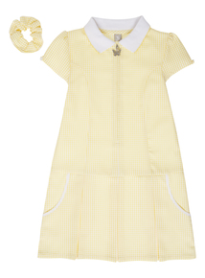
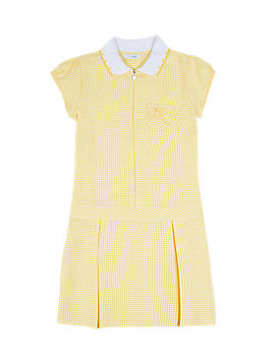M and S
Asda 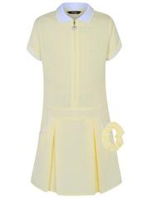
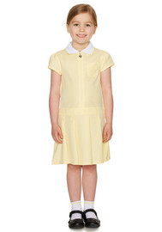Tesco

Let’s hope we get some warmer weather to wear these lovely yellow dresses.

Dates for diaries:

Please check these weekly - all are subject to change or additional dates being added:-
- 19th /20th June New Nursery visits with parents 1-2pm
- Tues 20th June - Big Gig Music Event for Willow class at JCSC. All Year 3 and 4 in the afternoon will be attending JCSC to take part in a music celebration. They will be back by the end of the day.
- Wed 21st June - Y4 Leavers service with staff at St. Nicholas cathedral in Newcastle, details to follow. Out all day + packed lunch required please. See the office if you need a Free school meal packed lunch as these MUST be ordered, thankyou
- Fri 23rd June - Summer Fair at 3pm
- 26th /27th June New Nursery visits without parents 1-2pm
- Tues 4th July- Y4 transfer day to JCSC and all classes move around
- Fri 7th July – NO FAMILY WORSHIP
- SPORTS DAY weather permitting 1.10pm . Bring a rug and a picnic ? All Nursery pupils in the morning session and parents invited at 10.45am. Reports out.
- Mon 10th July – Y4 Quad kids in the morning to be confirmed then Cricket festival pm Willow class at Warkworth TBC.
- Wed 12th July Eucharist Service 2pm in school hall with Rev Joanna Dobson
- Mon 17th July 4pm -5.15pm ish Year 4 Leavers Tea at Sambucca’s in Morpeth please share lifts to meet us there. Separate letter to follow.
- Wed 19th July 5.30pm Leavers Show- Y4 Movie and refreshments for all Y4 families
- Fri 21st July - School closes at 1.30pm for the summer holidays
- Mon 5th Sept – TTD, school closed to pupils
- Tues 6th Sept – school opens at 8.50am for the Autumn Term

Stars of the week

Beech
Merit – Nikola, Michal
Sparkle – Jaiden
Writing – Ashton
Presentation – Riley R

Willow
Merit – Ethan, Acacia
Sparkle – Elena
Writing – Macey
Presentation – Paige

Acorns
Merit – Olivia, Poppy A
Sparkle – Jacob
Writing – Lucie
Oak
Merit – Grace B, Joshua
Sparkle – Leah
Writing – Sean-Lucas
Presentation – Harry
Elm
Merit – Imogen, Aidan
Sparkle – Alfie
Writing – Ashpreet
Presentation – Heavenlee

Football
Jayden
James N

Message from Mrs Chapman
A BIG THANK YOU to everyone who supported my
Fundraising in school for The Evie Campbel Fund.
We raised a fabulous £85 and the prize has been claimed.
Thanks again.

DON’T Forget- Easy Fund Raising www.easyfundraising.org.uk. Please register and keep Shopping online on this website for school funds. Every penny you spend helps school.

Kind Regards

Louise Laskey
Mrs L Laskey – Headteacher

