

**Grange View C.E. First School**   
Grange Road, Widdrington  
Morpeth, NE61 5LZ.

Telephone: 01670 790 686email: [admin@grangeview.northumberland.sch.uk](mailto:admin@grangeview.northumberland.sch.uk)

Headteacher: Mrs Louise Laskey

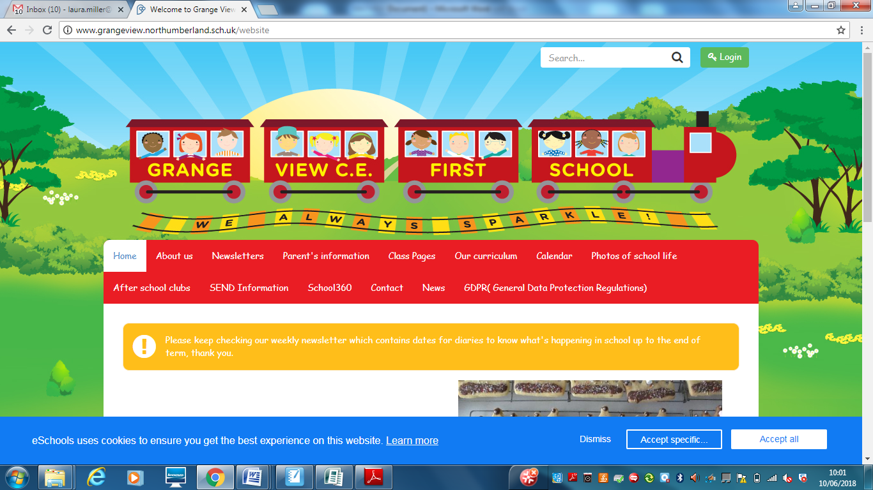

***We aim to SPARKLE!***

**Dear Parents / Carers 30 April 2021**

**September 2021**

**We are currently planning and organising the school and classes for September. Obviously we hope all Covid restrictions are lifted by then but we will be writing to all families after May half term to confirm as much as possible, If you require any new uniform please contact the office now to ensure we have stock. Thankyou.**

A HUGE thankyou to Councillor Scott Dickinson who has supported the school with a donation of £3000 towards LED lighting refurbishment. This is a massive support to our small school and means we can finally complete classrooms and offices that have not all been replaced. THANKYOU Scott!!

**Parent Phone call Consultations**

Please make sure you have made an appointment with your child’s teacher via Dojo even if you have missed your booked slot. Every child has brought home their target sheet before your appointment to talk about with the class teacher ahead of each consultation. Please make sure you have read it and have any questions ready as each call is 10 minutes.

**New Books on elibrary**

FREE Library books- eLibrary Service. Please remember you have access to an online eLibrary service allowing you to loan eBooks at home. Each child has their own individual username and password on Class Dojo to log in to this service. Mrs Timmins has uploaded a video some time ago onto Class Dojo and the school website with a step-by-step guide on how to download the app and access the books. Please use this service if you would like more books for your child to read as we are still following COVID guidance and cannot change books as regularly as we would like to.

**Gentle Reminders**

**NO Jewellery** in school please for health and safety reasons, this includes earrings, rings, necklaces etc. Your child must be able to remove them independently or earrings must be taped up for all PE days. We do not want your child to miss any lessons and to avoid any accidents during the school day.

**Only water in bottles please**, no juice please only with packed lunches. We are happy to refill any water bottles during the day for your child.

**NUT ALLERGIES-** Please can we remind you that we have children in school with NUT ALLERGIES and NO products containing all nut ingredients must be sent into school in lunch boxes at all. Thankyou.

**Forest School**

We are so lucky to have amazing grounds to access for our outdoor learning across the curriculum. Mrs Gray has just completed a whole week of Forest School leader training and will be supporting each class with their outdoor learning. The school has a Risk assessment in place for this and it is available for any families who would like a copy.



**Sparkling Afternoon Tea**

**4 wonderful Year 3’s joined Mrs Laskey outside last week. Poppy, Heidi, Elliot and Amelia had treats and a chat for all their efforts last week in school. I wonder who it will be this Friday ?????**

**Class Photos**

**We have managed to secure a booking with a local Photographer for 9th June to take a class photo for every class. This will be a lovely keep sake and memory for you and your child. To order a copy please email the office by 14th May. The cost will be £10 per copy. Thankyou.**

**AFTER SCHOOL CLUBS**

We are resuming after school club provision after Easter with our professional coaches.

We need to know how many pupils wish to join certain clubs as we will be remaining in Key stage Bubbles for all our clubs.

**These are the clubs we are offering for the Summer Term:**

**Mondays- Fun and games outdoors- Y3 and Y4 with Bear and coaches from Cramlington Rockets**

**Tuesdays - Football Club- Y1 and Y2 with Ryan from Trident football and coaches- FULL**

**Tuesdays- Craft club through story- Reception with Miss Adams and Mrs Tait**

**Thursdays- Little Movers - Y1 and Y2 with Fiona**

**Please can children wear joggers and school polo and sweatshirt on these days and ensure they have the correct footwear. NO JEWELLERY IS PERMITTED.**

These clubs are FREE, there is no charge for any of these clubs for the Summer Term to support all our families and the children's well-being.

**SUMMER FOOTBALL CLUB**

**We would like to work with Trident Football club and provide a Summer Football school during the holiday’s this year. If they have enough families interested it would take place at Grange View on weeks beginning 26th  July and 2nd August. The Football camps run for four days and the cost is £40, or £10 a day.**

**\*\*\*If you are interested in booking a place please ring the office to add your child’s name to the list asap\*\*\***

**Dates for the diary:**

* Mon 2nd May- Bank holiday- school closed
* Fri 7th May - NSPCC Numbers Day in your diary – More info to follow on class dojo
* Mon 24th May – KS2 KINGSWOOD ACTIVITY DAY – Y4 only
* Fri 28th May – Half term- school closes normal time
* Mon 7th June- School reopens
* Wed 9th June- Class Photos- full uniform required

**Shopping Link to support Grange View CE First School**

<https://smile.amazon.co.uk/ch/1049905-0>

This is the link to The Friends of Grange View Fundraising. It takes you to Amazon for any purchasing. Everything you buy raises funds for the school and generates extra funding to the PTA who in turn spends it on resources for your child and the school. Thankyou for supporting us with this as every penny counts.

**SIMS Online payments – COVID SAFE CASH FREE SYSTEM**

Our new online payment system for any services in school is now active. Thank you to all of those who have already signed up and began using it. You should have received an activation code via email. Please follow the online instructions to set this up to make any future payments. Any issues please email or call the office. Thank you.

Please don’t hesitate to contact us if you have any questions or concerns at [admin@grangeview.northumberland.sch.uk](mailto:admin@grangeview.northumberland.sch.uk)

****Please note – no cash is to be brought into school unless we ask specifically (often for the Friends of Grange View events) All payments for school lunch, milk, uniform, trips etc. should all be made online. Due to Covid, we need to avoid handling cash as much as we can.*****

**Beech**

Merit – Matilda & Bailey R

Sparkle – Jayce

**Chestnut**

Merit – Roseann & George

Sparkle – Eva H

**Willow**

Merit – Harry & Ayden

Sparkle – Leah

**Acorn**

Merit – Millie D & Jacob

Sparkle – Faith

**Oak**

Merit – Robson & Bella-Rose

Sparkle – Lara-Lee

**Elm**

Merit – Joseph & Leo

Sparkle – Jessica

**Stars of the Week:**

**ATTENDANCE**

**The most important message is children should be in school as much as possible as every day that a child misses school, for whatever reason, they miss out on vital learning.**

We will be continuing to monitor our classes’ attendance every week and individual class percentages will be published here each week. It is vital that children attend school every day possible to ensure that they are able to start catching up on learning that they may have missed during the school closure and holidays.

Children should not attend school if they are showing any Covid symptoms or if they are required to self-isolate as a result of being in contact with anyone who is showing symptoms.

**Can my child go to school if they have a cold?** The NHS advises that if a child has mild cold-like symptoms they should continue to go to school. Sore throats and blocked or runny noses are not symptoms of Coronavirus. We have routines in place should a child in school show symptoms of Coronavirus and will isolate the child and contact parents to collect them immediately, self -isolate and book a test.

**This week’s attendance stars**

Well done to Oak Class who won with 99.4%

Acorn – 89.5% Oak – 99.4% Elm – 98.8% Beech – 97.5%

Chestnut – 96.8% Willow – 93.1%

TOTAL FOR THE WEEK 96.2%

Which is slightly below our new school target which is now 97% -

**W/C: 26.04.2021**



**COVID Update:**

**COVID STAFF TESTING**

**Staff testing continues.** Any staff who test postive will then have to follow government guidelines and isolate for 10 days as well as booking another PCR TEST through 119 . Therefore this may obviously have an impact on any children who are in the same bubble as that member of staff and the bubble will also have to close until the PCR Test results come back. If the postive test is confirmed then the whole bubble will isolate for the recommended 10 day period. If the result comes back negative then the bubble will reopen.

We hope you can understand that this a postive move to stop any further transmission of the virus and we will continue to keep all staff and children as safe as possible.

However, pupils, staff and other adults should not come into school if they have coronavirus (COVID-19) symptoms, or have tested positive. Anyone developing those symptoms during the school day will be sent home.

This includes any of the following symptoms:

● New and persistent cough

● Fever / temperature

● Loss of sense of taste and / or smell

They will be advised to follow ‘stay at home: guidance for households with possible or confirmed coronavirus (COVID-19) infection’, which sets out that they must self-isolate for at 10 days and should arrange to have a test to see if they have coronavirus (COVID-19). Other members of their household (including any siblings) should self-isolate for 10 days from when the symptomatic person first had symptoms.

If, during the course of the school day, your child demonstrates any symptoms of COVID-19 (as outlined above), they will be isolated immediately and you will be contacted to collect them from school with immediate effect. Your child will be treated with care and compassion, but there is a process that we are required to follow and this may include the member of staff dealing with them using PPE kit to protect themselves (goggles, face mask and gloves) while they await collection if a distance of 2 metres cannot be maintained.

Any pupils who have been in close contact with them do not need to go home to self-isolate unless they develop symptoms themselves (in which case, they should arrange a test) or if the symptomatic person subsequently tests positive or they have been requested to do so by NHS Test & Trace.

**Remote education will still be provided where pupils are self-isolating or shielding.**

**Asymptomatic testing information for parents and adults in households with children at school or college**

NHS Test and Trace announced earlier this week, that all adults in households with school and college age children without symptoms can now access regular rapid coronavirus (COVID-19) testing.

Test kits can either be collected or ordered online, as set out below.

Undertaking regular, rapid coronavirus (COVID-19) testing helps reduce transmission of the virus. Parents and other adults in households with children at school or college, who do not have symptoms, can now access regular, rapid coronavirus (COVID-19) testing. This includes childcare and support bubbles.

Tests are fast, easy and completely free. There are [different ways](https://www.gov.uk/guidance/rapid-lateral-flow-testing-for-households-and-bubbles-of-school-pupils-and-staff) for a household, childcare or support bubble to collect their test to take at home, twice-weekly:

|  |
| --- |
| * **through your employer, if they offer testing to employees** * **by collecting a home test kit from a local test site – anyone aged 18 or over can collect 2 packs of 7 tests** * **by ordering a home test kit online – please do not order online if you can access testing through other routes, this frees up home delivery for those who need it most** |

If you have any queries about the tests, and you live in England, please call 119 (free from mobiles and landlines). Lines are open every day from 7am to 11pm.

Children of primary school age (and below) without symptoms are not being asked to take a test.

Testing is voluntary, but strongly recommended to all who are eligible. Alongside the vaccine, washing hands, wearing face coverings, and maintaining social distancing, rapid testing plays a vital role in reducing transmission rates. Getting into the habit of regular testing as part of our everyday lives will help us all to play our part and do what we can to protect each other.

Thank you once again for your support and patience during all of these changes.

**We continue to follow the government message:**

**Hands- Face- Space- Fresh Air**

Louise Laskey – Headteacher



**Safe to Learn section**

This is a section on our newsletter where we will share and update any safeguarding information for all parents/carers to be aware of. Mrs Pat Treanor is our Chair of governors and safeguarding governor, Mrs Laskey and Mrs Chapman are our Designated Safeguarding lead staff.

 

Mrs Laskey- Head Mrs Chapman-Assistant Head

**OPERATION ENCOMPASS INFORMATION**

The original initiative was aimed at supporting children who are affected by domestic abuse. The next part of the project will help all children to learn about friendships, relationships, emotions and rules so that they can live and work together safely. Our Safeguarding liaison officer Karen Kirkbride will be in school this term delivering these workshops.

**Operation Endeavour**- This is an innovative project in which schools and colleges in Northumberland are participating, and which is run in partnership with Northumberland County Council and Northumbria Police.

Operation Endeavour commenced in November 2018, aims to support children and young people who go missing from home. Children who go missing from home are at risk of significant harm and they may be vulnerable to sexual exploitation, violent crime, gang exploitation, or to drug and alcohol misuse.

As a result, following any report of a child going missing to the Police, the Police will make contact with Children’s Social Care who will then communicate relevant and necessary information to nominated school staff.

Each school has members of staff (key adults) who have been fully trained in liaising with the Police and Children’s Social Care when required, and will ensure that the necessary support is made available to the child or young person following their return.

I believe that this project demonstrates our school’s commitment to working in partnership to safeguard and protect children, and to providing the best possible care and support for our pupils.

**Onecall**

Onecall is the number for all adult social care, children’s services and community health enquires in Northumberland. Helping the most vulnerable to keep safe and well 24-7.

**Telephone- 01670 536400**

